Chapter N
The air indicator of VIVA certification for the sustainability of Italian wine: analysis and perspectives

Nicola Casolani ¹, Lolita Liberatore ²
¹⁻² Department of Economic studies - University G. D’Annunzio of Chieti-Pescara - Viale Pindaro 42, 65127 Pescara (Italy)
¹nicola.casolani@unich.it, orcid.org/0000-0002-6600-3912;
²l.liberatore@unich.it, orcid.org/0000-0001-7460-9757.

Corresponding author: Nicola Casolani, nicola.casolani@unich.it.

Abstract. The agri-food sector contributes significantly to greenhouse gas emissions which are responsible for global climate change. Carbon emissions represent a critical issue in the wine sector. The air indicator of Italian VIVA certification expresses the impact of wine production on climate change. This paper analyzes the impacts of air indicator of VIVA certified wines in the different stages of production (agricultural production, industrial processing, bottling) and, furthermore, the data variability. The sample is represented by 45 wines produced by Italian companies (functional unit refers to a bottle of wine of 0,75 liter). The results reveal average values ​​of 0,25 kg CO₂/bottle in the agricultural phase, while in the industrial processing phase the values ​​are slightly higher (0,28 kg CO₂/bottle). The production of packaging (bottling) represents the most impactful phase (0,58 kg CO₂/bottle). The values of coefficient of variation applied to the impact of the entire production cycle ranged between 0,05 and 1,46 kg CO₂/bottle, revealing a very heterogeneity scenario.
Monitoring the performance of VIVA certified companies and implementing eco-sustainable business management strategies are essential issues for reducing climate-altering gas emissions. Strategies for the reductions of carbon emissions (especially in bottling phase) are needed, in line with continuous improvement philosophy.

Keywords: VIVA certification, carbon footprint, climate-altering gases, wine sustainability

1.1 Introduction
Italy, France and Spain together produce more than 50% of the world’s wine production and have about 33% of the vineyards in the world (Ferrara and De Feo, 2018). The environmental issues of wine industries were left unexplored for a long time (Christ and Buritt, 2013) and have appeared only in recent years. Studies have been published mainly from 2013 onward (Ferrara and De Feo, 2018). Agriculture contributes to climate change with carbon emissions (Pant, 2009) and its determinations represent a critical issue (Notarnicola et al., 2003; Rugani et al., 2013); market and regulatory drivers push the wine industry to assess, reduce and communicate carbon emissions (Pattara et al., 2012). The Carbon Footprint (CF) is an indicator of Greenhouse Gases emissions that measures the impact of human activities in terms of the quantity of greenhouse gases produced (Weidema et al., 2008; Röös et al., 2013), useful for understanding the contribution to the Global Warming Potential (GWP).
In 2011, the Italian Ministry of the Environment and the Protection of the Territory and the Sea launched the national project VIVA “Sustainability in viticulture in Italy”; this program aims to measure the sustainability performance of the wine supply chain, through the application of indicators based on international standards and guidelines: air indicator (climate footprint), water indicator (water footprint), vineyard indicator (impact of agronomic management practices) and territory indicator (socio-economic-cultural impact). VIVA certification uses a supply chain approach (Corbo et al., 2014). The air indicator expresses the impact that the production of a specific product and/or company activities have on climate change and is referred, in terms of functional unit, to a bottle of 0,75 liters. The air indicator follows the standard ISO 14067:2018 (Greenhouse gases - Carbon Footprint of Products - Requirements and guidelines for quantification), the standard ISO 14044:2006 (Environmental management - Life cycle assessment - Principles and framework), the standard ISO 14026:2017 (Environmental Labels and declarations – Principles, requirements and guidelines for communication of footprint information). VIVA methodology framework for air indicator was described by D’Ammaro et al. (2021).
The Italian context lacks Life Cycle Inventory (LCI) datasets related to Italian wine (Notarnicola et al., 2022) and more specific data related to Greenhouse Gases emissions are limited to a few studies (e.g. Bosco et al., 2011; Bonamente et al., 2016; D'Ammaro et al., 2021).
This paper aims at analyzing the impacts of air indicator of VIVA 2.0 certified wines (and subsequent update 2.1, hereinafter reported only as VIVA 2.0) and the degree of variability.

1.2 Materials and methods
The sample investigated is represented by VIVA 2.0 certified wines (n= 45) on 23-02-2022. Most of the products are located in Italian regions such as Tuscany (13), Emilia-Romagna (9), Veneto (8), Piedmont (6), Friuli Venezia Giulia (3), Umbria (3), Marche (2) and Sicily (1).
Most of the sample (53%) is represented by red wines (n= 24), 20% of white wines (n= 9), while the sparkling type represents in total about 27% (n= 12). In this paper, the following phases will be considered: vineyard management (hereinafter referred to as “agricultural phase”), industrial transformation of grapes into wine (hereinafter referred to as “industrial phase”), and the packaging production (hereinafter referred to as “bottling phase”).
This paper does not consider the distribution and end-of-life phases of the products, considering an approach “from cradle to gate”.
The values of air indicator were taken from the latest VIVA 2.0 report which is available on the site:
http://www.viticolturasostenibile.org/ProdottiViva.aspx.

1.3 Results
Table 1 shows grape yield and air indicator values of VIVA 2.0 certified wines in relation to the phase of production. The average value of air indicator for the agricultural phase is 0,25 kg CO₂/bottle. In relation to the industrial phase, the air indicator shows slightly higher values (0,28 kg CO₂/bottle). The production of packaging represents the most impactful phase, with the average values of the air indicator of 0,58 kg CO₂/bottle; furthermore, the standard deviation of this phase has lower values than others, revealing a lower variability of the data. The total impact (sum of agricultural, industrial and bottling phase impacts) ranged between 0,73-2,08 kg CO₂/bottle, with an average of 1,11 kg CO₂/bottle.

Table 1. Grape yield, air indicator values of VIVA 2.0 certified wines.
 | Grape yield  q/ha | Agricultural phase  kg CO₂/bottle | Industrial phase  kg CO₂/bottle | Bottling phase  kg CO₂/bottle | Total impact  kg CO₂/bottle
Minimum | 37 | 0,05 | 0,03 | 0,30 | 0,73
Maximum | 180 | 0,80 | 1,03 | 0,94 | 2,08
Average | 104 | 0,25 | 0,28 | 0,58 | 1,11
Standard deviation | 42 | 0,18 | 0,20 | 0,12 | 0,27

In terms of average impact, the agricultural phase represents the 22,5% of the total, while the industrial phase and bottling phase respectively 25,2% and 52,3% (Figure 1). The packaging production, according to other authors (e.g. Bosco et al., 2011; Ponstein et al., 2019), is the most impactful phase. Ponstein et al. (2019), in a study conducted in Germany, found that 19% of emissions of wine production are related to agricultural phase, while 81% to industrial production, mainly due to packaging materials (57%); in the same way, Bosco et al. (2011) found that the main impact of wine chains was the production of the bottle-glass.

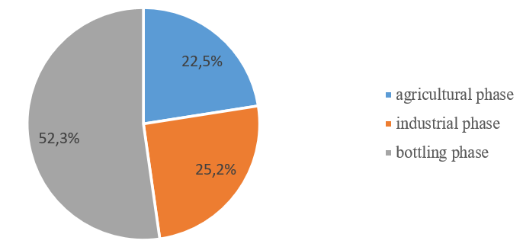
Fig. 1. Average impact of air indicator of VIVA certified wines for each phase.

Figure 2 shows the distribution of the air indicator for the cultivation of grapes on the productivity (yield per hectare) of VIVA 2.0 certified. The range that takes into account a production yield from 60 to 80 quintals per hectare presents a high number of wines (n=17; 37,8%), and values of the air indicators ranged between 0,11 and 0,43 kg CO₂/bottle correspond to it. Bosco et al. (2011) highlight that the use of fertilizers represents one of the interventions that most affects the carbon footprint in the agricultural phase. In addition, fuel consumption strongly improves carbon footprint in agricultural phase (Litskas et al., 2020).

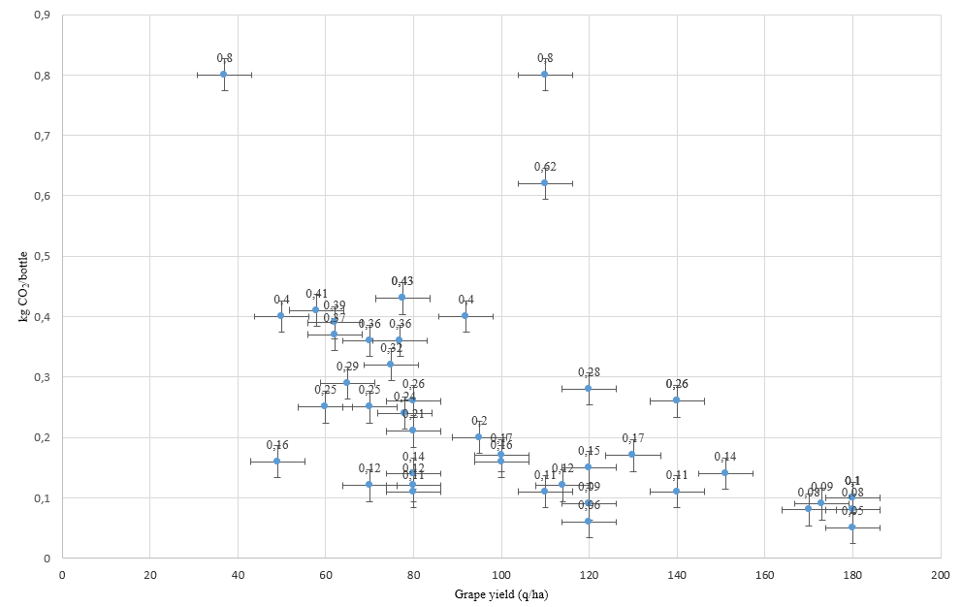
Fig. 2. Distribution of the air indicator (agricultural phase) on the production yield of the sample.

Figure 3 shows the total distribution of the air indicator values in all stages of production; 4 wines (8,9%) present values until 0,76 kg CO₂/bottle, 15 wines (33,3%) show values until 0,90 kg CO₂/bottle. The range between 1,02-1,46 kg CO₂/bottle is represented by 25 wines (55,5%). Only two wines have values that are more than 1,5 kg CO₂/bottle.
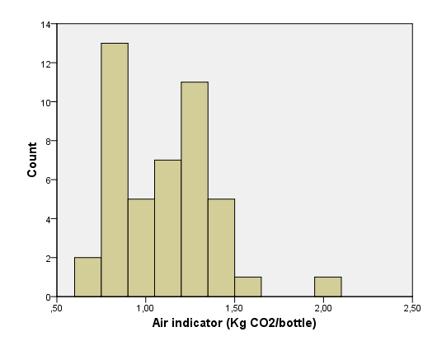
Fig. 3. Total distribution of the air indicator values (sum of agricultural phase, industrial phase, bottling phase).

The Coefficient of Variation (Lovie, 2005) applied to the agricultural, industrial and bottling phases for each VIVA 2.0 certified wine was calculated (Figure 4). The coefficient of variation ranges from a minimum of 0,05 kg CO₂/bottle to a maximum of 1,46 kg CO₂/bottle, while the sum of the air indicator values for the three phases ranges between 0,73 and 2,08 kg CO₂/bottle, revealing a very heterogeneity scenario.

Fig. 4. Distribution of the Coefficient of Variation of VIVA 2.0 certified wines and total values of the air indicator (sum of agricultural phase, industrial phase and bottling phase).
1.4 Conclusions
Wine production in Italy constitutes an important asset of the national economy and plays an important role in international markets. In the last years, various programs for environmental sustainability in agri-food sector were offered in Italy; VIVA represents a tool for assessment and then improvement of the sustainability in the wine production. This study is limited to the analysis of the air indicator, which refers to the impact that wine production has on climate change through gas emissions, revealing significant differences depending on the production phase; from the analysis of the data, it emerges that the most impacting phase is the bottling, with an extreme variability of the gas emission values in relation to the different types of wines (ranged from 0.30 to 0.94 kg CO₂/bottle). This issue deserves special attention from producers, consumers and policy makers, fighting for an effective decarbonization of the wine supply chain (Pointstein et al., 2019). The data of the agricultural and industrial transformation phases has similar impact and standard deviation values. These results are useful in a perspective of continuous improvement for companies that adhere to the VIVA 2.0 certification.
Future research should consider the distribution and end-of-life phases of the products.

1.5 References
Bonamente E, Scrucca F, Rinaldi S et al (2016) Environmental impact of an Italian wine bottle: Carbon and water footprint assessment. Sci. Total Environ. 560:274-283.
Bosco S, Di Bene C, Galli et al (2011) Greenhouse gas emissions in the agricultural phase of wine production in the Maremma rural district in Tuscany, Italy. Ital. J. Agron. 6(2):e15-e15.
Christ KL, Buritt RL (2013) Critical environmental concerns in wine production: An integrative review. J. Clean. Prod. 53:232-242.
Corbo C, Lamastra L, Capri E (2014) From Environmental to Sustainability Programs: A Review of Sustainability Initiatives in the Italian Wine Sector. Sustainability 6:2133-2159.
D'Ammaro D, Capri E, Valentino F et al (2021) Benchmarking of carbon footprint data from the Italian wine sector: A comprehensive and extended analysis. Sci. Total Environ. 779:146416.
Ferrara C, De Feo G (2018) Life cycle assessment application to the wine sector: a critical review. Sustainability 10(2):395.
ISO 14026:2017. Environmental labels and declarations. Principles, requirements and guidelines for communication of footprint information.
ISO 14044:2006. Environmental management Life cycle assessment. Requirements and guidelines.
ISO 14067:2018. Greenhouse gases - Carbon footprint of products. Requirements and guidelines for quantification.
Litskas V D, Tzortzakis N, Stavrinides M C (2020) Determining the carbon footprint and emission hotspots for the wine produced in Cyprus. Atmosphere 11(5):463.
Lovie P (2005). Coefficient of variation. Encyclopedia of statistics in behavioral science.
Notarnicola B, Tassielli G, Nicoletti G M (2003) Life cycle assessment (LCA) of wine production. Environmentally-friendly food processing, 306:326.
Notarnicola B, Tassielli G, Renzulli P A et al (2022) Life cycle inventory data for the Italian agri-food sector: background, sources and methodological aspects. Int J Life Cycle Assess 1-16.
Pant K P (2009). Effects of agriculture on climate change: a cross country study of factors affecting carbon emissions. Journal of Agriculture and Environment 10:84-102.
Pattara C, Raggi A, Cichelli A (2012) Life cycle assessment and carbon footprint in the wine supply-chain. Environ Manage 49(6):1247-1258.
Ponstein H J, Meyer-Aurich A, Prochnow A (2019) Greenhouse gas emissions and mitigation options for German wine production. J. Clean. Prod. 212:800-809.
Röös E, Sundberg C, Tidåker P et al (2013) Can carbon footprint serve as an indicator of the environmental impact of meat production? Ecol. Indic. 24:573-581.
Rugani B, Vázquez-Rowe I, Benedetto G, Benetto E (2013) A comprehensive review of carbon footprint analysis as an extended environmental indicator in the wine sector. J. Clean. Prod. 54:61-77.
VIVA project. Available at: http://www.viticolturasostenibile.org.
Weidema BP, Thrane M, Christensen P et al (2008) Carbon footprint: a catalyst for life cycle assessment? J. Ind. Ecol. 12(1):3-6.

