Chapter N (please do not write anything in this line. Editors will annotate the chapter number)
Sustainability of rural supply chains in Nepal: selection, characterization and labelling of spices for the local market
Patrizia Pinelli°, Daniela Tacconi#, Vittoria Vineis^{ç}, Leonardo Borsacchi§
°Department of Statistics, Computer Science, Applications "Giuseppe Parenti" (DiSIA), University of Florence, Viale Giovanni Battista Morgagni, 59 - 50134 Florence, Italy
^{#ç§} ARCO (Action Research for CO-Development) – PIN, University of Florence, Piazza G. Ciardi 25 – 59100 Prato, Italy
°patrizia.pinelli@unifi.it ORCID 0000-0002-2520-8479; #daniela.tacconi@arcolab.org; ^{ç}vittoria.vineis@arcolab.org; §leonardo.borsacchi@pin.unifi.it ORCID 0000-0001-6334-6146
Corresponding author: Patrizia Pinelli patrizia.pinelli@unifi.it .

Abstract. The agricultural sector plays a major role in Nepal’s economy, contributing about one-third of the country’s Gross Domestic Product. Although subsistence farming still dominates agricultural production, the proportion of farmland used for the production of high value crops like spices increased by 24% in this last decade. However, Nepal has not yet been able to establish direct trade relationships with buyers in potential destination markets.
This paper focuses on the project “Spices and sEEDs value chain improvement for rural development in Nepal, enhancing women and youth empowerment”, implemented by ASIA NGO and funded by AICS. The project aims at supporting small-scale farmers by improving agricultural production and the sale of seeds and spices of high commercial value. The work focuses on the sustainability of rural supply chain of Nepali spices and the actions carried out aims at describe the action-research carried out by ARCO PIN-Unifi in order to introduce upgrading in the processes of selection, preservation and packaging/labelling of the selected spices. Spectrophotometric analysis are also carried out for the evaluation of polyphenols, flavonoids and antioxidant activity, in order to enhance the functional value of spices and for the preparation of data sheets, also useful for the possible export of the product.

Keywords. Ginger, Turmeric, Cardamom, sustainability, supply chains, high value crops, bioactive compounds

1. Introduction
Agriculture sector is central to the national economy of Nepal. According to the International Labour Organisation, agriculture provides livelihoods for 68 percent of Nepal's population, contributing about one-third of the Gross Domestic Product. The subsistence farming still dominates agriculture production and the economic well being is very closely bound to its natural resources, particularly in the hilly regions where people depends on agriculture for their food source, income, and livelihood. Most of the farmers of Nepal are smallholder farmers with 52.7 percent households having less than 0.5 hectare of land holding and about 70 percent of landholdings is less than 1.0 ha size (FAO, 2022). Nevertheless, people depending on agriculture and the sectorial contribution to the economy is shrinking over the years (MoF 2019). Despite the slump in agriculture sector’s share in GDP, the agriculture sector in Nepal is characterized by a rapid growth in production of high value crops. Due to the increasing demand in domestic and foreign markets, the farming and production of high value products like spices increased by 25% in the past ten years (Acharya et Al., 2021).
If in one hand this shift could have positive implications in terms of livelihood of farmers and the farming system, at the same time the sector is still affected by poor access to market infrastructure, weak institutions, poor competitive capacity of farmers and heavy price fluctuations. In particular, Nepal has not yet been able to establish direct trade relationships with buyers in potential destination markets due to an underdeveloped and highly fragmented supply chain.
This paper took place within the project ““SPEED for Life: SPices and sEEDs value chain improvement for rural development in Nepal, enhancing women and youth empowerment” (hereafter SPEED Project), implemented from 2020 to 2022 by ASIA NGO and funded by the Italian Agency for Development Cooperation. The main objective of the project is to support the livelihood of small-scale farmers in the central region of Nepal, by improving agricultural production of micro-enterprises and strengthening the whole value chains of seeds and spices of high commercial value. This paper presents the results of an action-research conducted by ARCO, a university action-research centre founded in 2008 at PIN S.c.r.l. (Polo Universitario “Città di Prato”) – University of Florence. In this context, the activities carried out by ARCO focus on the analysis of the sustainability of the value chains of local spices destined to the local market, with the purpose of introducing upgrading in the processes of selection, preservation and packaging/labelling of the selected spices. Within a perspective of local development based on the whole valorization of local productions, this research has focused in particular on the following specific objectives: (1) to understand more about the existing procedures adopted by a sample of selected local farmers and local seller, in order to elaborate a value chain analysis; (2) to prepare technical specifications sheets and labels for the domestic market. The final common aim is to investigate and enhance the supply chains from a quality perspective for specific selected spices, creating new business potential opportunities.

2. Materials and methods
In order to achieve the above-mentioned objectives, this action-research study has adopted a methodology based on the active involvement of the project stakeholders, in the districts of Kavrepalanchowk and Sindhupalchowk (Katmandu, Nepal). In particular, the activities were carried out before and during a field mission: a) Desk-based analysis of internal reports (e.g. previous field mission reports by project partners) and existing literature. b) Conduction of semi-structured interviews and on-field visits. It should be noted that, following the pandemic emergency, part of the activities have been conducted from remote (i.e. on-line interviews, on-line evaluation of production sites), with a final field mission in in the target areas in Nepal in April 2022. The elaboration of a value chain analysis and the preparation of the technical specification sheets was generally based on local field data, through the conduction of semi-structured interviews and focus groups with farmers and cooperatives. Within the framework of the project samples of fresh ginger, turmeric powder and cardamom have been also analysed and characterized by spectrophotometric methods in order to identify and quantify secondary bioactive compounds. Hence, polyphenols, flavonoids, antioxidant and radical-scavenging activities have been evaluated for each sample using in vitro methods of Folin-Ciocalteu and stable radical DPPH, then compared with literature data to identify the compounds or subclasses responsible for biological activities. Results on the functional value of spices have been used in the elaboration of the technical specifications sheets, envisioning further market opportunities both locally and internationally.

3. Results and Discussion
The main key players of the value chain have been identified, providing a framework on the role of farmers, middlemen and retailers and outlining the mechanism of the chains. Figure 1 shows the different channels of the value chains:

Fig. 1. The different channels of the value chain for the selected products in Kavrepalanchowk and Sindhupalchowk
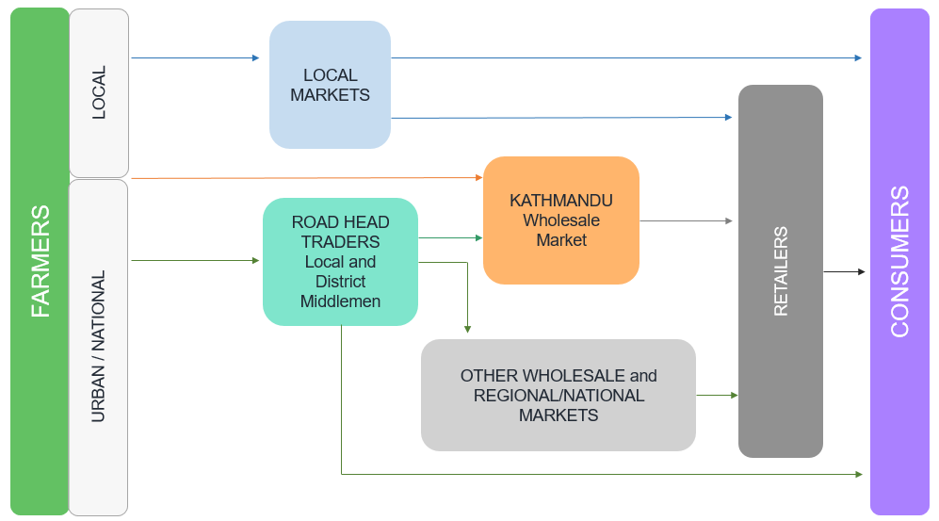
Source: Authors
Some farmers in Kabhrepalanchowk and Sindhupalchok sell their products in the local market without using intermediaries (middlemen), either directly to consumers or by delivering products to local retailers. Most of the farmers disposed their products at the nearest road-head point to the traders. Such products are then delivered to the wholesale markets or sold to retailers and consumers directly by the middlemen. A limited number of farmers place their productions in Kathmandu markets directly via wholesalers: major part of the road-head collection is canalized to Kathmandu through the middlemen. Because of the perishable nature of the vegetables and lack of safe storage, the farmers, due to their weak negotiation power, have to accept the prices offered by the middlemen. The analysis shows that the demand exceeds the supply in the local and regional markets and sometimes in the national market. Farmers’ offer is often much lower compared to middlemen and retailers’ offers. Low quality infrastructure, weak market orientation of small holder farmers, poor market access, low productivity and high post-harvest losses impose relevant issues for the supply chain, generating an inconsistent supply of products from farmers. This situation results in an increase in imports, often leading to market paradox within the market, as is the case for ginger: exported fresh at low price to the Indian market and re-imported in the form of ginger powder at higher prices to the individual customers. This mechanism generates a consistent “loss of value” along the entire supply chain. Process and storage facilities appear to be weaker links, together with high-quality and hygienic requirements to access national and international market and high price-competitiveness of imported products. Technical specification sheets have been elaborated for the three selected products, chosen both for their commercial interest (current and potential) and by their commodity profile. By preparing these documents, the aim is to provide the social enterprise/cooperative a useful tool, both for commercial and for marketing purposes. Each technical specifications sheet outlines relevant information, according the following scheme:
- General Information, with composition, place of origin.
- Processing, with the detail of production process.
- Properties, outlines information about the functional properties of the product. According to studies and scientific literature, functional activities have been described basing on the different bioactive compounds that characterize single spices.
- Packaging and storage description.
- Organoleptic properties.
- Microbiological parameters (i.e. bacteria and moulds limits according EU standards).
Tab 1. Summary of technical specifications sheets of the target spices
 | Fresh ginger | Turmeric powder | Cardamom
 | Zingiber officinale | Curcuma longa | Amomum subulatum Roxb.
Origin | Produced in Melanchi in compliance with cultural heritage and territorial systems
Processing | Harvesting. Transport to Melanchi.  Cleaning. Sorting and grading. Visual inspection. Packaging. | Harvesting.  Transport to Melanchi. Washing. Sorting. Pealing and cutting into slices. Drying. Grinding. Visual inspection. Packaging. | Harvesting of capsules and storage for 2-3 days. Capsules separation. Cleaning. Drying. Grading. Visual inspection. Packaging.
Properties | Very high levels of phenolic compounds and total flavonoid with important antiradical capacity in ginger from Melanchi. | Very interesting content of polyphenol and flavonoids with a good antiradical power evaluated by DPPH test | Very interesting content of antioxidants and flavonoids. Modest anti-radical power, which is contrast with literature data
Packaging | 25 kg sales-unit.  Plastic bag. | 100 g sales unit.  Clear plastic bag. | 5 kg, 10 kg, 20 kg sales unit. Plastic bag (Polyester fiber)
Organoleptic properties | In form of hand and fingers, sour and spicy taste, yellow-white colour | Soft and fine powder, with bright yellow-orange in colour. Pungent, bitter flavour | Spindle-shaped pods that are light to dark brown in colour. Warm, slightly pungent, sweet, smoky, citrus aroma
Microbiological parameters | TBC: ≤ 1x10⁶ cfu/g  Moulds: ≤ 1x10⁴ cfu/g | TBC: ≤ 1x10⁵ cfu/g  Moulds: ≤ 1x10⁴ cfu/g | TBC: ≤ 1x10⁶ cfu/g  Moulds: ≤ 1x10⁴ cfu/g
Source: Authors

As regard the chemical characterization of the selected spices, in terms of functional molecules, it should be noted an interesting presence of bioactive compounds in the sample of ginger. In particular, fresh Ginger sampled in Melanchi has a very interesting Total Phenolic Content - TPC (141.20 mg GAE/g), higher with respect samples reported in literature (Ahmed Hassan El-Ghorab et al., 2010) on Pakistane ginger evaluate with the same test (95.2 mg GAE/g). Another research paper (Shirin Adel P. R. and Jamuna Prakash, 2011) shows a very high TPC value (840 and 830 mg/g), this is presumably due to, despite using the same test (Folin-Ciocalteau), tannic acid is used instead of gallic acid, as standard compound. Moreover, fresh ginger from Melanchi has an important total content of flavonoids – TFC (56.36 mg QE/g) with respect the already reported paper about Pakistane ginger (6.85 mg QE/g) evaluated with the same test and using quercetin as standard. In Malaysian ginger (Mojani, M. S. et al., 2014), flavonoid and phenolic content were reported to be 3.66±0.45 mg gallic acid/g and 10.22±0.87 mg quercetin/g of dry weight basis of rhizome. Finally, the antiradical activity of Melanchi sample (DPPH test) was calculated as IC₅₀ (102.2 μg/mL). According to a recent work (Mošovská et al., 2015), the evaluation of antioxidant activity of extract from Zingiber officinale reports TPC = 181.41 mg GAE/g from which flavonoids contributed to 7.8 % (14.15 mg QE/g). In the same paper ginger extract showed antioxidant effect in inhibiting DPPH radical and IC50 was 4.25 mg/mL, then, the Melanchi sample, with IC50 127.19 μg/mL seems highly more active (see Figure 2). Hence, the ginger rhizome originated from Melanchi may exhibit anti-oxidative and anti-inflammatory potentials due to high levels of phenolic compounds and total flavonoid with important antiradical capacity.

Fig. 2. TPC, TPF and antiradical assay (by DPPH test) of ginger extracts.
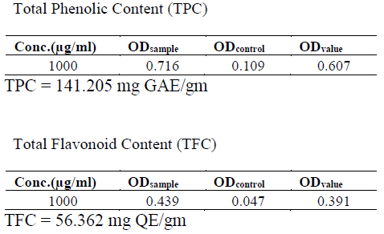
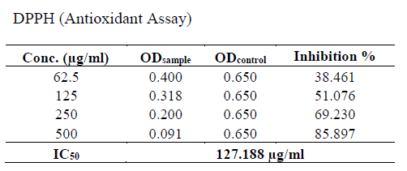
Source: Authors

4. Conclusions
This work focuses on the improvement of the sustainability of the value chains of ginger, turmeric and cardamom in Nepal, introducing upgrading in the processes of selection, preservation and packaging/labelling. Both value chain and analytical evidences suggest furthering investigating with a more significant number of samples in order to confirm that profile. If confirmed, ginger in particular could potentially be increase its value.

References
Acharya et al. Does High-Value Agriculture Build Resilient Livelihood? Insights from the Study of Cardamom and Vegetable Farmers of Nepal. Journal of Forest and Livelihood. December 2021.
Ahmed Hassan El-Ghorab et al. A Comparative Study on Chemical Composition and Antioxidant Activity of Ginger (Zingiber officinale) and Cumin (Cuminum cyminum). J. Agric. Food Chem. 2010.
Keezheveettil Parukutty Amma Padmakumari Amma et al. Chemical composition, flavonoid - phenolic contents and radical scavenging activity of four major varieties of cardamom. International Journal of Biological & Medical Research. 2010.
Mojani, M. S. et al. Assessment of bioactive compounds, nutritional composition and antioxidant activity of Malaysian young ginger (Zingiber officinale Roscoe). International Food Research Journal 21(5): 1931-1935 (2014).
Mošovská et al. Antioxidant activity of ginger extract and identification of its active components. Acta Chimica Slovaca, Vol. 8, No. 2, 2015, pp. 115—119.
Moulai-Hacene F. et al. Chemical Composition and Antimicrobial Properties of Elettaria cardamomum Extract. Pharmacogn J. 2020; 12(5): 1058-1063.
Shirin Adel P. R. and Jamuna Prakash. Chemical composition and antioxidant properties of ginger root (Zingiber officinale). Journal of Medicinal Plant Research 4(24):2674-2679. 2011
Thapa G. et al. Agricultural Diversification in Nepal Status, Determinants, and its Impact on Rural Poverty. International Food Policy Research Institute. Discussion Paper 01634. April 2017.
https://www.usaid.gov/nepal/agriculture-and-food-security (last visited 20.06.2022)
https://www.fao.org/documents/card/en/c/CB8001EN (last visited 21.06.2022)
https://cbs.gov.np/ (last visited 15.06.2022)
https://www.mof.gov.np/ (last visited 16.06.2022)

https://www.usaid.gov/nepal/agriculture-and-food-security
https://www.fao.org/documents/card/en/c/CB8001EN
In fact, microbiological analyses carried out on samples of target spices demonstrated a high number of bacteria and the presence of moulds (probably due to a lack of adoption of GMP in processing and storage phases) and they are not suitable for European market.

