Valorization strategies of technological and therapeutic properties of orange by-products
Paola Campana, Raffaella Preti, Anna Maria Tarola
Department of Management, Sapienza University of Rome, Via del Castro Laurenziano 9- 00161, Rome, Italy
paola.campana@uniroma1.it and ORCID 1 0000-0002-0786-0965,
raffaella.preti@uniroma1.it and ORCID 0000-0003-0109-0303; annamaria.tarola@uniroma1.it and ORCID 0000-0001-6821-5129

Corresponding author: Paola Campana, paola.campana@uniroma1.it

Abstract. Orange by-products are generated from the production of citrus juice and consist about 45%–60% of the fruit. It has been estimated that global orange juice production could generate between 0.8 to 1 million tons of by-products each year This waste represents for the producers not only an underutilized commodity, but a source of environmental pollution and a heavy cost for its disposal.
The most common processes implemented for improve their management is the use as fertilizers or as animal feed, as well as other minor uses. Recently, many alternatives have been proposed to add value to these residues. Most of them aim to exploit the higher dietary fiber, phenolic and antioxidant values contained in the peel of orange and pomace compared with the fruit and the presence of characteristic beneficial compounds present only in the peel, such as limonoids, alkaloids, pectin and essential oils. Starting from this evidence, valuable molecules generated from orange waste can be used in food, cosmetic, or pharma industry. Other interesting applications reported in literature involve the production of bioethanol, enzymes, adsorbent materials, food packaging, paper and fabric.
The purpose of this paper is to examine a variety of different novel products derived from this waste as a key strategy for the application of the circular economy in the orange juice processing industries.

Keywords. Technological innovation, environmental pollution, circular economy.

Introduction
About 24% of world production of citrus is in the Mediterranean countries of Spain, Italy, Greece, Egypt, Turkey and Morocco with Brazil (24%) being major individual citrus producing countries. Fruit and vegetables are the most responsible for food waste in all supply chain stages, i.e., around 45%, and approximately 21.7% of this food waste is generated at the processing and manufacturing stages (Alves de Castro et al., 2020). In particular, the global sweet orange (Citrus sinensis) juice production is estimated to generate between 0.8 to 1 million tons of by-products, or waste, each year, and represent one of the largest sources of food waste worldwide (Ravindran and Jaiswal, 2016). The by-products from orange processing account for over half the weight of the incoming raw material: roughly 45 per cent is accounted for by the peel, 6 per cent by the pulp, and 3.5 per cent by the citrus molasses. This waste can represent a serious environmental problem with important impact for the agri-food industries and the population, as may cause phytotoxicity phenomena, contamination of the water bodies and deterioration of drinking water quality, death of sensitive marine organisms and inhibition of seed germination (Castro Munoz et al., 2022). When fruit is processed, parts such as the core, peel, pips, and kernel are discarded, even if these by-products contain large number and amount of valuable components that can represent a resource and not a waste.The most common uses to recover this waste are as animal feed or as fertilizer, or they are disposed of in landfills or incinerated.
Previous studies have reported higher dietary fiber values from the peel of orange and pomace, and also higher levels of phenolic compounds and antioxidant capacity as compared with the fruit (Liu et al., 2021).
The aim of this paper is to examine the several applications to valorize the compounds hidden in orange by-products, such as food additives, functional foods, nutraceuticals, cosmetics, pharmaceuticals, and bio-packaging.

Antioxidant compounds
Phytochemical and nutritional assessments show that citrus peels contain a variety of functional compounds, including flavonoids, limonoids, essential oil and pectin, which could be used for medicinal purposes (Hou et al., 2019). Citrus by –products is a major source of phenolic compounds; and peel are reported to possess highest amounts of polyphenols compared to other edible parts of the fruit, with a total phenol content in peel of 736 mg/Kg GAE (Rafiq et al. 2018). Flavonoids are the most abundant, with more than 60 types of flavonoids isolated and identified. They include naringin, hesperidin, eriocitrin, narirutin, rutin, and tangeretin hesperidin, naringenin, narirutin, and neohesperidin, and have different biological activities such as antioxidant, anticancer, antiviral, cardiovascular and antinflammatory beneficial properties. Such characteristics have attracted attention and peel has been proposed to be used as functional ingredient in cosmetics, nutraceuticals and as functional foods in their raw material for additive processes. These perspectives are of particular interest considering that the global market of functional food ingredients is estimated to be USD 98 billion in 2021, and it is expected to grow up to USD 137 billion by 2026 (Castro-Munoz et al., 2021).
Limonoids are a series of natural tetracyclic triterpenoids compounds that have demonstrated to exert many biological activities in vitro including antioxidant, antibacterial, antiangiogenic and anti-inflammatory effects.
In general, conventional extraction of bioactive compounds from agro-food waste and by products is carried out with three consecutive steps: (1) pretreatment, (2) extraction, and (3) purification and conservation (Fierascu et al., 2019). For the extraction of citrus flavonoids, organic solvent extraction is the most widely used because of its ease of use and efficiency.
The antioxidant capacity of orange peel extract has been proved by in vitro chemical assays, such as ferric reducing antioxidant power (FRAP), oxygen radical absorbance capacity (ORAC) and 2,2-Diphenyl-1-picrylhydrazyl (DPPH) (Liew et al., 2018) and in vivo on animal models (Chen et al., 2013). The antioxidant capacity demonstrated to be related to the flavonoid content and in fact different orange varieties had different capacities.

Dietary fiber
Regular consumption of dietary fiber is recommended for the prevention of gastrointestinal, cardiovascular diseases, diabetes, hypercholesterolemia and obesity.
The effectiveness of citrus peel in lowering the plasma liver cholesterol, serum triglyceride level, serum total cholesterol, liver total lipids, and liver cholesterol is proven by many epidemiological studies. The peel fiber derived from orange fruit is involved in the improvement in intestinal function and health. Peel, pulp and peel fiber from Citrus hystrix and Citrus maxima (red and white variety), could be used as potential dietary fiber sources in the enrichment of foods because of their high physicochemical properties. Citrus fiber, which possesses bioactive functions due to the presence of polyphenol-like components, can be used as effective inhibitors of lipid oxidation in meat products, thereby improving their oxidative stability and prolonging their shelf life (Rafiq et al., 2018).

Essential oils
Essential oils, volatile oils extracted from the citric fruit peel have several applications in the pharmaceutical and food industries. Also, these oils can contain compounds with biological activity, such as limonoids and their glucosides, that possess insecticidal activity similar to Neem oil and proved to cause the inhibition of cancerous tumors induced in rats, mice, and hamsters. Essential oils from orange peel have shown a good antimicrobial activity against yeasts, fungi, and bacteria, and Limonene and γ-terpinene, as the major components in citrus peels essential oils, have a wide spectrum of biological activities such as antimicrobial, antioxidant and anticancer properties (Gavahian et al., 2019).
Because of peculiar aromas and low costs, citrus essential oils can be used in perfumes, food, and pharmaceuticals. Recently, the incorporation of citrus essential oils into edible films has received innovative attention because of their antibacterial and antioxidant activities, in particular in the control of Listeria monocytogenes (Mahato et al., 2019) but also to improve the physicochemical properties of edible films, such as moisture content and solubility.
The traditional methods of extracting essential oil are cold pressing and steam distillation. Cold pressing is the standard method for extracting essential oil from citrus peels, mainly uses strong pressure to squeeze the citrus peels, so that the oil cells burst and the essential oil flows out (Gavahian et al., 2019).

Biofuel
Various studies have investigated the application of citrus peels waste as a promising feedstock for biofuel production due to its rich composition in organic compounds (Fazzino et al., 2021). On the contrary, it is not suitable for any co digestion in biogas production since orange peels contains D-limonene, an antibacterial agent (Mahato, et al., 2019).
A ton of solid orange byproducts can yield up to 600 kg of bio-oil. The citrus processing waste can be used to produce ethanol, limonene, and other co-products. Enzymatic hydrolysis can be applied to the organic waste to maximize the monomeric sugar content, then sugars can be converted into ethanol by fermentation. If enzymatic hydrolysis is followed by saccharification and fermentation processes the ethanol yields can reach the 94%. Lignin content in citrus peel can serve as a promising alternative to lignocellulosic biomass to produce also biofuels (Liu et al., 2019).

Livestock feed
Citrus by-products are utilized as a low cost nutritional supplement to the diets of cattle, as they are suitable for inclusion in ruminant diets because of the ability of ruminants to ferment high fiber feeds in the rumen and present fewer negative effects on rumen fermentation than starch rich feeds.
The citrus by products showed also the ability to inhibit the growth of both Escherichia coli and Salmonella within mixed ruminal microorganism fluid media. Citrus by-products commonly used as high energy ruminant feed are fresh citrus pulp, citrus silage, dried citrus pulp, citrus meal and fines, citrus molasses, citrus peel liquor and citrus activated sludge. They are often used as supplementation to support growth and lactation of cattle due to their composition in soluble carbohydrates and a readily digestible fiber. Citrus pectin is easily and extensively degraded, producing acetic acid, which is less likely than lactic acid to cause a pH drop and result in acidosis (Alnaimy et al., 2017).

Pectin
Citrus peels are rich in pectin (for dry weight basis: orange (C. Sinensis), 28%; grapefruit (C. Paradisi), 23%; mandarin (C. Resticulata), 19%). Citrus pectin has been investigated intensively due to its beneficial effects on human health. Its main effects are on intestinal inflammation and on the reduction of the incidence of heart disease and of blood cholesterol levels
The traditional methods of extraction are by acid, alkaline and enzyme extraction, but microwave assisting, subcritical water and ultrasound-assisted extractions have been also investigated to reduce time and solvents (John et al., 2017).

Food packaging
The incorporation of orange peel in food by extracts, powder or by complex encapsulation technology to exploit its natural antioxidant capacity has been investigated to improve storage qualities. Another way to use this by products is its incorporation in edible films, or the use of orange essential oils in non-edible, biodegradable and compostable polymers. Orange waste presents the essential constituents of the biobased plastic, i.e., pectin and cellulosic fibers, that can provide the required strength and also ensured biodegradability. Recently there are encouraging studies in this field with promising biofilms produced entirely from orange waste that can replace conventional plastic with an ecofriendly material (Jayachandra et al., 2022).

Sustainable fabrics
The high content in cellulose of orange by products has been applied also to the production of a novel cellulosic fiber to be employed in the fashion industry for the production of sustainable fabrics. Orange Fiber is an Italian company established in Sicily that has that has patented and produces sustainable fabrics from citrus fruit by-products coming from the local orange processing industry. Its products are used in the fashion-luxury sector, by important brands such as Ferragamo and Marinella, that are interested in disseminating the circular economy positive and innovative values. The company’s goal is to produce 60 tons of fabrics from citrus waste per year (Orange Fiber).

Conclusions
Applying various extraction and purification techniques and analytical methods, it is possible to recover important components from citrus waste and further transform them into a wide range of added value products
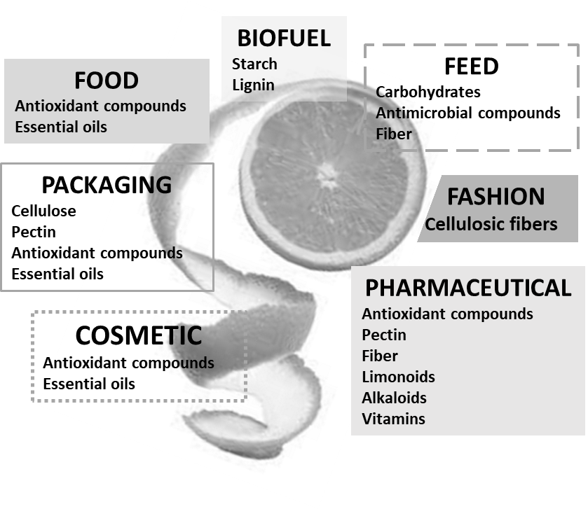
Fig. 1. Application areas of citrus processing by-products, with relative key compounds.

for food, feed, pharmaceutical and even fashion industry (Fig. 1).
These sustainable applications can also improve the economics of citrus fruit processing and cotemporally reduce its environmental impacts.

References
Jayachandra SY, Nagaraj RB, Sharanabasava VG et al. (2022) Bio-based material from fruit waste of orange peel for industrial applications. J Mat Res Tech 17: 3186-3197. https://doi.org/10.1016/j.jmrt.2021.09.016.
Alves de Castro, L, Lizi, JM, Galvão Leite das Chagas E et al. (2020) From orange juice by-product in the food industry to a functional ingredient: application in the circular economy. Foods 9: 593-609. https://doi.org/10.3390/foods9050593
Castro-Muñoz R., Díaz-Montes E., Gontarek-Castro E. et al. (2022) A comprehensive review on current and emerging technologies toward the valorization of bio-based wastes and by products from foods. Compr Rev Food Sci Food Saf 21: 46–105. https://doi.org/10.1111/1541-4337.12894
Ravindran R, Jaiswal AK (2016) Exploitation of food industry waste for high-value products. Trends Biotechnol 34: 58-69. https://doi.org/10.1016/j.tibtech.2015.10.008
Liu N, Li X, Zhao P (2021) A review of chemical constituents and health-promoting effects of citrus peels Food Chem 365: 1-13 https://doi.org/10.1016/j.foodchem.2021.130585
Hou HS, Bonku EM, Zhai R et al. (2019) Extraction of essential oil from Citrus reticulate Blanco peel and its antibacterial activity against Cutibacterium acnes (formerly Propionibacterium acnes). Heliyon 5- e02947. https://doi.org/10.1016/j.heliyon.2019.e02947.
Rafiq S, Kaul R, Sofi SA et al. (2018) Citrus peel as a source of functional ingredient: A review. J Saudi Soc Agric Sci, 17: 351-358. https://doi.org/10.1016/j.jssas.2016.07.006.
Fierascu RC, Fierascu I, Avramescu SM et al. (2019) Recovery of natural antioxidants from agro-industrial side streams through advanced extraction techniques Molecules 24: 4212-424. http://doi.org/10.3390/molecules24234212.
Liew SS, Ho WY, Yeap SK et al. (2018) Phytochemical composition and in vitro antioxidant activities of Citrus sinensis peel extracts. PeerJ 3: e5331. http://doi.org/10.7717/peerj.5331.
Chen, SY, Chyau CC, Chu CC et al. (2013) Hepatoprotection using sweet orange peel and its bioactive compound, hesperidin, for CCl4-induced liver injury in vivo. J Func Foods 5: 1591–1600. https://doi.org/10.1016/j.jff.2013.07.001.
Gavahian M, Chu HW, Khaneghah AM (2019) Recent advances in orange oil extraction: an opportunity for the valorisation of orange peel waste a review Int J Food Sci Tech 54: 925–93. http://doi.org/10.1111/ijfs.13987.
Mahato N, Sharma K, Koteswararao R at al. (2019) Citrus essential oils: extraction, authentication and application in food preservation. Crit Rev Food Sci Nutr 59:611-625. https://doi.org/10.1080/10408398.2017.1384716.
Alnaimy A, Gad AE, Mustafa MM, et al. (2017) Using of citrus by-products in farm animals feeding. Open Acc J Sci. 1: 58‒67. http://doi.org/10.15406/oajs.2017.01.00014
Fazzino F, Mauriello F, Paone E et al., (2021) Integral valorization of orange peel waste through optimized ensiling: Lactic acid and bioethanol production. Chemosphere 271: 129602. https://doi.org/10.1016/j.chemosphere.2021.129602.
John I, Muthukumar K, Arunagiri A (2017). A review on the potential of citrus waste for D-Limonene, pectin, and bioethanol production. Int J Green Energy 14: 599–612. https://doi.org/10.1080/15435075.2017.1307753
Orange Fiber. Sustainable fabrics from citrus juice by-products. http://orangefiber.it

