Chapter N
Personal Protective Equipment recycling scenarios for the production of reinforced bituminous conglomerates

Mattia Gianvincenzi¹, Marco Marconi², Enrico Maria Mosconi³, Francesco Tola⁴
^{1,2,3,4}Department of Economics, Engineering, Society and Business Organization, Università degli Studi della Tuscia, Piazza G.Verdi, 1, 00053, Civitavecchia, Italy
¹mattia.gianvincenzi@unitus.it 0000-0002-5363-3448; ²marco.marconi@unitus.it 0000-0002-5677-1459; ³enrico.mosconi@unitus.it 0000-0001-7065-7313; ⁴francesco.tola@unitus.it 0000-0003-4093-7714;
Corresponding author: Mattia Gianvincenzi, mattia.gianvincenzi@unitus.it

Abstract. Due to the COVID-19 pandemic, Global Personal Protective Equipment (PPE) volume demand increased by 300-400% between 2019 and 2021. In Italy, in 2021, an average quantity of 473 tons of masks and 958 tons of gloves were disposed of in landfills or incinerated daily. This study aims to propose and validate an innovative circular-economy-based supply chain for PPE waste, reusing the waste polymeric textile fiber deriving from PPE to produce reinforced bituminous conglomerates. Several studies confirmed the value of plastic in the mixture for asphalt production to extend its useful life. Despite that, none of these investigated the potential of the PPE, therefore the scenario of this study is unique in the scientific panorama. The results demonstrate the feasibility of the proposed scenario. Using end-of-life masks and gloves in the mix, improvements were observed in the asphalt in terms of indirect tensile strength, stiffness, and ductility. From an environmental point of view, a longer lifespan and less material usage leads to a reduction in long-term impacts. At the same time, the reduction of the disposal of PPE in landfills and incinerators means a significant reduction in the environmental impact of masks.

Keywords.
Sustainable EoL, PPE Reuse, Green Cities, Closed Loop, Reinforced Asphalts, Waste Management

Introduction
During the COVID-19 pandemic, the production of personal protective equipment (PPE) has grown considerably. In detail, it is estimated that the global PPE volume demand increased by 300-400% between 2019 and 2021 (FCDO, 2020). There are different types of PPE, but masks were the most relevant flow, with an increase by 2.500-3.000% in just one year, going from representing 2-4% of the PPE market in 2019 to representing 25-30% in 2020 (FCDO, 2020). This is mainly due to the fact that protective masks were recommended (even imposed) to the entire population throughout the pandemic period (Barbanera et al., 2022). However, the largest market share among PPE is gloves which accounted for 60-70% in 2019 and 2020, growing by 30-35% in one year. As a consequence, a monthly use of 129 billion gloves and 65 billion masks to be disposed of is estimated globally since the beginning of the pandemic (WHO, 2022).
To get even more specific, the situation of Italy (Table 1) was taken as an example (ISPRA, 2021). Considering that around 72% of PPE is made up of PP (Harussani et al., 2022) and a 50/50 division between nitrile and latex gloves (FCDO, 2020), in Italy alone in 2021 there was an annual production of 126.789, 252 t of PP waste, 174.771,855 tons of nitrile and latex waste.

Table 1. Estimations on the use of masks in Italy
 | Year | U.M | 2020 | 2021 | 2025
Masks | Daily requirement | n° (mln) | 37,5 | 43,3 | 3,6
 | Daily Waste production | t | 410 | 473,1 | 39,4
 | Annual requirement | n° (mln) | 13.687,5 | 15.792,6 | 1.316,1
 | Annual Waste production | t | 149.650 | 172.665,9 | 14.388,85
 | Year | U.M | 2020 | 2021 | 2025
Gloves | Daily requirement | n° (mln) | 75 | 86,6 | 63,7
 | Daily Waste production | t | 830 | 957,7 | 705,5
 | Annual requirement | n° (mln) | 27.375 | 31.585,3 | 23.267,8
 | Annual Waste production | t | 302.950 | 349.543,7 | 257.497,2
Sources: (FCDO, 2020; ISPRA, 2021)

For the abovementioned reasons, recovery and recycling methods for such PPE must be studied. The present study aims to investigate the feasibility and the environmental benefits of an innovative circular scenario: the reuse of mixed PPE waste as reinforcement in bituminous conglomerates.

Literature review
Several scientific literature studies investigated the use of plastics in asphalt mixtures (Appiah et al., 2017; Biswas et al., 2020; del Rey Castillo et al., 2020). An interesting study evaluated at laboratory scale the use of three commercially available recycled plastic products in the same asphalt mixture for the purpose of extending and modifying the binder. The results confirmed that the recycled plastic improved deformation and fracture resistance, had minor effects on moisture resistance and increased the structural contribution of asphalt to pavement (White & Reid, 2019). In addition, the use of textile fibers deriving from the disposal of end-of-life tires to produce reinforced asphalt was tested. The application has shown increases asphalt drainage, leading to a significant increase in fatigue resistance (Landi et al., 2018a, 2020).
Closely related to the present study is a recent experimentation about the introduction of shredded face masks (SFM) in a recycled concrete aggregate (RCA) for base/sub-base flooring applications (Saberian et al., 2021). In the experimental program, shredded surgical masks (without nose pads and ear loops) to the size of 0.5 cm in width and 2 cm in length were used. The chopped templates were mixed with 1%, 2% and 3% (wt%) dry RCA, with an observed increase in strength and stiffness, but also improvements in terms of the suppleness and flexibility of the RCA/SFM blends.
The scenario of the present study is configured as original since the use of PPE as reinforcement in bituminous conglomerates has never been investigated in previous research or development experiences, as also confirmed by a patent search in the Orbit database. At the same time the scenario seems feasible because it is based on very widespread ideas such as the use of reinforcements in construction materials.

Material and methods
Through the context analysis and the literature review, the study was oriented towards the experimentation of an innovative product based on the reuse of PPE, widely used during the COVID-19 pandemic, and currently disposed of in landfills or incinerated. The product will be a bituminous conglomerate intended for the construction and civil market, in particular for the construction and maintenance of road infrastructures.
Four different bituminous conglomerates were tested, one representing the reference scenario without the use of PPE and three mixing the bitumen with PPE in percentages representing realistic scenarios based on previous studies: (1) Reference hot mix asphalt (HMA) bituminous conglomerate, without PPE; (2) HMA bituminous conglomerate with masks; (3) HMA bituminous conglomerate with masks and gloves; (4) Warm mix asphalt (WMA) bituminous conglomerate with masks. The details of the tested mixtures are reported in the following Table 2.

Table 2. Tested bituminous conglomerates
Mixture | Components
Mixture 1  Standard HMA | Virgin aggregate 80%, T = 180 °C  Milled 20%, T = room temperature  Virgin bitumen 4.3% (total bitumen about 5.3%), T = 150 ° C
Mixture 2  HMA – Masks | Virgin aggregate 80%, T = 180 °C  Milled 20%, T = room temperature  Virgin bitumen 4.3% on the mix (total bitumen about 5.3%), T = 150 ° C  PPE Masks (75% PP masks, 25% PET / PBT masks) = 0.5% on the aggregate, T = room temperature
Mixture 3  HMA - Masks+Gloves | Virgin aggregate 80%, T = 180 °C  Milled 20%, T = room temperature  Virgin bitumen 4.3% on the mix (total bitumen about 5.3%), T = 150 ° C  PPE Masks + Gloves (45% PP masks, 15% PET / PBT masks, 20% latex gloves, 20% nitrile gloves) = 0.5% on the aggregate, T = room temperature
Mixture 4  WMA – Masks | Virgin aggregate 80%, T = 145 °C  Milled 20%, T = temperature 4.3% virgin bitumen on the mixture (total bitumen about 5.3%), T = 150 °C  Iterlow type additive 0.5% on the weight of the bitumen (to be mixed with the bitumen before adding it to the mix)  PPE Masks + Gloves (75% PP masks, 25% PET / PBT masks

Several tests were performed during the experimental phase. For each mixture, 4 specimens were compacted with a rotary press according to the UNI EN 12697-31 standard. The void content of these specimens was measured according to the UNI EN 12697-6 standard using the dry method. Subsequently, the specimens were broken in an indirect tensile configuration according to the UNI EN 12697-23 standard. From this test the indirect tensile strength (Rt), the indirect tensile coefficient (CTI) and the cracking tolerance index (CT-Index) were determined. Furthermore, the bitumen extraction (UNI EN 12697-1) and then a visual analysis of the residual solid material was carried out on the loose bituminous conglomerate collected at the end of the mixing, to evaluate the effect of the high processing temperatures on PPE.
The environmental benefits, instead, have been preliminarily estimated on the basis of literature data deriving from previous studies on similar topics, conducted by using the Life Cycle Assessment methodology (Barbanera et al., 2022; Landi et al., 2018b).

Results and discussion
The results of the tests (Figure 1) show that the introduction of the masks increases the content of the voids, therefore the porosity, passing from 4.5% to 6.5% in mixture (2) and even to 8.5% in mixture (4). As porosity increases, mechanical strength generally decreases, because the bonds between the granules of the conglomerate decrease. This can be explained through the visual analysis which shows that a large amount of masks that did not dissolve and remained present among the aggregate granules in the form of fibrous filaments. In case of mixture (3) with masks and gloves the nitrile component, with a melting point around 120°, has melted, being incorporated into the binder, increasing its volume and reducing its voids, reaching a similar result to mixture (1). Probably an even higher percentage of gloves would lead to a lower porosity.
Regarding the indirect tensile strength, mixture (1) and (2) have a similar result, while mixture (3) has a 25% higher (Rt) than the first, and mixture (4) is non-classifiable.
The same trend is also observed for the CTI in which mixture (2) shows a slight improvement in stiffness and ductility, mixture (3) shows a significant improvement of 50%, and the mixture (4) worsens the characteristics originating in the standard HMA. Greater stiffness in certain soil conditions (i.e., stable grounds) allows asphalt to last longer.
On the contrary, as regards crack resistance, mixture (4) leads to the best results, while mixture (3) has the worst crack resistance.

Figure 1. Void, Rt, CTI and CT-Index tests results
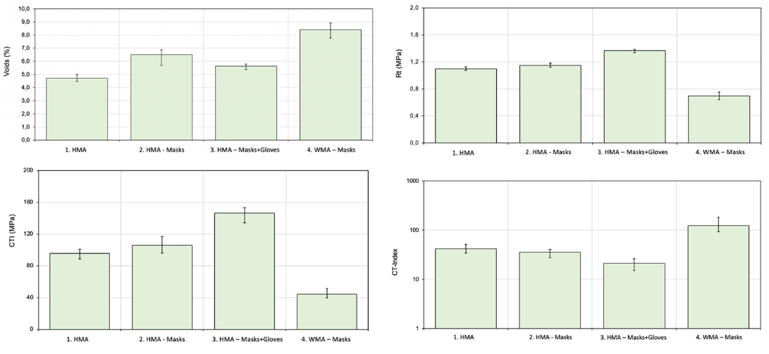
By deriving data from the abovementioned LCA studies, it was possible to carry out a preliminary environmental assessment considering the materials used to produce and maintain 1 m² of asphalt in a time horizon of 30 years. On the basis of a previous LCA on reinforced bitominous conglomerates (Landi et al., 2020), and of the present tests, it was possible to deduce that a road pavement made with mixture (3) (i.e. the most promising) has a life span higher than the standard HMA mixture with an increase of 17% for base, 10,7% for binder, and 12,5% for wearing course layers. Table 3 reports the materials used to produce 1 m² of asphalt using the HMA+Mask/Gloves.

Table 3. Inventory of materials to produce and maintain 1 m² of asphalt for 30 years
 | HMA+Mask/Gloves mixture
Materials | Base % | Binder % | Wearing % | Tot mass (kg) | Tot mass % | GWP kgCO2eq
Limestone12/20 | 16 | 16 | 32,3 | 199,6 | 20,2 | 0,5424
Limestone 8/16 | 30 | 30 | 32,3 | 366,7 | 37,1 | 4,2792
RAP | 17,9 | 15 | 0 | 121,6 | 12,3 | 0
Sand 0/4 | 30 | 31,7 | 23 | 229,3 | 23,2 | 6,5844
Filler | 1,8 | 2 | 6,1 | 42,5 | 4,3 | 13,0944
Bitumen | 4 | 5 | 6 | 23,7 | 2,4 | 8,1048
Mask/Gloves | 0,5 | 0,5 | 0,5 | 4,9 | 0,5 | -15,6147
 |  |  |  | 988,3 | 100 | 16,9910

Figure 2 shows the results of the simplified environmental assessment in terms of Global Warming Potential (GWP) midpoint indicator, obtained by comparing the mixture (1) and the mixture (3) with the split of contributions for each material. As regards the amount of Mask/Gloves, by analogy to the study (Barbanera et al., 2022), approximately 1.680 of PPE between masks and gloves were used in 1 m2 of asphalt for a duration of 30 years. These PPEs are recycled instead of disposed of in incinerators or landfills, avoiding polluting the environment.

Figure 2. GWP of standard and reinforced HMA
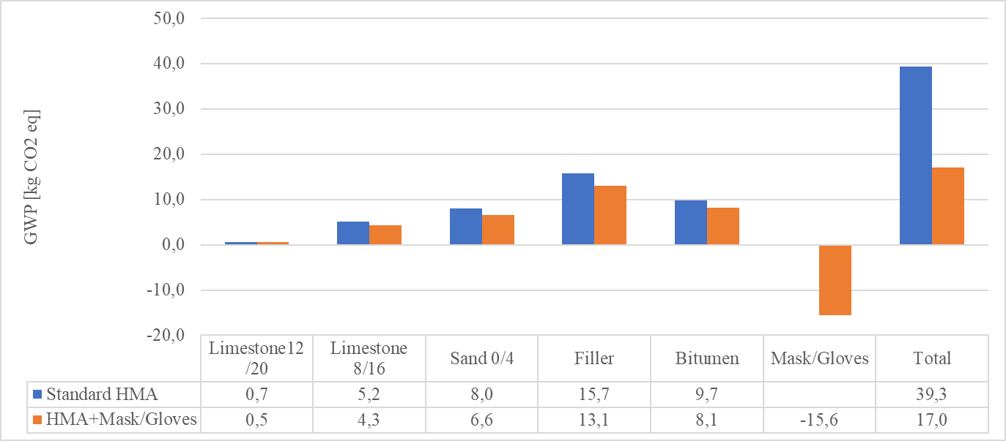
According to Figure 2, the reuse of masks and gloves significantly impacts the result, which indicates how the mixture (3) scenario impacts the environment with a GWP index of less than 56,79% compared to the standard HMA. In addition to this item, the lower impacts of the other materials must be considered, as described above, the life cycle of the reinforced asphalt is greater, therefore it results in fewer pavement remakes over the time horizon considered.

Conclusions
As a first conclusion, it is possible to confirm the technical feasibility of the proposed scenario since the reuse of PPE waste as asphalt reinforcements does not lead to a worsening of the performance of the original asphalt. Secondly, the use of gloves together with masks, recommended due to the presented forecasts for 2025, has given promising results as nitrile and PP significantly improve tensile strength, stiffness and ductility compared to other blends. Thirdly, the use of masks and gloves seems to significantly reduce the GWP related to road pavement construction and maintenance.
Further studies could focus on the experimentation of additional mixtures by increasing the dosage of masks/gloves. Indirect tensile stiffness modulus and fatigue resistance laboratory tests are required to better estimate the potential useful life of the PPE-reinforced asphalt, as well as testing of mixtures in operating environments. Finally, full LCA, cost, and social LCA studies are needed to establish the sustainability benefits.

Bibliography

Appiah, J. K., Berko-Boateng, V. N., & Tagbor, T. A. (2017). Use of waste plastic materials for road construction in Ghana. Case Studies in Construction Materials, 6. https://doi.org/10.1016/j.cscm.2016.11.001
Barbanera, M., Marconi, M., Peruzzi, A., & Dinarelli, S. (2022). Environmental assessment and eco-design of a surgical face mask. Procedia CIRP, 105, 61–66. https://doi.org/10.1016/j.procir.2022.02.011
Biswas, A., Goel, A., & Potnis, S. (2020). Performance comparison of waste plastic modified versus conventional bituminous roads in Pune city: A case study. Case Studies in Construction Materials, 13. https://doi.org/10.1016/j.cscm.2020.e00411
del Rey Castillo, E., Almesfer, N., Saggi, O., & Ingham, J. M. (2020). Light-weight concrete with artificial aggregate manufactured from plastic waste. Construction and Building Materials, 265. https://doi.org/10.1016/j.conbuildmat.2020.120199
FCDO. (2020). Covid-19 – PPE demand & supply perspectives. Foreign, Commonwealth and Development Office, December.
Harussani, M. M., Sapuan, S. M., Rashid, U., Khalina, A., & Ilyas, R. A. (2022). Pyrolysis of polypropylene plastic waste into carbonaceous char: Priority of plastic waste management amidst COVID-19 pandemic. Science of the Total Environment, 803. https://doi.org/10.1016/j.scitotenv.2021.149911
ISPRA. (2021). I rifiuti costituiti da dpi usati. 12.
Landi, D., Gigli, S., Germani, M., & Marconi, M. (2018a). Investigating the feasibility of a reuse scenario for textile fibres recovered from end-of-life tyres. Waste Management, 75. https://doi.org/10.1016/j.wasman.2018.02.018
Landi, D., Gigli, S., Germani, M., & Marconi, M. (2018b). Investigating the feasibility of a reuse scenario for textile fibres recovered from end-of-life tyres. Waste Management, 75, 187–204. https://doi.org/10.1016/j.wasman.2018.02.018
Landi, D., Marconi, M., Bocci, E., & Michele, G. (2020). Comparative life cycle assessment of standard, cellulose-reinforced and end of life tires fiber-reinforced hot mix asphalt mixtures. Journal of Cleaner Production 248.
Saberian, M., Li, J., Kilmartin-Lynch, S., & Boroujeni, M. (2021). Repurposing of COVID-19 single-use face masks for pavements base/subbase. Science of the Total Environment, 769, 145527. https://doi.org/10.1016/j.scitotenv.2021.145527
White, G., & Reid, G. (2019). Recycled waste plastic modification of bituminous binder. Bituminous Mixtures and Pavements VII- Proceedings of the 7th International Conference on Bituminous Mixtures and Pavements, ICONFBMP 2019, April, 3–12. https://doi.org/10.1201/9781351063265-1
WHO. (2022). Available online: https://covid19.who.int/. June, 2022.

