Chapter N (please do not write anything in this line. Editors will annotate the chapter number)
Tomato supply chain and production quality control for international markets

G. Palumbo§, A. Senatore#, D. Tuccillo#, I.M. De Clemente§

§ Commodity Science Laboratory,
Department of Economics, Management, Institutions,
University of Naples “Federico II”, Via Cintia,23 – 80126 Naples, Italy

# Commodity Science Laboratory SI Impresa, Naples,
Corso Meridionale, 58, 80143 Napoli

§ e-mail:gpalumbo@unina.it and ORCID 0000-0001-5202-2971;
§isabellamaria.declemente@unina.it and ORCID 0000-0003-4166-3524;
#antonellosenatore@gmail.com
#direzione@si-impresa.na.camcom.it

Corresponding author: Isabella M. De Clemente isabellamaria.declemente@unina.it

Abstract. In addition to being one of the most important Italian horticultural crops, the tomato is also one of the most cultivated in the world. Due to its organoleptic and nutritional qualities it plays a central role in the Mediterranean diet, therefore, the demand is high both from the fresh market and as a raw material for the processing industry. There is a wide range of industrial derivatives such as peeled tomatoes, purées, concentrates, juices and, just from the processing of tomatoes, a sector of extreme importance in the Italian manufacturing scene has arisen, the canning sector. Tomato pulp, puree and peeled tomatoes represent the main categories of industrial derivatives, of which the commercial importance of exports should be noted, both to Europe (Germany, France, United Kingdom) and to other countries (Asia, USA, Japan, Oceania). According to ISMEA data, over 60% of national production is destined abroad, equal to a market share of 13% of world production and 53% of European production. The processed tomato supply chain is controlled, certified and oriented towards environmental sustainability. Therefore, it is in the interest of companies to enhance both on the domestic and foreign market the quality characteristics of the productions, characteristics linked to a specific territoriality, in order to incentivize the growth of consumption and consolidate the market. Quality productions currently protected include the Pachino IGP tomato, a typical fresh variety, as well as the Pomodorino del Piennolo del Vesuvio Dop, and the San Marzano dell'Agro Sarnese-Nocerino Dop tomato, which is well suited for industrial processing.
In a logic of safeguarding national peculiarities, the national origin of the product and traceability must represent for the canning companies in the sector, as well as a communication and marketing tool, above all a factor of competitiveness on international markets. To this purpose, the control parameters are fundamental to discriminate between the different cultivars and to enhance their typicality.
Keywords. canning industry, quality, territorial specificity

1.1 Introduction
The tomato with its by-products, as well as other typical Italian food products, represents a true symbol of national identity. Born in the New World, it has found its adopted home in our country so much so that it has become a staple of the Italian culinary tradition. In addition to being one of Italy's most important vegetable crops, it also turns out to be one of the most cultivated in the world. Due to its organoleptic and nutritional qualities it has a central role in the Mediterranean diet, therefore, demand is high both from the fresh market and as a raw material for the processing industry, so much that the world supply of tomatoes for processing has also grown (+1%), thus reaching 38.7 million tons, driven by the recovery of Italian production, but also Spanish and Portuguese. According to data from the World Processed Tomato Council (Wptc), California is confirmed as the main production area globally with more than 9.6 million tons processed in 2021 and a 25% share of total production, followed by Italy (16%), China (12%), Spain (8%) and Turkey (6%) (ISMEA, 2021).
Italy is, therefore, the world's second largest producer of fresh tomatoes for the canning industry. More than 6 MLN tons of tomatoes were produced and processed in our country in 2021, accounting for 52% of European production and 16% of world production. This is what emerges from the report 'Tomato preserves: main dynamics of the 2021 campaign' prepared by ISMEA (Institute of Agricultural Food Market Services).
There are two national tomato production basins: that of the Central South, with the highest concentration of processing companies in Campania, and agricultural production companies in Puglia, and that of the North, concentrated especially in the Emilia Romagna region.
In particular, the Campania region, with the provinces of Caserta and Salerno, guarantees discrete volumes of processing tomatoes in addition to table tomatoes. Production is mostly equally divided between the two production basins, although a different specialization between the two districts should be highlighted: in the North, mainly pulps (36.6%), concentrates (32.5%), passata (28.6%) and sauces (1.9%) are produced (OI Nord Italia, 2018); on the other hand, the Center-South is a leader in the production of peeled tomatoes, pulps, passata and cherry tomatoes (ISMEA, 2019).
The balance of the 2021 harvest year was more than satisfactory in both basins both in terms of quantity harvested and the excellent quality of fresh tomatoes, which also resulted in good yields at the processing stage. In particular, a 22.3% growth over 2020 was seen in the Central South, where 2.96 Mln tons of tomatoes were processed, compared to 3.09 Mln tons processed in the North (+12.8 %). Certainly favorable climatic conditions, such as the absence of rain and high temperatures, which accelerated the ripening of the berries and facilitated their harvesting activity, had a decisive impact on the result, bringing daily deliveries to record levels and making Italy's position among the largest producers globally even more solid, right after California (Marzialetti, 2021). The increase (+8.5%) in the areas involved compared to the previous year and the improved agricultural yield (more than 85 tons per hectare) also contributed to this result. In particular, in the Northern Italian production basin, the area invested in tomatoes grew by 4.2%, while in the Center-South there was an increase of 14% (Pascale, 2021).
In our country, the industrial turnover of the sector is worth 3.7 billion euros, 1.9 of which comes from exports. As mentioned above, in 2021 in Italy, according to data released by the Interprofessional Organizations of processing tomatoes, 6,063,000 tons of fresh tomatoes were delivered to the industry, an increase of 17% compared to 2020.
This is data that, in a stable international context in terms of supply, reinforces not only Italy's leading position in the world in the production of tomato derivatives destined directly for consumers - indeed, more than 60% of national production is destined for foreign countries, with a market share of 13% of world production and 53% of European production - but also the important role of the tomato chain within the national agribusiness.
It should also be pointed out, however, that despite the positive results of the last campaign, the consequences of the recent war events will not be long in making themselves felt in this sector as well, where a 10% loss is estimated, due not only to energy price increases and its consequences, but also to the adverse weather conditions that have affected especially the production district in Northern Italy.
The Italian tomato industry, which specializes in the production of derivatives that are each characterized by different degrees of concentration and processing, is, therefore, one of the strengths of Italian agribusiness. Wide is, in fact, the range of industrial derivatives such as peeled tomatoes, purees, concentrates, juices and, just from the processing of tomatoes has arisen a sector, the canning sector, of extreme importance in the Italian manufacturing scene so much to baptize the tomato with the appellation of "Red Gold." It is a sector that employs more than 30,000 workers, of whom about 10,000 are permanent and 25,000 seasonal, to which must be added the labor employed in the allied industries. In addition to meeting domestic needs (35kg per capita/year), more than 50% of production is for export to markets in EU countries, especially Germany and France but also the United Kingdom. While, outside European borders, the flow of processed tomatoes involves a growing number of countries, such as Asia, the USA, Japan, and Oceania, with an export share of more than 1.9 billion euros. In particular, the presence of a significant share of the population of Italian origin, fostering the knowledge and spread of our gastronomy, has proved decisive in the intensification of shipments to the United States.
Tomato puree, tomato pulp and peeled tomatoes represent the main categories of industrial derivatives, whose export trade importance should be noted. At the national level, in 2021, passata (60.4%) was the most sold in the retail channel, followed by pulp (22.2%), peeled tomatoes (11.8%), cherry tomatoes (3.9%), and concentrate and others (1.7%). While 30% of the entire sector's turnover is accounted for by the Ho.Re.Ca. out-of-home consumption channel (bars, restaurants, food service) (ANICAV).
The processed tomato supply chain is controlled, certified and oriented toward environmental sustainability. Therefore, it is in the interest of companies to enhance both in the domestic and foreign markets the quality characteristics of the productions, characteristics linked to a specific territoriality, in order to stimulate the growth of consumption and consolidate the market. Quality productions that are currently protected include the Pachino Tomato Igp, a typical fresh species, as well as the Pomodorino del Piennolo del Vesuvio Dop, and the San Marzano Pomodoro dell'Agro Sarnese-Nocerino Dop, which is well suited for industrial processing. San Marzano is undeniably one of the symbols of the Italian canning industry, known and appreciated worldwide for its special quality characteristics (Nomisma, 2017).
In a logic of safeguarding national peculiarities, the national origin of the product and traceability must represent for canning companies in the sector not only a communication and marketing tool, but above all a factor of competitiveness in international markets.
In particular, Regulation (EU) No. 1151/2012 "on quality schemes for agricultural products and foodstuffs" requires that agri-food products benefiting from a PDO or PGI be obtained in accordance with the relevant specification and that verification of compliance with the regulated requirements be carried out by competent authorities and/or control bodies, authorized by Member States.

1.2 Material and methods
Over the period 2020-2021, 160 samples per year of canned peeled tomatoes were analysed, in particular samples of canned Pomodoro San Marzano dell'Agro Sarnese-Nocerino PDO intended also for foreign markets. The following checks were carried out on these samples in order to verify their compliance with the requirements set out in the production specifications of the 'Pomodoro San Marzano dell'Agro Sarnese-Nocerino' PDO:
- Color (red typical of the variety)
- Odor and taste
- Visual inspection for changes of a parasitic nature and stylar rot
- Drained weight expressed as % of net weight (DM 03/02/1989 SO GU n. 168 del 27/7/1989 Titolo II Met 4)
- pH (DM 03/02/1989 SO GU n. 168 del 27/7/1989 Titolo II Met 17)
- Wholeness (DM 25/03/1961 GU n.105 del 29/4/1961 Tit III Met 4)
- Total D and L lactic acid content (UNI EN 12631 : 2000)
- Determination of added salt (MIP 04 rev3-2021)
- Refractometric optical residue (digital refractometer Ohaus dbr 95)

1.3 Results and discussions
As can be seen from the statistical summary shown in Table 1of the data of the individual samples represented in the graphics below (Figs. 1,2,3,4,5,6), all the samples analyzed substantially fall within the limits of the parameters set by the specifications, parameters that are not particularly discriminating for the peculiarities of products with protection marks.

Table 1. Statistical summary of analytical data of San Marzano peeled tomato samples for the years 2020-2021
Samples year 2020 | Wholeness % | Drained weight% | pH | D/L lactic acid g/kg | NaCl % | RO %
160 | >60 | >60 | 4,2-4,5 | <0,4 |  | >4
Average | 86,6 | 72,0 | 4,32 | 0,19 | 0,09 | 6,8
Deviation | 4,74 | 9,12 | 0,09 | 0,13 | 0,03 | 0,65
Dev % | 5,48 | 12,67 | 1,98 | 69,93 | 34,46 | 9,57
Samples year 2021 | Wholeness % | Drained weight % | pH | D/L lactic acid g/kg | NaCl % | RO %
160 | >60 | >60 | 4,2-4,5 | <0,4 |  | >4
Average | 85,0 | 70,6 | 4,27 | 0,20 | 0,15 | 6,3
Deviation | 7,65 | 6,97 | 0,08 | 0,15 | 0,07 | 0,50
Dev % | 9,01 | 9,88 | 1,84 | 75,64 | 47,01 | 8,07

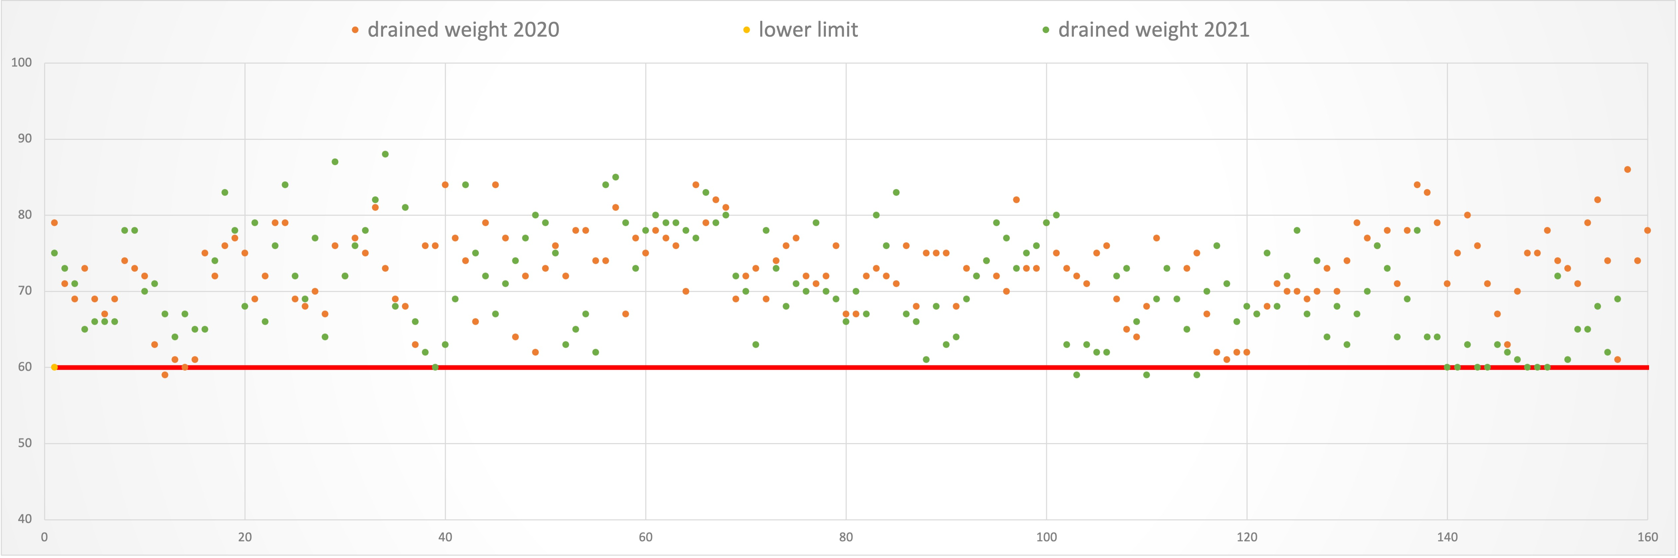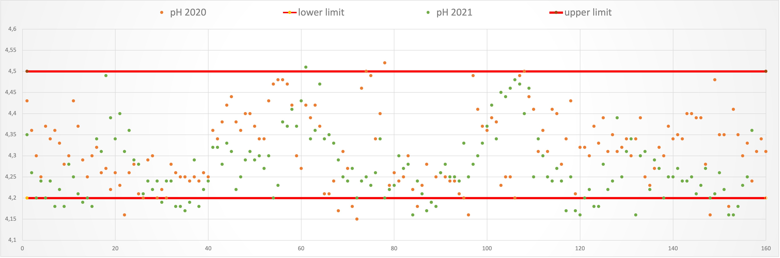
Fig. 1. Drained weight % vs sample number Fig. 2. pH units vs sample number

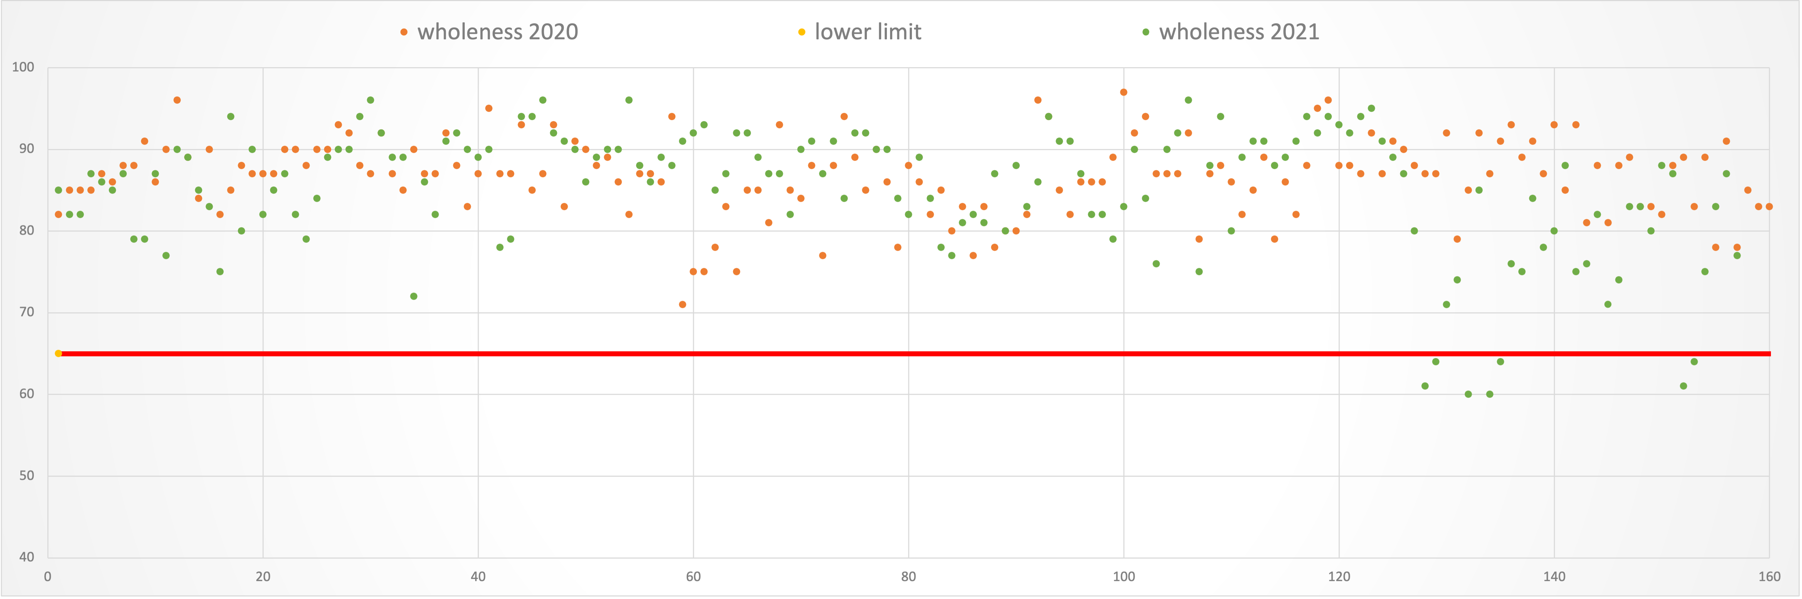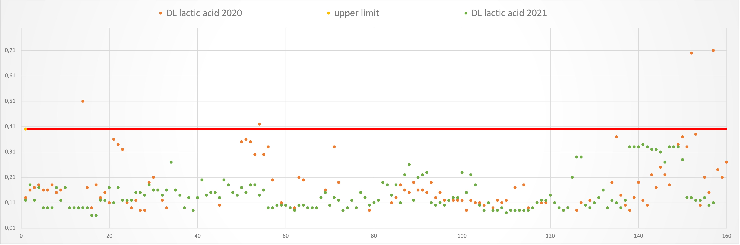
Fig. 4. D/L lactic acid content (g/kg) vs sample number

Fig. 3. Wholeness % vs sample number

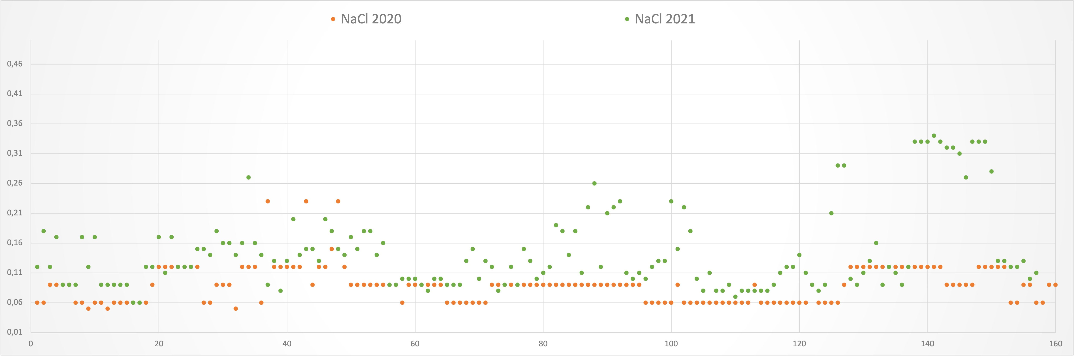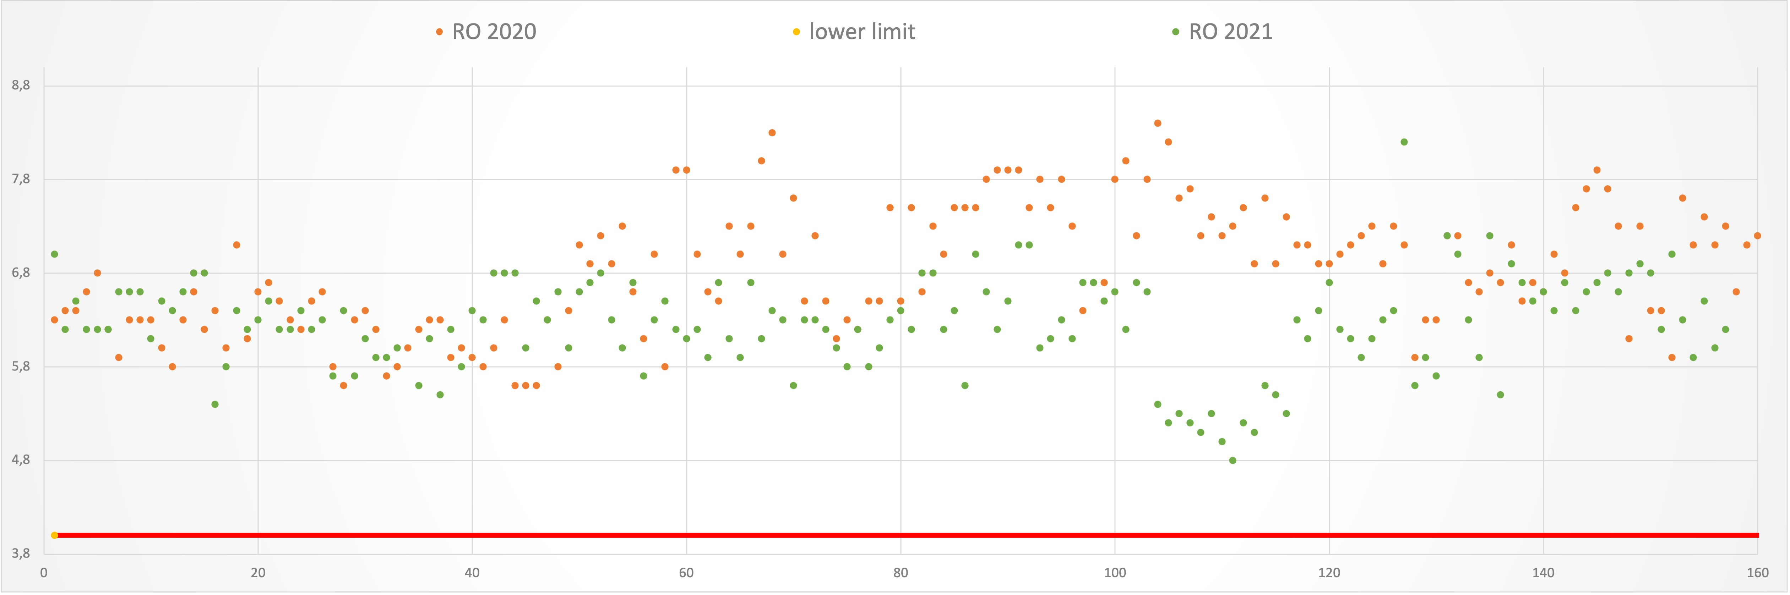
Fig. 6. Refractometric optical residue (RO) % vs sample number

Fig. 5. NaCl % vs sample number

In recent years, other countries worldwide, including non-EU countries, have taken a leading role as producers and exporters of tomato derivatives. These are mainly China, which has achieved a considerable position in the global processed tomato market over the years, given its growing exports. Chinese production, oriented toward the production of concentrates and preserves, is in competition with the Italian product, which is intended, on the other hand, mainly for direct consumption and not for the production of semi-finished products. The peeled tomato is the type of preserve that allows a greater valorization of the raw material since the whole fruit with its original characteristics turns out to be clearly visible in the finished product and this obviously requires higher costs for the sorting and processing stages. That is, it is not simply a commodity, but a specific preserve with even higher production costs. For the quality of the product, the raw material must, in fact, be processed in the shortest possible time, that is, within 24/36 hours of harvesting. It is, therefore, about fresh tomatoes necessarily made in Italy, being uneconomic a supply from abroad. Given the health potential of tomatoes, the enhancement of production in relation to the territory of origin is now more than ever felt.
In an era of globalization where Italian companies are finding it difficult to stand out, quality certifications become more important today than ever, which, to be effective without being just a cost to companies, must adapt to the product and the historical reference period. Generally, production specifications and analysis protocols for the certification of PDO products are developed at the same time as the historical reference period. However, the natural evolution of technology positively affects the quality of the finished product, hence the need to reconsider the chemical-merceological parameters. Here, then, is the need to update the analyses provided for certification.

1.4 Conclusions and future perspectives
In particular, for the San Marzano dell'Agro-Sarnese-Nocerino PDO, it is considered appropriate to propose the exclusion from routine analysis of both the determination of added salt and that of mold count according to Howard, which is the most commonly used method for determining the microbiological quality of the raw material. In fact, both of these analyses are better suited to tomato quality control in general, not highlighting any particular peculiarities of the quality of PDO San Marzano dell'Agro-Sarnese-Nocerino. Specifically, the determination of added salt is done in order to correct the value of the optical residue expressed in degrees Brix, altered by the possible addition of salt; but all the samples analyzed show values of added salt close to zero or with otherwise negligible values, confirming the possibility of excluding this determination from routine ones. Furthermore, mold control represents a parameter related to the hygienic and sanitary conditions of the raw material and the plant, conditions that are already monitored as part of the company's self-control. Today, plants are more advanced than in the past, and product quality can be monitored with more sensitive analyses, including the determination of D and L lactic acids as an indicator of alteration of a microbiological nature.
Given the experience made on extra virgin olive oil, where for the various PDOs not all the analyses required by Reg. (EEC) No. 2568/91 are carried out, but only those that best characterize the product, it would be desirable to take the same path. The 'exclusion of the above-mentioned two parameters from the list of those normally provided for, would meet the needs of the Consortium for the Protection of San Marzano Tomato to decrease cost and time of analysis; while one could consider introducing more effective analyses for PDO qualification. In particular, it could be useful to define sensory parameters to be used in a possible panel test, which, as in extra virgin olive oil, could be useful in order to be able to highlight the quality of the product.

References and Citations
ANICAV https://anicav.it/i-prodotti/pomodoro/
ISMEA Mercati (2021) Conserve di pomodoro: principali dinamiche della campagna 2021. n.1
ISMEA (2019) Il comparto del pomodoro da industria (OI Pomodoro Nord Italia e OI Centro Sud Italia - agosto)
Marzialetti S. (2021) Pomodoro, a sorpresa il raccolto sfiora 6 milioni di tonnellate. il Sole24ore 4 ottobre
Nomisma (a cura di) (2017), Un primato da tutelare, FOOD dicembre
OI - Organismo Interprofessionale pomodoro da industria Nord Italia, dati 2018
Pascale A. Ufficio stampa ANICAV, Pomodoro da industria: campagna 2021 da record con oltre 6 milioni di tonnellate di prodotto trasformato

