Chapter N (please do not write anything in this line. Editors will annotate the chapter number)

Textile industry between past and future in the Museum of Merceology (MuMe)

¹Darica Paradiso§, ²Giulianan Vinci#, ²Laura Gobbi&, ²Lucia Maddaloni£
¹Polo Museale, Sapienza University of Rome- Piazzale Aldo Moro, 5, 00185 Rome,
²Department of Management, Sapienza University of Rome -
Via del Castro Laurenziano, 9 – 00161 Rome, Italy
§darica.paradiso@uniroma1.it; #giuliana.vinci@uniroma1.it; &laura.gobbi@unirroma1.it; £lucia.maddaloni@uniroma1.it
*Corresponding author: Giuliana Vinci; giuliana.vinci@uniroma1.it

Abstract. In Italy, the textile industry represents one of the most important and strategic manufacturing sectors, characterized by new policies related to sustainable transition and digital innovation. The Italian textile industry is also associated with the workmanship, tradition, and ancient knowledge that has characterized Italian history. According to the 2020 ISTISAN report, Italy ranks not only as a country that produces the best fashion in the world but also as the only Western nation that still has production chains that start from raw materials and arrive at the finished clothing. Indeed, the Italian textile industry is composed of companies that meet sustainability requirements more than their competitors. This peculiar situation is determined by several factors stemming from historicity, traditions, and existing legislation regarding environmental protection and respect for employees' health. The new Museum of Merceology (MuMe) at the Sapienza University of Rome, currently undergoing major renovations, preserves numerous textile artifacts: animal and vegetable fibers such as cotton, wool, linen, hemp, jute, kapok, silk, byssus, ramie, straw, etc.; man-made fibers such as viscose, rayon, cupro, acetate, etc.; and synthetic fibers such as nylon, polyester, kevlar, lycra, gore-tex. The new museum exhibition will highlight the entire textile production chain that characterizes by both traditional museography and museological apparatuses, especially through new technologies and direct experiences that visitors will be able to have such as microscopic observation of the various types of fibers, tour routes with sensory experiences, spinning on traditional looms, and designing and printing cloth with a 3D printer.

Keywords. Fiber, 3D printer, handloom, MuMe

1. Introduction

The textile industry is one of the main manufacturing sectors characterized by complex production processes. The textile and clothing sector includes the products of the textile industry (production of textile fibers), the production of clothing, and the preparation of leather goods. The size of the global textile market has been estimated at $ 993.6 billion in 2021 and is expected to grow by 4.0% annually from 2022 to 2030. In addition, an increase in clothing demand is related to the fashion industry growth and to the development of e-commerce platforms. In the European economic framework, this sector has a significant market share, with a turnover of around 162 billion euros. In the European Union (EU), this sector accounts for 11.9% of world exports, with a growth of + 6.2% in the year 2019/2018 (STATISTA, 2022).
The Italian Textile Industry is characterized by a clear prevalence of small and very small businesses, many of which are "family-own". The entire production chain is well represented in Italy, although with the increase in competition linked to the production of raw materials in Developing Countries (DCs), in recent years there has been a massive delocalization of production processes to countries with a lower labor cost of some production phases (such as spinning and weaving). Furthermore, the Italian textile industry has found itself facing not only the delocalization of the production process but also massive and sudden competition in this sector from third countries, such as China, India and Bangladesh. Italy is the third-largest exporter in the world of textile products, which include both fibers and clothes, contributing approximately 25 billion euros to the Italian trade balance (2020) (EUROSTAT; 2022). At a European level, Italy is the first producing country, followed by Germany, Great Britain, France, and Spain. Although the Textile Industry is widespread in the country, due to historical, social, and economic reasons, the companies are for the most part concentrated in well-defined districts, for example, Prato and Biella for wool, Como for silk, and Varese for cotton. The sector has recently undergone a radical change to maintain its competitiveness by moving towards products with high added value (Uddin, 2019).
The sector has recently undergone a radical change to maintain its competitiveness by moving towards products with high added value. Therefore, the Museum of Merceology (MuMe) fits into this context, which through the collection of yarns and textile objects aims to preserve, make known and transmit knowledge about traditional and innovative yarn production techniques.

2. Textile fibers
The textile fibers we mean fibrous products which, due to their structure, height, strength, and elasticity, have the property of joining, through spinning, into thin, tenacious, and flexible threads that are used in the textile industry for the manufacture of yarns, which, in turn, are transformed into fabrics (by weaving) or jersey. Textile is divided into natural fibers, which in turn are divided into vegetable and animal fibers, and chemical fibers that are divided into artificial fibers, i.e., fibers produced starting from polymers of natural origin (e.g., cellulose, viscose, etc.) and synthetic, if produced from synthetic polymers, such as plastics (e.g., nylon, Teflon, etc.) (Figure 1)(Uddin, 2019).
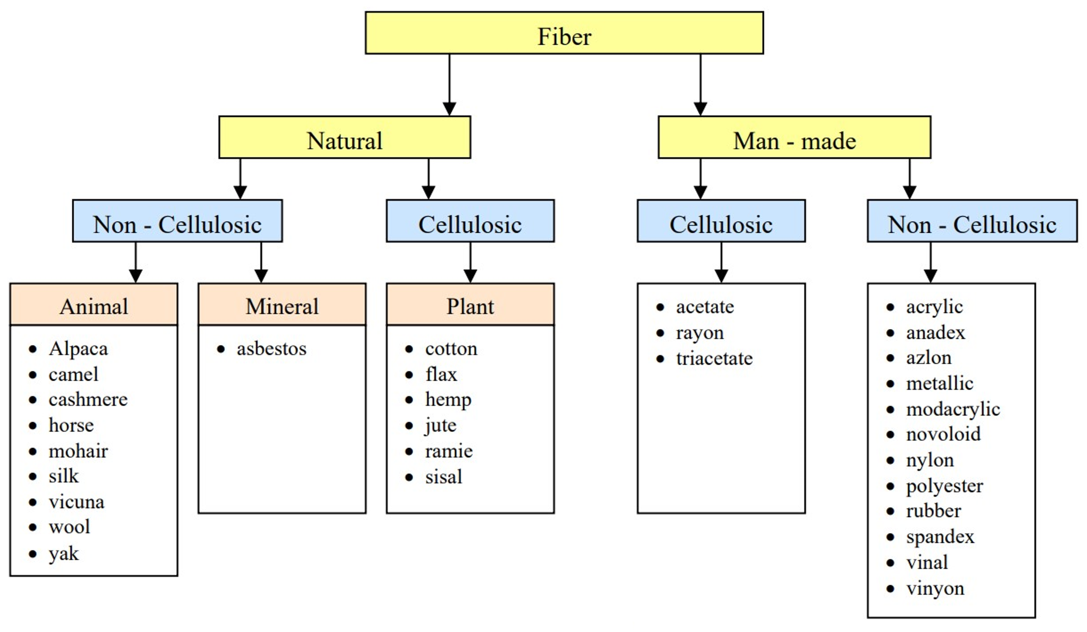
Fig.1 Classification of textile fibers

Each fiber is characterized by aesthetic properties (geometry, luster, hand, etc.), chemical (material stability, resistance, etc.), physical-mechanical (hygroscopicity, heat behavior, electrical behavior etc.), and physiological properties (allergenicity, resistance to bacteria/melds, etc.) which make it optimal for a specific use. Globally, cotton is the best-selling and most used natural fiber to produce clothes, this is attributed to its superior properties such as high resistance to traction and torsion. Cotton accounted for over 39% of the textile sector turnover. Wool-based textiles are the second natural fiber by use (13.3% of the market). Wool is widely used to produce insulation products such as winter clothing, blankets, carpets, upholstery, etc.
Natural fibers led the market in 2021 with a maximum revenue share of over 44.5%. This strong growth has been attributed to changing trends in various applications of the fashion and apparel industry. Chemical-based textiles are estimated to account for around 60% of textile fibers. Among the chemical fibers most used in the textile industry, we find synthetic fibers obtained from polyethylene, polypropylene, and polyamides, characterized by high resistance to humidity, acids, and alkalis (Jahandideh et al., 2021; Panda et al., 2021).

3. Textile processes

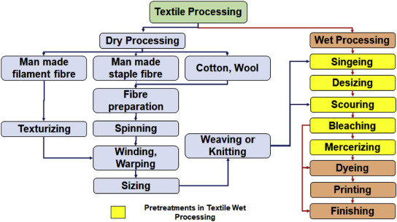
Today, the textile industry includes a significant number and variety of processes that add value to fiber. These processes can range from yarn production to woven production, via garment sewing, textile embossing, and composite manufacturing. However, considering textile fiber as the basic unit of any textile product, textile production can be identified as and technical textile. The conventional textile production process has a long history of converting natural fiber into useful products including textiles, home textiles, and clothing. and, more recently, into a technical textile using special finishing effects (Figure 2)(Sule, 2012; Uddin, 2019).

Fig.2 Textile processing

Instead, the production of synthetic and semisynthetic fibers is diversified with the use of monomers, chemical agents, precursors, catalysts, and a variety of auxiliary chemicals that lead to the formation of fibers or yarns (Uddin, 2019).
Innovation in textile production has introduced a variety of raw materials and production processes that require process control to ensure the quality of the finished product. Monitoring and control of process parameters can reduce waste, cost, and environmental impact in the textile industry. All processing steps in textile production, from fiber production to the finished fabric, are experiencing improvement in process control and evaluation. It includes the production and processing of textile fibers through the blowing chamber, carding, ironing, and combing; the production of textiles, including knitting, weaving, nonwovens, and subsequent dyeing and finishing; and the production of garments. The global textile industry, in terms of yarn and fabric production, is strongly present and growing. Apparel production is another important area of the textile supply chain. Arguably, clothing is what an individual wears for purposes of body coverage, embellishment, or comfort(Aniello, 2001; Greta & Lewandowski, 2010).

4. Museography and museology

Italy, due to its close links with the textile industry, has numerous museums, which collect and conserve textiles and collect data on them. This link between textiles and museums is often interpreted through temporary or semi-permanent exhibitions, publications, and website interventions. These interpretations are either presented in isolation or are sometimes embedded in a broader framework including the history of art and design, science and technology, social history and anthropology, local history, and world cultures (types of textiles and approaches used in the major fashion capitals, as London, Paris, Milan, New York, with a long tradition of textile production and consumption, or manufacturing cities such as Krefeld, Lyon, or Manchester, for example).
Nevertheless, museums dedicated to the history of textiles rarely attract public attention or critical acclaim. Therefore, the Museum of Merceology (MuMe) intends to draw on the diverse cultural experiences of the participants and the different disciplinary backgrounds they embody (Figure 3).
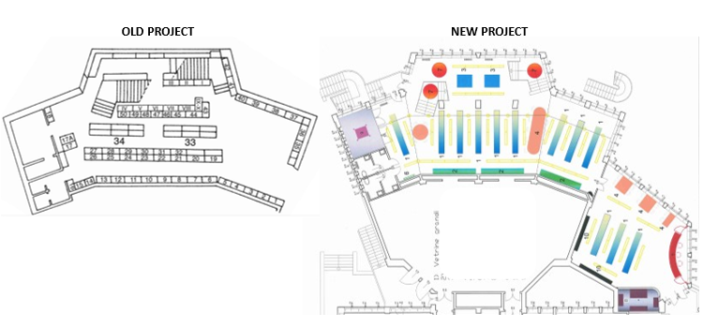
Fig.3 Old and New Project of Merceology Museum

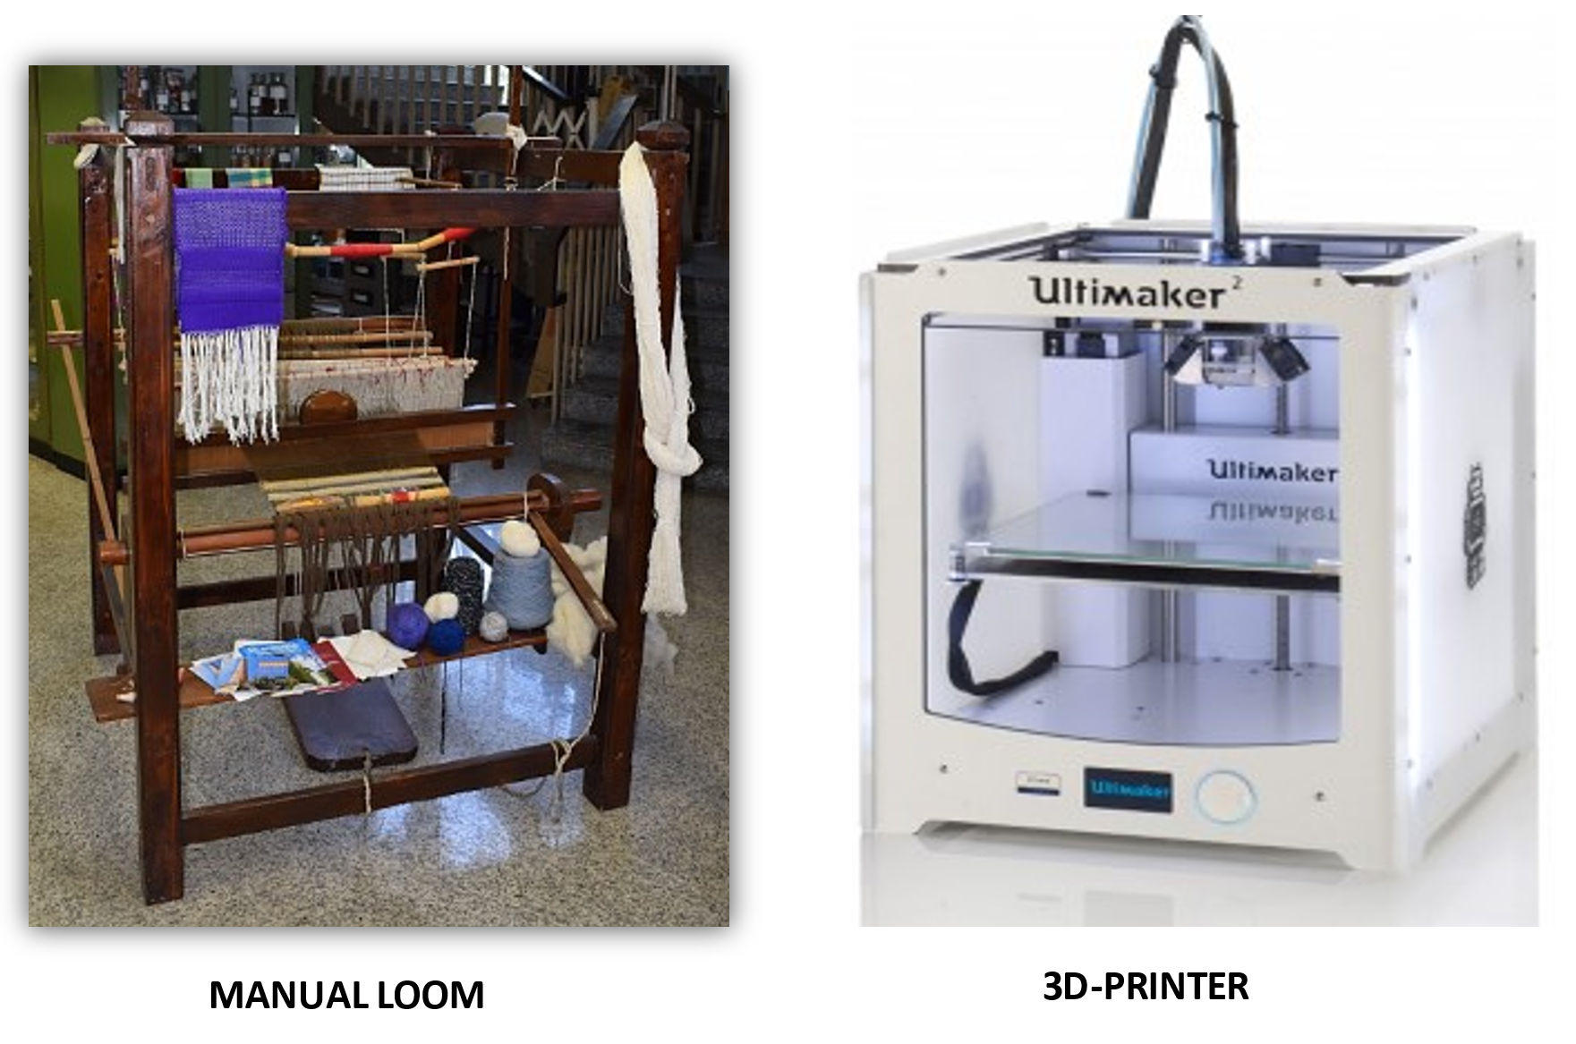
The complete renovation of the entire museum area has made it possible and will make it possible to improve knowledge about the numerous and very diverse production processes in this industrial sector through the display of textile objects according to the production chain. In addition, thanks to the logistical transformation of the museum, it has been possible to create an area dedicated to interactive textile laboratories, which allow people to get hands-on with past (e.g. loom) and future (3D printer) textile production technologies (Figure 4), enabling the MuMe to not simply be a repository of textile objects, but to be a means of expanding knowledge in the textile sector, thanks also to the exchange of knowledge between academic research and the museum.
Fig.4 Manual loom and 3D-printer of the textile laboratory of Merceology Museum (MuMe)
4. Conclusions

The art of weaving tells the story of our civilization, from the rudimentary coverings in use among the Palaeolithic to the refined vintage garments of our times. Knowing, documenting, cataloguing, preserving, and enhancing the techniques of the Italian and world textile industry are just some of the tasks of the Museum of Merceology (MuMe). The MuMe can boast some important textile collections ranging from yarns to precious fabric fragments. Therefore, the renewed and innovated MuMe in its exhibitions will be the meeting point of science, history, and knowledge.

References

STATISTA, 2022. www.statista.com/stistic/textile _market

EuroStat, 2022. https://ec.europa.eu/eurostat/data/database

Aniello, V. (2001). The competitive Mezzogiorno (Southern Italy): Some evidence from the clothing and textile industry in San Giuseppe Vesuviano. International Journal of Urban and Regional Research, 25(3), 517–536. https://doi.org/10.1111/1468-2427.00327

Greta, M., & Lewandowski, K. (2010). The textile and apparel industry in Italy: Current State and challenges to further growth. Fibres and Textiles in Eastern Europe, 83(6), 20–25.

Jahandideh, A., Ashkani, M., & Moini, N. (2021). Biopolymers in textile industries. Biopolymers and Their Industrial Applications, January, 193–218. https://doi.org/10.1016/b978-0-12-819240-5.00008-0

Panda, S. K. B. C., Sen, K., & Mukhopadhyay, S. (2021). Sustainable pretreatments in textile wet processing. Journal of Cleaner Production, 329, 129725. https://doi.org/10.1016/J.JCLEPRO.2021.129725

Sule, A. (2012). Life Cycle Assesment of Clothing Process. Research Journal of Chemical Sciences.

Uddin, F. (2019). Textile Manufacturing Processes. Intech, 13. https://doi.org/DOI: http://dx.doi.org/10.5772/intechopen.87968

