Chapter N 008

Application of the DNSH principle to the restoration and enhancement of a historical garden: the project "Well-being and spirituality: Orto-giardino Laudato Sì"

Abstract. The application of the "Do No Significant Harm" (DNSH) principle, as foreseen by the Italian Recovery and Resilience Plan (so-called PNRR in Italian), intends to demonstrate that a project intervention does not cause significant harm to the environment and can produce positive impacts. This paper describes the results of a preliminary analysis of environmental aspects and impacts, in accordance to DNSH, related to the restoration and reforestation of the historic garden of Villa San Leonardo al Palco, in Prato. Alongside the care and restoration of the villa, which already hosts events, conferences and retreats, the project “Well-being and spirituality: Orto-giardino Laudato Sì” will enhance the garden and preserve biodiversity, with benefits for citizens and tourist attractions. One of the main objectives is the adoption and development of ecosystem functions in the garden, with direct and positive environmental effects. The principles of both circularity and sustainable agriculture let inspire the creation of the bioactive garden, to cultivate local biodiversity for self-consumption, with the possibility to enhance sustainable food models, health and well-being. The garden will become an ecological, economic and social laboratory, capable of strengthening and spreading scientific, technical, botanical and environmental knowledge.

Keywords. urban gardens, circular economy, environmental impacts, well-being

1. Introduction
The mechanism for Recovery and Resilience (according EU Regulation 241/2021) stipulates that all measures in Recovery and Resilience plans must comply with the principle of “Do No Significant Harm” (DNSH) to environmental objectives and impacts. This requirement translates into an assessment of the project intervention and the evaluation of compliance with DNSH. The Italian National Recovery and Resilience Plan (the so-called PNRR in Italian) also includes the DNSH principle and ask for its application in new project interventions.
In 2022, the Italian Government lauched a call, on the framework of the PNRR, with the aim to fund the restoration and the enhancement of historic parks and gardens (i.e. Misura 2 “Rigenerazione di piccoli siti culturali, patrimonio culturale, religioso e rurale” Investimento 2.3: “Programmi per valorizzare l’identità dei luoghi: parchi e giardini storici” la Missione 1 – Digitalizzazione, innovazione, competitività e cultura, Componente 3– Cultura 4.0 - M1C3). Promoting this financial line, the main objectives for the Italian Government are the increasing of the touristic and the cultural appeal of historic gardens (public and not public) by: i) modernizing material and immaterial infrastructure of historical and artistic heritage; ii) improve cultural usability and tourist accessibility through digital investments and investments aimed at removing physical and cognitive barriers to heritage; iii) renewing and modernizing the tourism offer also through the upgrading of accommodation facilities and the strengthening of strategic tourism infrastructures and services; iv) support the recovery of the cultural and creative tourism industry.
In response to the above-mentioned call, the Diocesi of Prato decided to submit a project proposal for the restoration and modernisation of the historic garden of the monastery of San Leonardo al Palco, in Prato. The main aim of the project, called “Well-being and spirituality: Orto-giardino Laudato Sì” is to promote of space fully harmonic with the nature and living beings; an ecological, economic and social laboratory aimed at identifying the optimal dimensions of a sustainable, resilient and autonomous living space. By applying DNSH principle, an assessment was made regarding the consistency of the proposed intervention in relation to the PNRR measures.
2. Materials and methods
The DNSH principle is based on what is specified in the taxonomy system of environmentally sustainable activities indicated in Article 17 of Regulation EU 2020/852, adopted to promote private sector investment in green and sustainable projects and to help realise the objectives of the Green Deal. All projects and reforms proposed in the Italian National Recovery and Resilience Plan were, therefore, evaluated considering the DNSH criteria. Consistent with European guidelines, the technical evaluation estimated the expected direct and indirect effects of each financed intervention in a long-term perspective. In fact, there is currently no unambiguous methodology for assessing DNSH in Italy. The main reference are checklists prepared at European level, for the compilation of which no standardised instructions are provided (e.g. on how to measure specific requirements or any reference methods).
For this work, in order to carry out the assessment using the DNSH principle, on-site visits were made to the monastery, where, through a series of interviews, it was possible to collect information regarding the structural interventions planned for the project. As reference, we considered the requirements included in the check-lists “Afforestation - Table 19” and “Cultivation of perennial and non-perennial crops - Table 20”.

3. Results and discussion
The project intervention over the garden of the monastery of San Leonardo al Palco includes the courtyard within the perimeter walls (area of 15,000 m²). It contains approximately 350 olive trees and a water source. A hydraulic system compensates for the water levels originating from the spring by a system of cascade basins. The courtyard is substantially flat, all around the main body of the monastery, and is characterised by the presence of numerous plant varieties, trees and an Italian-style garden.
The interventions included in the project proposal are listed in Table 1:
Table 1: Major interventions proposed
- Plant component and garden design: | • introduction of new plant elements respecting and consistent with the historical, landscape and soil characteristics of the site;  • creation and recovery of bioactive orchards;  • creation of suitable habitats and arrangements to attract insects;  • inclusion of hives and swarms of bees that will perform pollination and gene exchange between plants.
- Architectural and sculptural component: | • restoration of stone walls and “Belvedere”;  • resurfacing of the forecourt and the drainage of rainwater.
- Plant component: | • restoration and upgrading of hydraulic systems of historical interest and the restoration of tanks with phyto-purification functions);  • implementation of energy-efficient lighting systems;  • installation of photovoltaic panels
- Safety and accessibility: | • installation of a video surveillance system;  • installation of an access ramp  • construction of a pedestrian boulevard;  • installation of charging systems for electric mobility.
- Valorisation and communication: | •inclusion of the garden within cultural, landscape itineraries in the area;  •participation in participatory local development initiatives  • involvement of voluntary associations and citizens in maintenance, management, enhancement and communication activities.
Sources: Author

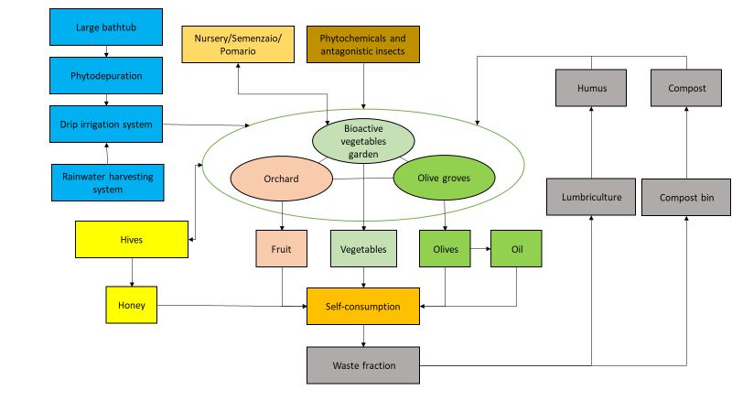
Fig. 1. Circular system of the intervention.
Source: Authors
Figure 1 summarises the interventions and their interconnections by application of virtuous practices of circular economy and environmental and climate protection.
The self-assessment was conducted through the use of DNSH self-assessment form for Measure 2 (Table 2) and by check lists (source: https://italiadomani.gov.it/it/Interventi/dnsh.html) “Afforestation” and “Cultivation of perennial and non-perennial crops”. The purpose of the datasheets is to provide a summary of operational and regulatory information that identifies DNSH constraints, for activities that are part of the Plan's interventions.

Table 2: DNSH self-assessment form for Measure 2
Environmental objectives | Questions | Yes/No | Substantive justification if NO has been selected
1. Climate change mitigation | Is the measure expected to lead to significant GHG emissions? | NO
2. Climate change adaptation | Is the measure expected to lead to an increased adverse impact of the current climate and the expected future climate, on the measure itself or on people, nature or assets? | NO
3. The sustainable use and protection of water and marine resources | Is the measure expected to be detrimental: (i) to the good status or the good ecological potential of bodies of water, including surface water and groundwater; or (ii) to the good environmental status of marine waters?
4. The circular economy, including waste prevention and recycling | Is the measure expected to: (i) lead to a significant increase in the generation, incineration or disposal of waste, with the exception of the incineration of non-recyclable hazardous waste; or (ii) lead to significant inefficiencies in the direct or indirect use of any natural resource at any stage of its life cycle which are not minimised by adequate measures; or (iii) cause significant and long-term harm to the environment in respect to the circular economy (art. 27 of the Taxonomy)? | NO | Given its nature, the investment has no foreseeable impact on this environmental objective, taking into account both direct and primary indirect effects. However, parks and gardens produce a huge numer of cubic metres of bulk green waste annually from tree and shrub removal, pruning, weed removal and lawn mowing throughout the park.
5. Pollution prevention and control to air, water or land | Is the measure expected to lead to a significant increase in the emissions of pollutants into air, water or land? | NO | Treatments against parasites, pathogens and pests must preferably be carried out by recurring to coltural criteria, and other biological control or chemical substances of low or zero toxicity to humans, on wild fauna and flora. In order to manage the soil pollutants it is planned to create guidelines for the correct management of agronomic activities and the collection and disposal of agricultural waste.
6. The protection and restoration of biodiversity and ecosystems | Is the measure expected to be: (i) significantly detrimental to the good condition and resilience of ecosystems; or (ii) detrimental to the conservation status of habitats and species, including those of Union interest? | NO
Sources: Authors

The initial situation with 350 mature olive trees plays a significant role with a CO₂ absorption in one year of about 3500 kg (Palese et al., 2013). The intervention includes the planting of more than 1000 plant species, that together, will bring the total CO₂ absorption balance to 9500 kg per year.
The selection of crops will be added to those already present, bringing the soil coverage to almost all of it, thus well above the minimum 75% required. Observing Figure 2, the area covered by the project will already be covered almost in its entirety by green areas, in particular a garden (approximately 4,200 m²), an olive grove (approximately 8,000 m²) and woodland (approximately 800 m²). An additional green area dedicated to a vegetable garden will also be created. The garden management method (bioactive garden) will have a productive function intended for self-consumption and high social impact purposes. Finally, in the garden area, medicinal and aromatic plants will be planted, as well as flower strips, respecting the historical design of the Renaissance garden (Nanni P, 2010). The analysis of physical climatic risks can be traced back to phenomena that are now particularly frequent and habitual due to climate change. The use of the motors is compensated by the increased absorption of CO₂ due to the inclusion of the new greenery. In addition, there is already a rainwater collection system that conveys rainwater to a cistern located inside the villa. A drip irrigation system is planned for the irrigation of the garden and vegetable garden, which will contribute to the efficient management of water resources. Inside the perimeter wall of the garden is a large tank for which phytodepurative plants are planned, with the aim of purifying the water without the use of chemical inputs. Through the construction of a compost heap and an area for mowing, it is intended to generate a closed cycle in which the residues and by-products of production and mowing can return as organic fertilisers. In order to promote the circular economy it is planned to create guidelines for the correct management of the above different materials.
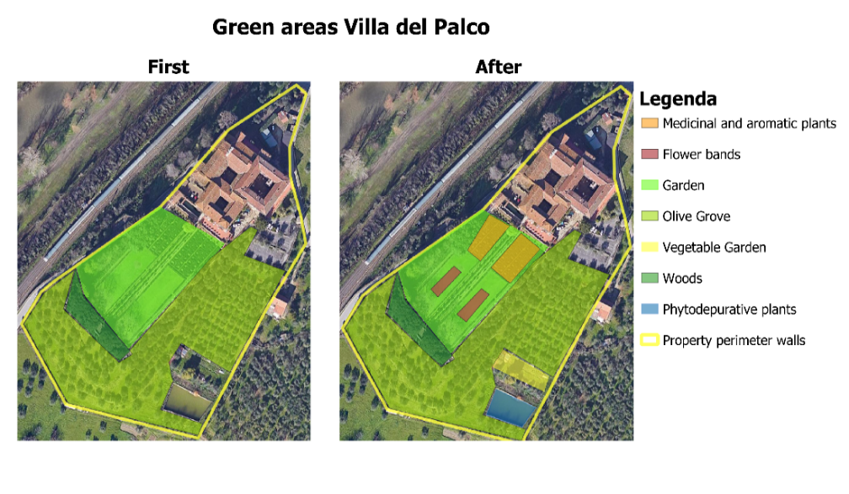
Fig. 2. Green areas Villa del Palco
Sources: Authors

In Table 3, the planned interventions are summarised, dividing them into those that contribute to the absorption/reduction of CO₂ and those that produce it.
Table 3: Factors that absorb and produce CO₂ emissions
Factors that absorb or reduce CO2 emissions | Factors producing CO2 emissions
- Introduction of new plant elements (trees, shrubs and hedges, grasses).  - Rehabilitation of pomaria and orchards.  - Introduction of bioactive vegetable garden with compost bins. Use of compost bins.  - Creation of suitable habitats to attract insects.  - Insertion of hives and swarms of bees.  - Restoration of plumbing systems and stormwater management.  - Introduction of phytodepurative plants.  - Installation of photovoltaic panels.  - Energy-efficient electrical renovation.  - Charging systems for sustainable mobility. | - Using motors for irrigation pumps.  - Use of tractor for garden maintenance and landscaping.  - Conveyance of construction waste as a result of improvements to the architectural component.  - Use of electrical equipment (video-surveillance, accessibility) in case of energy needs that are not guaranteed by photovoltaic panels.
Sources: Authors
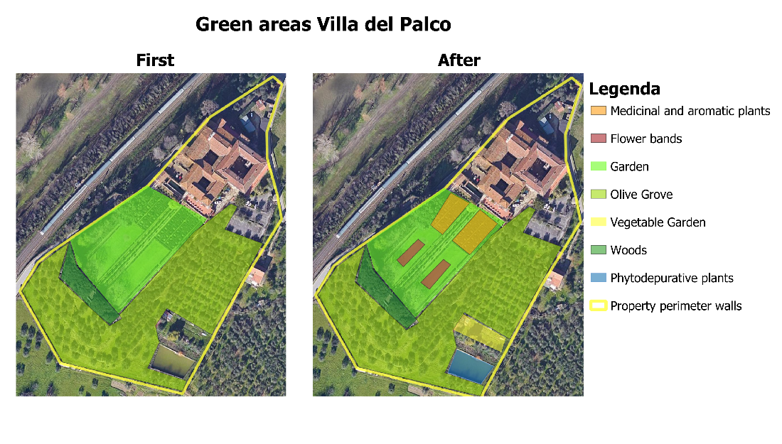

5. Conclusions and future perspectives
Even a standardised method is not yet in place, by the application of the DNSH principle, it is possible to carry out an evaluation to show that the proposed intervention would not generate excessive impacts on the environment. The project “Orto-giardino Laudato sì” is intended to be a balanced model of landscaping areas, with the possibility also of enhancing sustainable food models that promote wellbeing and health. At the local level, the project fits into the policies defined in the Prato area for the creation of a circular urban and peri-urban agricultural system.

References
Guida operativa per il rispetto del principio di non arrecare danno significativo all’ambiente (cd. dnsh) https://italiadomani.gov.it/it/news/pubblicata-la-guida-operativa-per-il-rispetto-del-do-no-signific.html (last visited 22/06/2022)
https://italiadomani.gov.it/it/Interventi/dnsh.html (last visited 22/06/2022)
Nanni P, 2010, “Agricoltura e agricoltori nelle terre di Francesco di Marco Datini (XIV-XV secolo)”, in Rivista di Storia dell'Agricoltura - a. L, n. 2. dicembre 2010, pp. 3-34, Accedemia dei Georgofili, Firenze.
Palese A M, Pergola M, Celano G, Xiloyannis C., (2013), L’oliveto sostenibile per il sequestro di CO₂, Edizioni L’Informatore Agrario
https://sanleonardoprato.it/ (last visited 22/06/2022)

