Chapter N 015

A combined economic-environmental assessment of an innovative chemical formulation for waterproofing applications in the leather manufacturing industry

Abstract. Industry is proven to be one of the most contributing sectors in terms of soil and water degradation, water and energy consumption, emission of greenhouse gases and other polluting compounds. Hence, sustainability issues of industrial products are gaining the increasing attention of practitioners, scientists, academia, company owners, policy and decision-makers, and other stakeholders, so much so that those issues are increasingly being placed at the centre of policy agendas and research projects, both on the local and the global scale.
In a recent project, attention was focused by this papers’ authors upon waterproof agents, with the aim of replacing highly environmentally damaging substances like the Perfluoroalkyl ones (PFAs) that, in fact, have been included on the list of Persistent Organic Chemicals by the Stockholm Convention.
In this context, the goal of this paper was to analyse the relevant environmental and economic issues associated with an innovative silica-based formulation through application of Life Cycle Assessment (LCA) and Life Cycle Costing (LCC) according to the specialised Standards and technical guidelines.
This study is conducted in the field of those projects to contribute to enhancing the literature and the knowledge on the important need for implementing sustainable, innovative paths of producing chemical compounds and products for usage in the leather manufacturing industry.
Through their study, the authors highlighted that the major environmental and economic hotspots stay in the production of the raw-material requirements for waterproof formulations which, so, demands for priority in the identification of the improvement potentials. Doing so can make it possible for the company to understand, already on the lab-scale dimension, where and how innovation solutions can be effective in enhancing the economic and environmental sustainability of its chemical products.
This paper also represents the first step towards sustainable material solutions to replace PFAs, thereby favouring the greening not only of the chemical industry but also the leather manufacturing one.

Keywords. LCA, LCC, PFA, waterproof agents, leather sector.

Introduction
Raw hides and skins are food-animal slaughtering by-products. The renewability and biologic nature of this raw materials recovered from slaughterhouse wastes make the leather sector part of the avant-garde in the transition towards a circular economic system (UNIC, 2020). There are, however, some criticalities about the impact on environment arising by leather tanning process that need to be addressed and solved, both regarding resource deployment and the release of liquid, solid, gaseous emission. In fact, leather manufacturing - beamhouse, tanning, post-tanning and finishing operations (Black et al., 2013; China et al., 2020) - involves a huge quantity of chemicals, water and energy determining significant impacts in the aquatic, terrestrial and atmospheric environment (Dixit et al., 2015; China et al., 2020).
Regarding chemicals, Sawalha et al. (2019) observe that tanneries consume about 130 types of chemicals, many of which are considered dangerous for environment and human health (Dixit et al., 2015). Looking at international regulation, the Annex XIV of REACH lists 59 Substances of Very High Concern (SVHCs) which must be subject to special authorizations for their manufacture and trade: more than 48% of those substances are involved in the leather manufacturing industry. It is therefore clear that the sustainability of tannery production system is influenced by the supplying chemical industry (Ingrao et al., 2021a). The choice of chemicals to be applied along tannery operations depends upon the technologies used and the characteristics of finished leather to be obtained (Ingrao et al., 2021a). So, the role of specialties chemical industry is fundamental in order to meet the demands of tanners, in terms of environmental sustainability too. This contribution is inserted in this context: it develops from the collaboration between University of Turin and supply chain companies in the leather sector in a project with the aim to develop an innovative waterproof nano-based formulation for finishing application in substitution to perfluoroalkyl-based formulation.
The perfluoroalkyl substances (PFASs) were historically manufactured since 1950s for a variety of application, i.e. firefighting foams, cosmetics, food packaging, coating for textiles and leather. Their release into the environment represents, however, a global concern (Wang et al., 2017; Higgins & Field, 2017; Xiao, 2017), which also affected north-east Italy too where part of population has been exposed to contaminated drinking water (Pitter et al., 2020). In fact, PFASs are characterised by high persistence and water solubility, which determine long exposure times and diffusion over long distance; moreover, PFASs family are hazardous for living organism due to their toxicity and bioaccumulative property (Ahrens & Bundschuh, 2014; Wang et al., 2017; Higgins & Field, 2017; Xiao, 2017). The release of these harmful substances in the environment can occur at every stage of their life cycle (Ahrens & Bundschuh, 2014). As illustrative, in the tannery field: it comes to the phases of production and processing (Pitter et al., 2020) into other intermediate or finished chemical products, in the phase of application (e.g. wastewaters of the tanneries), and during the use and disposal of the product in which they were applied (e.g. waterproof leather commodities).
To propose a more sustainable alternative to PFASs an innovative chemical based on nanomaterials was developed. Nanomaterials are considered an emergent keystone technology for a more sustainable growth (OECD, 2013; EC, 2015), the scientific literature testifies that different type of nanomaterials are currently being investigated as highly promising materials for various applications including leather treatment (Ingrao et al., 2021a). In this context, the Department of Management research group has carried out a life-cycle environmental and economic assessment of innovative nano-based formulation at pilot plant scale. In subsequent materials and methods section, life cycle tools used for assessment are introduced, while in discussion section environmental and economic impact are separately examined. This contribution, in addition to Ingrao et al. (2021a), enriches the current literature about evaluation of nano-chemicals specific designed for leather application and further, it highlights the importance for the company of conducting a performance assessment at early stage of industrialization when it is still possible to have a wider margin of improvement.

Material and methods

Description of processes
The system under investigation involves two phases of leather commodities supply chain: specialized chemical production and tannery operations. In particular, the waterproof formulation manufacturing and its application on leather in tannery were evaluated at pilot plant level.
The principal component of the new formulation is a synthetic silica subjected to chemical surface post-treatment, chosen in the design phase as an alternative to PFAS-based formulation. The surface functionalization allows to obtain a hydrophobic material to be used to impart water repellence in coatings and plastics. Final waterproof formulation is obtained by mixing silica with other intermediates along different continuous phases using a mixing machine. Then, the formulation is manually mixed with other chemicals during finishing tannery operations. The technology used for chemical mixture application in finishing phase allows to mechanically swabbing chemicals on leather ensuring a homogenous dispersion of hydrophobic materials.

Environmental assessment
The evaluation of this new formulation’s environmental sustainability was conducted using the Life Cycle Assessment methodology according to the International Standards 14040 - 14044 (ISO, 2006; 2018). Therefore, the analysis was developed by implementing four phases: Goal and Scope definition; Life Cycle Inventory (LCI); Life Cycle Impact Assessment (LCIA); and Interpretation.
The Goal of the analysis is the identification of the environmental hot spots along life cycle of the investigated new product before the industrialization stage with the scope to provide feedbacks to companies to improve their performance. The first phase includes also the functional unit (FU) definition and system boundaries delimitation. The assessment is a cradle to gate study: the system includes the raw material manufacturing and energy production, transport, waterproof formulation and other auxiliaries manufacturing at Chemical company and their application in tannery (Fig. 1). The last two subsystems constitute the foreground system for which the inventory data was directly collected in the field. The FU representative of the system was chosen in agreement with the company technicians and was identified in a 20 ft² of waterproof finished leather final output of tannery finishing operations. The second phase consists in the input and output quantitative compilation for every process unit in which system was divided. The life cycle inventory compilation was conducted by combining primary data directly collected with secondary data extrapolated from literature and recognised databases. The research team was supported by Scatol8® in energy data collection, whose contribute increased reliability of results achieved. In particular, through a sensor network it was possible to directly detect the real electricity consumption by machinery involved in the manufacturing processes (Ingrao et al., 2021b). Subsequently, on the base of LCI, the Life Cycle Impact Assessment was carried out. For this study endpoint approach was chosen and the Impact 2002+ method (Jolliet et al., 2003) was applied.

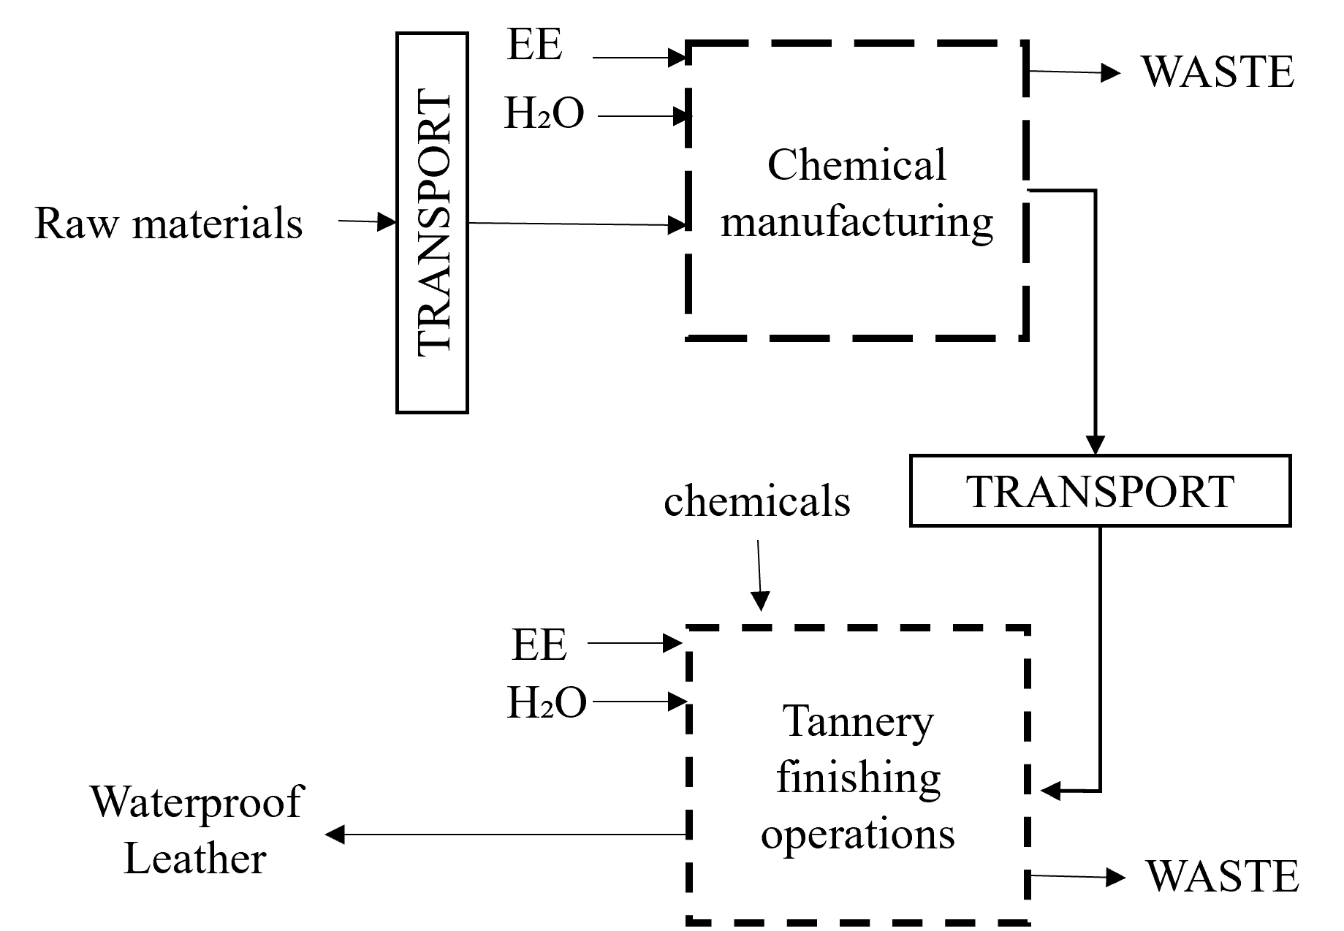
Fig. 1. System boundaries considered in the cradle to gate study of production and application of the new chemical formulation.

Environmental assessment
In addition to environmental assessment a Life Cycle Costing (LCC), traditionally considered the economic counterpart of LCA (Klöpffer, 2003), was carried out. Nowadays scientific literature includes various contributions on LCC but, despite the importance of this tools for Life Cycle Sustainability Assessment framework (LCSA) (Klöpffer, 2003), a unique definition and methodology is not yet consolidated. For this research, LCA-type LCC assessment (Notarnicola et al., 2009; Schau et al., 2011; Settanni et al., 2011) was considered the most suitable to evaluating physical life cycle product in economic terms and, at the same time, to taking into account the focal company point of view. In order to align with environmental analysis, the authors refer to the same general framework. So, economic analysis was articulated in the following steps: Goal and Scope definition; Economic Life Cycle Inventory; Life Cycle Cost Assessment; and Interpretation.
The contents of the first phase resulted coherent with the LCA setting. Goal and Scope are translated in economic terms while boundaries of the system are restricted only to foreground system. In the second phase, identification of economic flows for feed Economic Life Cycle Inventory starting to the physical inventory compiled for LCI (Schau et al., 2011) was carried out. A computational structure for LCC was implemented, in particular physical input and output flows related to foreground system are characterized in economic term and referred to FU through the application of matrix algebra rules. Then, for every process unit included the costs were assessed. In the interpretation final phase, consideration about value added concept was recalled as reported by Moreau & Weidema (2015) with the aim of supporting the clarification of LCC definition.

Results and discussion
The results of environmental damage calculation conducted according to Impact 2002+ (Jolliet et al., 2003) are showed in Table 1. Assessment of environmental impacts associated with the product system investigated reveals that the most impacting phase is represented by the first finishing operation conducted in tannery. In particular, considering all processes as the upstream phases connected with energy and raw material, the finishing phase impact derives by the production of raw material composing the chemical mixture used. Moreover, results expressed in terms of damage category showed that the consumption of natural resource, human health and climate change represent the 92.88% of total damage associated with the manufacturing and application of new formulation. Therefore, it is precisely in the chemical production phase that efforts must be concentrated to identify more sustainable alternatives e.g. an appropriate choose of intermediate by chemical company would determine an increase of environmental sustainability level associated to whole leather supply chain.
From the economic perspective, research was focused on a cost description to reveal the black box of leather manufacturing. Starting by Economic Life Cycle Inventory, which provides an overview of activity and resource drivers of the product system analysed, the Life Cycle Cost Assessment of 20 ft² of waterproof finished leather was implemented. First, the physical inventory was balanced according to a production plan associated to FU. Then, the direct variable costs of materials and energy and the unit cost of outputs were calculated for each process unit composing the physical life cycle of formulation in chemical plant and in tannery. The Life Cycle Costing results are represented in aggregate form by the unit cost of output of every phase showed in Table 1. These values were obtained through matrix algebra by adding the direct variable costs of the phase with the cost of inputs acquired from other process units. The identification of economic flows through this computational structure at different levels of disaggregation, i.e. for phase and single process unit, is resulted very useful for decision-support. In fact, these economic values reflecting the physical life cycle of formulation detected during the pilot plant phase provide to the company an adequate basis for definition of the product selling price.

Table 1. LCA and LCC results for every phase associated with production of waterproof formulation necessary to obtain 20 ft² of waterproof finished leather.
 | LCA | LCC
phase | Weighing points  (mpt/FU) | Cost outputs  (€/FU)
Waterproof formulation | 20,48 | 6,7
1° Step finishing | 59,05 | 0,02
2° Step finishing | 9,01 | 0,036
3° Step finishing | 11 | 0,037
Total | 99,54 | -

As opposed to LCA, the authors chose not to present an aggregated cost result as the final interpretation of economic sustainability. In fact, the simple sum of the cost along the life cycle phases of innovation would incur in double counting e.g. the cost of waterproof formulation is incorporated in the cost of finishing operations. The focus on value added as difference between the value of the goods produced and the value of the resources necessary for its generation allows to avoid economic impact accumulation in a life cycle perspective (Moreau & Weidema, 2015). Therefore, the authors agree with definition provided by Moreau & Weidema (2015), which intend the life cycle cost as the sum of the value added along the phases of product supply chain. For this study it has only been possible to accurately calculate the value added for formulation manufacturing phase and, therefore, to reveal only a part of economic value creation.

Conclusions and future perspectives
This contribution is part of a research aimed overall at exploring the feasibility of producing sustainable tanning and finishing products for leather finishing. The need to preserve ecosystem and human health from hazardous effect of PFAs boosts companies to search for other type of performing resources, like in this case in the field of nanomaterial technologies. In this context, through the environmental and economic assessment, the possible impacts of new waterproof formulation have been identified before its life cycle is active. Therefore, the analysis conducted at pilot plant level allow to investigate about further margins of sustainability improvement before fully industrialization. Based upon the findings of the study, chemical manufacturing emerges as an important environmental hot spot: the results suggest searching for alternative intermediate to combine with less harmful innovation. For investigating the economic aspect of product sustainability, the industrial costs associated to innovation life cycle was calculated through a computational model from which strategical information on cost structure was extracted to support companies cost management. In addition to Ingrao et al. (2021a), the research enriches the knowledge on nanomaterial innovations for leather manufacturing at first development stages promoting a multifunctional evaluation through the LCSA framework.
Nevertheless, this contribution will be subject to future developments: open questions emerge alongside the assessments, which provides a first response on innovation sustainability. First of all, comparative studies of products containing PFAs with the extensions of the system boundaries to EoL phase will be conducted in order to better validate their replacement. Instead, from a methodological point of view, it is necessary to deepen a standardization methodology for LCC and the integration methods of the life cycle tools to provide an overall reliable representation of product sustainability.

References and Citations
Ahrens, L., Bundschuh, M. (2014). Fate and effects of poly- and perfluoroalkyl substances in the aquatic environment: A review. Environmental toxicology and chemistry, 33(9), 1921-1929.
Black, M., Canova, M., Rydin, S., Scalet, B. M., Roudier, S., Sancho, L. D. (2013). Best available techniques (BAT) reference document for the tanning of hides and skins. European Commission Database, 46.
China, C. R., Maguta, M. M., Nyandoro, S. S., Hilonga, A., Kanth, S. V., Njau, K. N. (2020). Alternative tanning technologies and their suitability in curbing environmental pollution from the leather industry: A comprehensive review. Chemosphere, 126804.
Dixit, S., Yadav, A., Dwivedi, P. D., Das, M. (2015). Toxic hazards of leather industry and technologies to combat threat: a review. Journal of Cleaner Production, 87, 39-49.
European Commission (EC) (2015). Horizon 2020 Work Programme 2016–2017. 5.ii. Nanotechnologies, Advanced Materials, Biotechnology and Advanced Manufacturing and Processing. Belgium.
Higgins, C. P., Field, J. A. (2017). Our stainfree future? A virtual issue on poly-and perfluoroalkyl substances. Environmental Science & Technology 51 (11), 5859-5860.
Ingrao, C., Vesce, E., Evola, R. S., Rebba, E., Arcidiacono, C., Martra, G., Beltramo, R. (2021a). Chemistry behind leather: Life Cycle Assessment of nano-hydroxyapatite preparation on the lab-scale for fireproofing applications. Journal of Cleaner Production, 279, 123837.
Ingrao, C., Evola, R. S., Cantore, P., De Bernardi, P., Del Borghi, A., Vesce, E., Beltramo, R. (2021b). The contribution of sensor-based equipment to life cycle assessment through improvement of data collection in the industry. Environmental Impact Assessment Review, 88, 106569.
Jolliet, O., Manuele, M., Raphael, C., Sebastian, H., Jerome, P., Gerald, R., Rosenbaum, R., 2003. Impact 2002þ: a new life cycle impact assessment methodology. The International Journal of Life Cycle Assessment 8, 324-330
Klöpffer, W. (2003). Life-cycle based methods for sustainable product development. The International Journal of Life Cycle Assessment, 8 (3), 157 – 159.
Moreau, V., Weidema, B. P. (2015). The computational structure of environmental life cycle costing. The International Journal of Life Cycle Assessment, 20(10), 1359-1363.
Notarnicola, B., Settanni, E., Tassielli, G. (2009). Approcci all’integrazione dei costi in LCA: life cycle costing, analisi input-output. Atti del Convegno Scientifico della Rete Italiana LCA, Palermo, 11, 17-25.
Organisation for Economic Co-operation and Development (OECD) (2013). Nanotechnology for Green Innovation. OECD Science, Technology and Industry Policy Papers No. 5
Pitter, G., Da Re, F., Canova, C., Barbieri, G., Zare Jeddi, M., Daprà, F., Manea, F., Zolin, R., Bettega, A. M., Stopazzolo, G., Vittorii, S., Zambelli, L., Martuzzi, M., Mantoan, D., Russo, F. (2020). Serum levels of Perfluoroalkyl substances (PFAS) in adolescents and young adults exposed to contaminated drinking water in the Veneto region, Italy: A Cross-Sectional Study Based on a Health Surveillance Program. Environmental health perspectives, 128(2), 027007.
Sawalha, H., Alsharabaty, R., Sarsour, S., Al-Jabari, M. (2019). Wastewater from leather tanning and processing in Palestine: Characterization and management aspects. Journal of environmental management, 251, 109596.
Schau, E. M., Traverso, M., Lehmann, A., Finkbeiner, M. (2011). Life cycle costing in sustainability assessment—a case study of remanufactured alternators. Sustainability, 3(11), 2268-2288.
Settanni E., Tassielli G., Notarnicola B. (2011). An input–output technological model of life cycle costing: computational aspects and implementation issues in a generalised supply chain perspective. In: Burritt R., Schaltegger S., Bennett M., Pohjola T., Csutora M. (eds.) Environmental management accounting and supply chain management, vol 27. Springer, Dordrecht, 55–109.
UNIC – Concerie Italiane (2020). Sustainability Report.
Wang, Z., DeWitt, J. C., Higgins, C. P., Cousins, I. T. (2017). A never-ending story of per-and polyfluoroalkyl substances (PFASs)? Environmental Science & Technology 51 (5), 2508-2518.
Xiao, F. (2017). Emerging poly-and perfluoroalkyl substances in the aquatic environment: A review of current literature. Water research, 124, 482-495.

