Chapter N 042
Sustainable organic waste management in small communities: evidence from life cycle based evaluations

Abstract. Organic waste or biowaste is the largest component in municipal solid waste and, therefore, one of the main landfilled waste fractions with the consequent issue of greenhouse gases emissions. On the other hand, it represents a valuable resource that can be harnessed and returned to productive use in the framework of a circular economy approach, according to the EU Waste Framework Directive.
This paper presents the results of an environmental and economic life cycle assessment of specific organic waste management actions in two reference territories representative of “small communities”, paving the way for a deeper understanding of the benefits that can be gained by means of local composting.
Life cycle evaluations results showed that improvement potentialities are high, especially in terms of environmental impacts and externalities, confirming life cycle-based evaluations as very valuable tools for decision-makers to better understand benefits and costs of waste management policies.
Results also confirmed that, both from an environmental and economic point of view, a “local” waste management system, in which transportation is reduced, is particularly strategic, as well as a “tailored” management system that affect other specific territorial hotspots, such as for instance the temporary storage of waste.

Keywords. LCA, LCC, sustainability, organic waste, biowaste, waste management

Introduction
Organic waste or biowaste consists of food and garden waste, represents the largest component in municipal solid waste (MSW) with a share of 34% and is one of the main landfilled waste fractions, with an expensive management system that also creates significant greenhouse gas emission (EEA, 2020). On the other side, biowaste is a valuable resource that can be harnessed and returned to productive use, turned into compost to improve and fertilise soil or rescued to provide food for people and animals. The European Commission pushes a policy of diverting – so much biowaste as possible – from the residual municipal waste which is directed to landfilling to the recycling at source by home or community composting or to a separate collection where biowaste an be transformed into a soil improver, by composting treatment, or into biogas, by anaerobic digestion treatment.
In this context, the NETWAP project (a cross border cooperation initiative developed within the Priority Axis 3 “Environment and Cultural Heritage” of the Interreg Italy Croatia Programme) was aimed at defining a new approach for the autonomous and sustainable waste management in small communities – in general, intended as the ones with relatively small permanent population scattered across the reference territory, that lie quite away from the main logistic routes and which is characterized by a lack of main infrastructures for waste management – foreseeing procedures for: 1) stimulate waste reduction and boosting recycling through measures basically regarding three different levels of stakeholders’ involvement, i.e. societal level (information and awareness), political level (legislative acts) and economic level ( incentives and disincentives); 2) promoting local small scale composting and reducing the use of landfills, through the promotion and implementation of auto-composting, community composting and local composting
This research shows the results of the sustainability evaluations carried out in the framework of the NETWAP Project for the pilot actions implemented in two reference territories, in order to assess the environmental and economic benefits deriving from the specific actions proposed for the management (local composting) of organic waste.

Material and methods
    - Small communities case studies
The first case study considered is represented by the small community of Fossalto, a little hilltop village located in the Southern part of Italy (Molise Region) with a municipal territory extended over an area of about 28 km² and a total population of 1,258 inhabitants. The organic waste is door-to-door collected and then transported to a composting facility consisting of an active phase managed by dynamic biocells, completed in static cells and followed by a curing phase managed by aerated piles. In the countryside, compostable waste is partly used as feed for pets and courtyard animals and partly as feed in domestic composters. The second case study is the small community of Ist, an island located in the north-central part of the Zadar archipelago in Croatia, with an area of 9.65 km² and a resident population of 182 inhabitants, that strongly increases during the summertime reaching 3-4 thousand of tourists. Waste separate collection is carried out by means of a door-to-door system twice per week and collected waste is transferred to a deposit station (or reloading station) on the island where it is temporarily stored in press containers and thus prepared for transport to mainland via a ship concessionaire. Organic waste is included in the unsorted waste that is finally landfilled.
In the framework of the NETWAP project, a Dizio Inoxa electromechanical composter, model EcoKompos.T30 with a biowaste input capacity of 25.5 t/year was installed in both the territories.

    - Comparative Life Cycle Analysis
This comparative study was performed to analyze the environmental and economic impacts of different management strategies for the Organic Fraction (OF) of Municipal Solid Waste (MSW) produced in Fossalto and in Ist Island (for each pilot, the baseline scenario was compared with the NETWAP scenario). The aim of the study was to provide decision-makers with potentially useful recommendations for local waste management planning in small villages. The target audience is thus represented by all the interested stakeholders and decision-makers, such as the public administration.
Regarding LCA, in agreement with the ISO standards 14040-44 (ISO 2006 a,b) and the ILCD Handbook (EC, 2010), the attributional modelling principle was chosen and a gate-to-cradle approach was applied, considering the production of a soil improver (Ekvall et al., 2007). The functional unit (FU) is the treatment of 1 ton of organic waste produced. In the case of Ist Island, since the OF is not separately collected, it was assumed that an amount of 20.28 ton of kitchen waste is produced yearly, based on the estimated composition of mixed waste (namely, 30.9% according to (HR, 2020)) and considering an average amount of mixed MSW of 65.62 ton collected between 2018 and 2020 (versus a total amount of 43.14 ton/yr, in the reference year of 2020, for Fossalto). Both data set were provided by the municipal administrations of Zadar County and Fossalto. The boundaries of the investigated systems are schematically depicted in Figure 1.
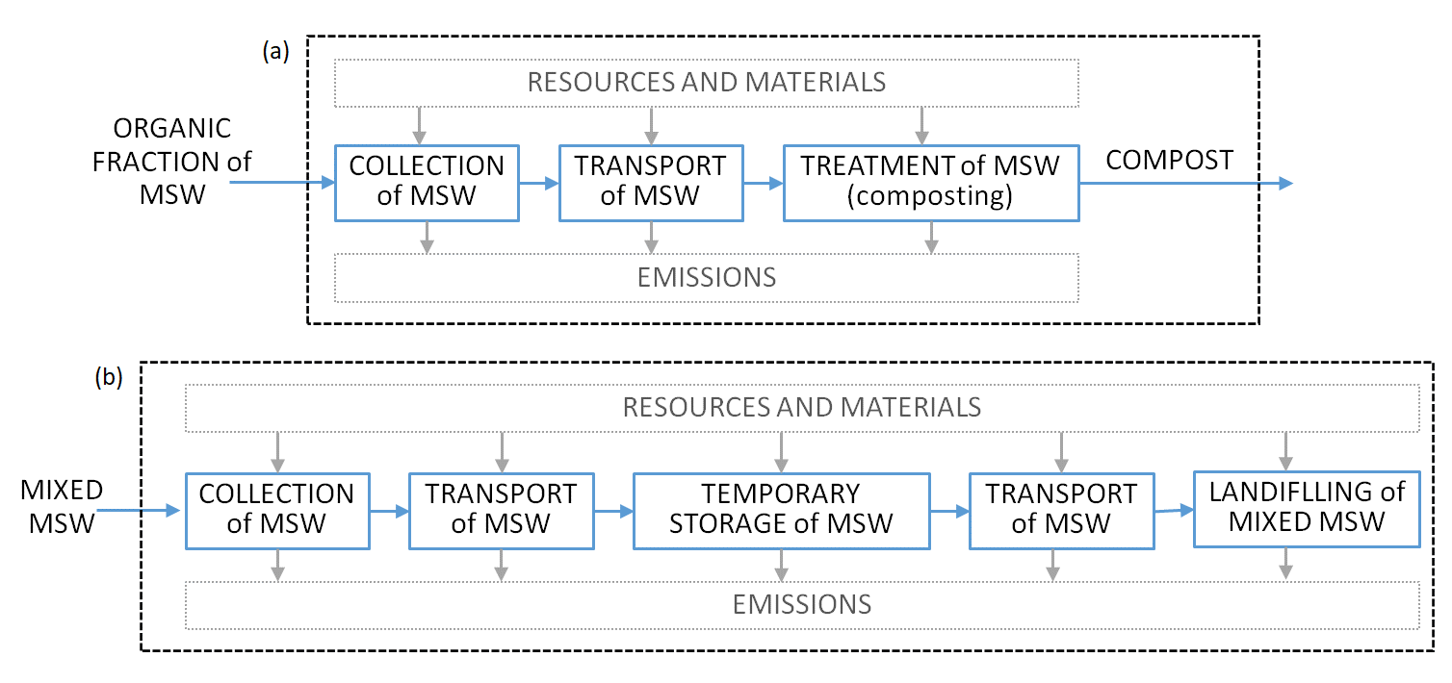
Fig. 1. System boundaries of (a) Fossalto and (b) Ist Island pilot actions.

The system boundaries were extended to encompass the whole organic waste chain: from the generation of waste (a zero burden approach was assumed, not including the generation of waste or the life cycle of the products before they became waste) to the treatment in the baseline scenario (Montagano composting facility for Fossalto, Diklo landfill in Zadar for Ist) or in the NETWAP scenario (electromechanical composter for both pilots), through the collection and transportation, up to the final disposal of residual waste. Finally, in order to evaluate the potential benefits linked to the different waste management strategies, a system expansion (or avoided burden approach) was also performed, including the avoided production of fertilizers for crediting the production of compost (1 ton of compost was assumed to substitute 23 kg of N-fertilizer, 9.5 kg of P-fertilizer and 9 kg of K-fertilizer, according to Ripa et al., 2017).
Regarding LCC, an environmental LCC (eLCC) was carried out applying the Environmental Priority Strategies (EPS) approach (version 2015dx) for the calculation of the externalities (Baumann & Tillman, 2004), consistently with the performed LCA.
Foreground data, i.e. specific information about material and energy flows related to the collection, transportation and treatment of the MSW organic fraction, were provided by Fossalto and Ist Island Municipalities. For the NETWAP scenario, since only preliminary experimental data were available, data referring to energy and material requirements, emissions and compost production were gathered from a previous composting campaign, based on an electromechanical composter similar to those installed in the pilot territories. For background data, the EcoInvent v.3.5 database (allocation at point of substitution, dataset of unit processes) was chosen. Data about the treatment of organic waste in a composting industrial plant were derived from the Ecoinvent database, as well as the environmental impacts generated from infrastructures and transport.
The ReCiPe Midpoint (H) included in the professional software SimaPro v.9.0.0.48 (PRé, 2022), was selected to investigate the following midpoint impact categories (Goedkoop et al, 2009): Global warming potential (GWP, in kg CO₂ eq), Fine particulate matter formation potential (PMFP, in kg PM2.5 eq), Terrestrial acidification potential (TAP, in kg SO₂ eq), Freshwater eutrophication potential (FEP, in kg P eq), Marine eutrophication potential (MEP, in kg P eq), Human carcinogenic toxicity potential (HTPc, in kg 1,4-DCB), Mineral resource scarcity potential (MRS, in kg Cu eq), Fossil resource scarcity potential (FRS, in kg oil eq).
For the eLCC, impacts from emissions and use of resources which cause significant changes in any of the safeguard subjects (i.e. areas of protection: Ecosystem Services – ES, Access to Water – AW, Abiotic Resources – AR, Human Health – HH, BioDiversity – BD), were investigated. The results of the impact assessment method are monetary values (monetarization) of environmental impacts from emissions and use of resources, indicated as damage costs and expressed as ELU (Environmental Load Units). One ELU represents an externality corresponding to 1 Euro that an average OECD-inhabitant, having the impacts on her/himself, is willing to pay to avoid environmental damage.

Results and discussions
The relative impacts, generated by the treatment of 1 ton of organic waste in the baseline and NETWAP scenarios of Fossalto and Ist Island, on a selection of impact categories, are shown in Figure 2.
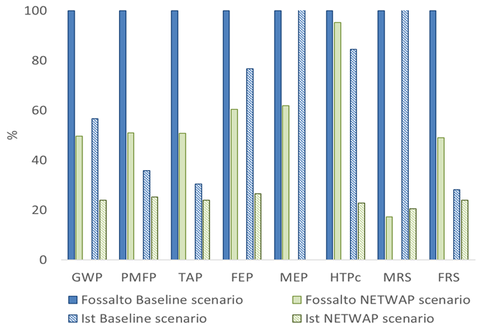
Fig. 2. A comparative analysis of the baseline and NETWAP scenarios investigated in Fossalto and Ist Island pilot territories.

Concerning the baseline scenarios, the impacts generated in Fossalto are generally higher than the impacts in Ist Island, except for MEP and MRS impact categories, that are the ones mostly affected by landfilling and by the temporary storage of waste. Transportation of waste by truck is the main hotspot in the baseline scenario of Fossalto, while the transportation by ship needed for the organic waste in Ist Island does not affect the investigated impact categories at the same level.
In the NETWAP scenarios, the reduction of the impacts is particularly relevant in the MRS impact category (83% for both Fossalto and Ist Island) and similar reductions are achieved also in the GWP category (50% in Fossalto versus 58% in Ist). A relevant difference can be noticed in the HTP_{c} impact category: in Ist Island the reduction of the impact amounts to 73%, while is limited to 5% in Fossalto. Analogously, the impact on MEP category is totally cancelled in Ist pilot, while only reduced by 38% in Fossalto. On the contrary, Fossalto gains slightly higher savings than Ist Island in PMFP, TAP and FRS impact categories.
Regarding the generated externalities, the environmental damage costs are shown in Table 1 for the baseline and NETWAP scenarios. The total environmental damage cost of baseline scenarios amounts to 5,847 ELU/FU in Fossalto versus 7,645 ELU/FU in Ist Island, while the values are reduced to 877 ELU/FU and 1,147 ELU/FU in Fossalto and Ist Island NETWAP scenarios, respectively. In all the investigated systems, the safeguard subject of Abiotic resources determines most of the external costs. In detail, the effect of the materials used for the containers of the deposit station, where organic waste is temporarily stored on the island, is strong enough to make the externalities of Ist Island higher than in Fossalto. Nevertheless, since most of the externalities are generated by the transportation of waste, as already highlighted for the environmental impacts by LCA, the implementation of the NETWAP pilot actions lower the total damage costs generated in both territories.

Table 1. Environmental damage costs for the baseline and NETWAP scenarios in Fossalto and Ist Island, referring to the selected FU (1 ton of treated organic waste)
Safeguard subject | Unit | Fossalto baseline | Fossalto NETWAP | Ist Island baseline | Ist Island NETWAP
Ecosystem services | ELU | 10.47 | 5.42 | 2.68 | 2.60
Access to water | ELU | 0.65 | 0.33 | 0.16 | 0.16
Biodiversity | ELU | 0.04 | 0.02 | 0.01 | 0.01
Human health | ELU | 473.36 | 222.12 | 132.54 | 111.51
Abiotic resources | ELU | 5,362.15 | 649.21 | 7,509.17 | 1,032.78
TOTAL | ELU | 5,846.67 | 877.10 | 7,644.57 | 1,147.05

Conclusions
This study analyzed the waste management systems in two reference territories representative of “small communities”, considering the baseline scenarios and the scenarios proposed within the NETWAP project. Results showed that a “local and tailored” management system is characterized by a significant environmental impacts improvement, also in terms of externalities. The solution proposed within the NETWAP project, in fact, not only reduces or eliminates common waste management hotspot (i.e. waste transportation by truck and by ship), but also affects other specific territorial hotspots, such as the temporary storage of waste and the landfilling. Results, in general, also confirmed life cycle-based evaluations as very valuable tools for decision-makers to better understand benefits and costs of waste management policies.

References
Baumann H, Tillman AM (2004) A Hitch Hikers guide to LCA- An orientation in life cycle assessment methodology and application. Edition 1:3. Lund: Studentlitteratur AB
EEA (2020) Bio-waste in Europe – turning challenges into opportunities. European Environment Agency, Luxembourg. https://doi.org/10.2800/630938
EC (2010) European Commission - Joint Research Centre - Institute for Environment and Sustainability: International Reference Life Cycle Data System (ILCD) Handbook - General guide for Life Cycle Assessment - Detailed guidance. First edition March 2010. EUR 24708 EN. Luxembourg. Publications Office of the European Union; 2010
Ekvall T, Assefa G, Björklund A, Eriksson O, Finnveden G (2007) What life-cycle assessment does and does not do in assessments of waste management. Waste Management 27, 989-996. https://doi.org/10.1016/j.wasman.2007.02.015
Goedkoop M, Heijungs R, Huijbregts M, DeSchryver A, Struijs J, VanZelm R (2009) ReCiPe 2008 — a life cycle impact assessment method which comprises harmonised category indicators at the midpoint and the endpoint level. Report I: Characterisation. Den Haag. https://doi.org/10.13140/RG.2.1.4872.6640
HR (2020) Government of the Republic of Croatia - Waste Management Plan of the Republic of Croatia for the period 2017-2022.
ISO (2006, a). ISO 14040 - Environmental Management and Life Cycle Assessment and Principles and Framework. International Organization for Standardization, Geneva, Switzerland
ISO (2006, b). ISO 14044 - Environmental Management - Life Cycle Assessment - Requirements and Guidelines. International Organization for Standardization, Geneva, Switzerland
PRé (2022) SimaPro software. https://simapro.com. Accessed 24 May 2022
Ripa M, Fiorentino G, Vacca V, Ulgiati S (2017). The relevance of site-specific data in Life Cycle Assessment (LCA). The case of the municipal solid waste management in the metropolitan city of Naples (Italy). Journal of Cleaner Production 142, 445–460. https://doi.org/10.1016/j.jclepro.2016.09.149

