Chapter N 053
Carbon, Water and Energy Footprint. A sustainability assessment for fruit & vegetable losses in Italy

Abstract. According to Boston Consulting Group, by 2050, food losses and waste (FLW) could reach 2.1 billion tons, up +40% from the estimates by the FAO in 2011. So, reducing FLW becomes important, not only because of the social and economic impacts they cause but also because when food is lost or wasted, so many resources used in its production are also wasted, as well as large amounts of greenhouse gas emissions (GHGs) are also emitted. Therefore, linking the resource depletion and emissions generated to the production of that food that will be lost or wasted could help to frame the extent of the problem. In this study, therefore, an assessment of the environmental impacts related to fruit and vegetable losses in Italy was carried out through the Carbon and Water Footprint and Cumulative Energy Demand in order to link, based on available data and databases, resource depletion (water and energy) as well as GHGs to the production of that food that was lost in Italy between 2019 and 2020, especially taking fruit and vegetable losses as a reference. The results show that between 2019 and 2020, horticultural losses decreased, which induced a reduction in CF by ‒24% and WF and CED by ‒40%. This could save and avoid significant amounts of emissions, water, and energy, and could thus fit into the context of achieving some national and international goals, as the European Green Deal, SDGs, and Directive 2000/60/EC.

Keywords. Carbon Footprint, Water Footprint, Cumulative Energy Demand, Italy, Food Losses, Sustainability

Introduction
As recently estimated by the Food and Agriculture Organization (FAO), the agri-food sector annually causes about 16.5 billion tons of greenhouse gases (GHGs) (including 400 million tons of CO₂ eq in Europe) (European Environment Agency, 2021) corresponding to 31% of total anthropogenic emissions, as well as the depletion of significant amounts of natural resources, including water, soil, energy, fossil fuels and fertilizers (Tubiello et al., 2022). Agri-food production, therefore, has a great impact on the environment, whether food is consumed or not, and in a context of competition for limited natural resources, FLW is a particularly sensitive issue, as well as a threat to the livelihood of future generations. The management of FLW is taken up in the 17 Sustainable Development Goals (SDGs), especially in sub-goal 12.3 (halve global food waste per capita by 2030). To date, in reality, very little progress has been made, and even risks going in the opposite direction, so much so that according to the Boston Consulting Group (2018), by 2050, FLW could reach 2.1 billion tons, up +40% from the figures estimated by the FAO in 2011 (Gustavsson et al., 2011). In the face of this, reducing FLW becomes important, not only because of the social and economic impacts (BCG, 2018) that they cause but also because when food is lost or wasted, so many resources such as water, energy, fossil fuels, fertilizers used in its production are also wasted (FAO, 2013). Therefore, linking resource depletion and the emissions generated to the food production that will be lost or wasted could help frame the problem's extent. This is also part of the ambitions set out in the European Green Deal, which aims to make Europe climate neutral by 2050, and a key to this could be reducing emissions from the agricultural sector by reducing leakage. In this study, therefore, an assessment of environmental impacts related to food losses in Italy was carried out, and Carbon Footprint (CF) (IPCC, 2006), Water Footprint (WF) (Mekkonnen & Hoekstra, 2011) and Cumulative Energy Demand (CED) (VDI, 1997) were used for this purpose. The objective was to link, based on available data and databases, resource depletion (water and energy) as well as GHGs emissions to the production of that food lost in Italy between 2019 and 2020 (pre- and post-pandemic), especially taking fruit and vegetable losses as a reference. The data used within the study were compiled based on fruit and vegetable production in Italy (ISTAT, 2021), and thus fruit and vegetable losses as of 2019 and those as of 2020 were considered. Due to the limited availability of data, some foods were excluded, while due to the absence of a specific database for Italian fruit and vegetable production, it was assumed to consider international databases that estimate an average production of a given type of food globally.

Material and methods
  - Methods

Carbon Footprint
CF expresses in kg CO₂ eq the direct and indirect climate-change emissions caused by a product or process, taking Carbon Dioxide (CO₂), Methane (CH₄), Nitrous Oxide (N₂O), Hydrocarbons, Hydrofluorocarbons (HFCs), Sulfur Hexafluoride (SF₆) and Perfluorocarbons (PFCs) as a reference (IPCC, 2006), and calculated in accordance with Forster et al. (2007) (eq.1)

$CF=\sum{{(G.G.}_{i} × k_{i})}$ (1)

Where G.G._{i} is the amount of GHGs produced and k_{i} is the CO₂ eq coefficient for that gas.

Water Footprint
WF (i.e., the direct and indirect use of freshwater required to arrive at the production of a good) was calculated following the framework of Mekonnen and Hoekstra et al. (2011) as the sum of the blue (WF_{blue}), green (WF_{green}), and grey (WF_{grey}) water footprint of the i-th agri-food products (eq. 2).

$WF= \sum{{(WF}_{i, blue}+ {WF}_{i, green}+ }{WF}_{i, grey}$) (2)

Specifically, WF_{blue} is the freshwater withdrawal from a reservoir that does not return directly to where it was withdrawn, WF_{green} is the amount of rainwater used by a crop to evapotranspire, and WF_{grey} is the volume of water needed to dilute pollutants generated during the production cycle below certain legal and toxicological limits.

Cumulative Energy Demand
The CED of a product represents the direct and indirect energy use during its entire life cycle, including energy consumed during the extraction, production, and disposal of raw and auxiliary materials (VDI, 1997). In this study, for each product, cumulative fossil energy demand, i.e., from hard coal, lignite, natural gas, and crude oil, was calculated based on the methodology proposed by Frischknecht and Jungbluth (2004)

  - Materials
Two cases were considered for the assessment: fruit and vegetable losses in Italy as of 2019 and 2020. It is good to clarify the distinction that ISTAT makes in fruit and vegetable production between total production and harvested production. By total production, it means the "totality of the product present on the plant in the hanging fruit state at the time when normal harvesting operations have begun". Harvested production, on the other hand, means the "quantity of a product actually removed from the place of production regardless of its use". Thus, harvested production turns out to be equal to the difference between total production and the share not harvested or lost. In contrast, food losses can be understood as the difference between total production and harvested production. As shown in Table 1, in 2020 vegetable losses were about 843 thousand tons, while in 2019 they were about 865 thousand tons. In fruit production, in 2020 in Italy, the losses were 436 thousand tons compared to 2019 when the losses were 485 thousand. Therefore, considering total fruit and vegetables, food losses in 2019 were about 1.35 million tons, while in 2020 they were about 1.27 million tons, with a reduction of 72,315 tons (‒5%), although food production increased. The first point that can be made is that assuming the average consumption of 160 kg/year of fruits and vegetables in Italy, avoiding 72,315 tons of fruit and vegetable losses could have fed 451,000 more people. However, it is noteworthy that, as a percentage, in both 2019 and 2020, the ratio of quantity produced to quantity lost is the same or about 3%. The reduction shown could most likely be attributable to the fact that the Lockdown following the Covid-19 emergency, has led to a greater need for food and therefore a greater focus on agricultural losses.

Table 1. Fruit and vegetable production in Italy, 2019 – 2020 (Million tons)
 | 2019 |  |  | 2020
 | Production | Harvest | Losses | Production | Harvest | Losses
Vegetables | 30.6 | 29.7 | 0.865 | 31.4 | 30.5 | 0.843
Fruits | 13.0 | 12.5 | 0.485 | 13.1 | 12.6 | 0.435
Total | 43.6 | 42.3 | 1.35 | 44.5 | 43.2 | 1.27
Source: (ISTAT, 2021)

In all three assessments, fruit and vegetable productions lost for both the years, 2020 (1.35 million tons of fruit and vegetables) and 2019 (1.28 million tons) were considered as functional units. The two situations were then compared, and CF, WF and CED were conducted from cradle to farmgate, i.e., considering the production process from seed purchase to ripening, excluding harvesting of the finished product. Specifically, all individual fruit and vegetable products (and their related production processes) that contribute to agricultural losses of fruits and vegetables in Italy were considered as inputs, and the total amount of fruit and vegetable losses, as well as emissions from production processes, were considered as outputs. As a matter of data availability, rice, artichokes, eggplants, figs, prickly pears, and beans, which are not in any database, were excluded from fruit and vegetable losses. In addition, since at the moment there is still no specific database for Italian fruit and vegetable production, a database that will see the light of day in 2023 (Notarnicola et al., 2021), the average production of a given type of food at the global level was considered in the study by taking international databases as a reference.

- Results and discussions
Analysis of the results shows that food losses in 2019 generated a CF of 3.16 × 10⁸ kg CO₂ eq. while in 2020 the CF was 2.55 × 10⁸ kg CO₂ eq (Figure 1). Therefore, between 2019 and 2020, the reduction in fruit and vegetable losses, could have induced a saving of ‒6.10 × 10⁷ kg CO₂ eq, or a reduction of ‒24%. Especially, this reduction could be attributable to less wastage of inputs, including less use of fuels, nitrogen fertilizers, pesticides and irrigation water.
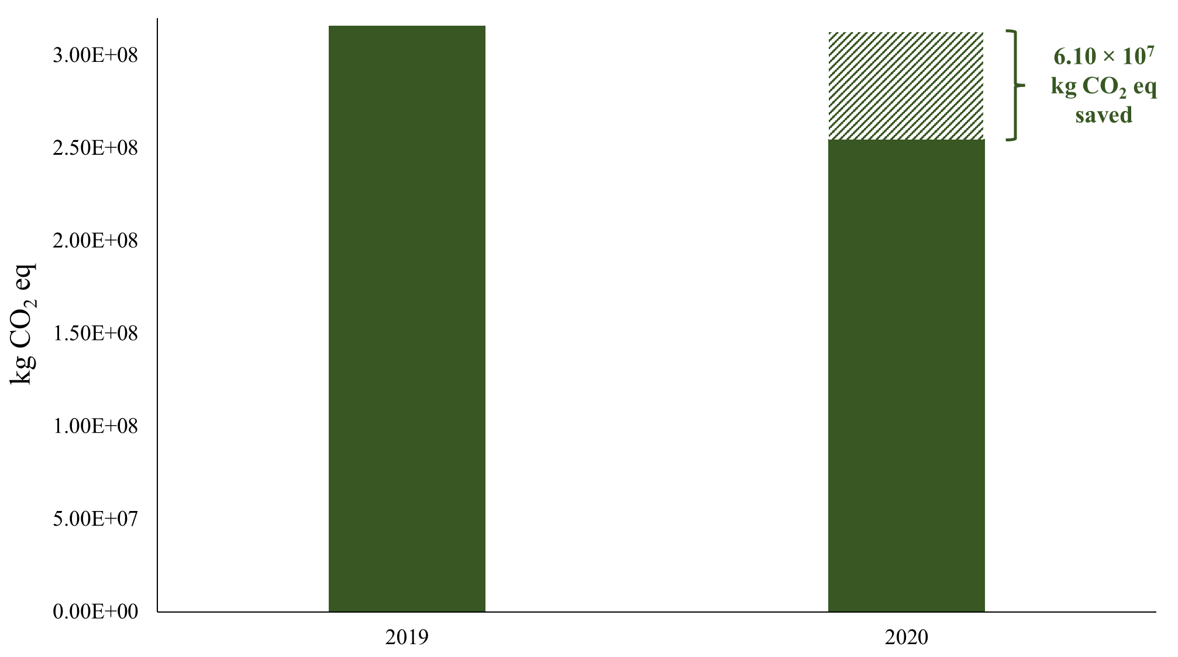
Fig 1. Carbon Footprint of fruit and vegetable losses in Italy (2019 and 2020)
Especially, the mechanization of fields is a significant source of climate-changing emissions due to the extraction of primary energy sources (crude oil and fossil carbon) for diesel production and its combustion during the agricultural phase (Morandini et al., 2020). Fertilizers, on the other hand, being synthetic products generate direct impacts related to their production processes and indirect impacts related to their use, since the nitrogen present in them, as is well known, tends to dissipate, either into the water in the form of nitrates or into the atmosphere as N₂O. To give an idea, the production, transportation and application of fertilizers make the synthetic fertilizer industry responsible for the emission of 1.25 billion tons of CO₂ per year (25% of the agricultural sector's emission contribution) (Menegat et al., 2021). Regarding the lower water consumption, finally, irrigation processes being highly energy intensive, have a high environmental impact due to the process of electricity production, which in the case of the Italian mix, despite coming for a 41.74% share from renewable sources, remains mainly composed of natural gas (methane) (43.2%), coal (7.9%), nuclear (3.55%), oil (0.50%) and other sources (3.1%) (GSE, 2022). Energy production, therefore, being based on the use of fossil fuels, is responsible for the direct emission of GHGs from, for example, lignite and bituminous coal from mines that are used for the electricity generation mix, and consumed for water pumping (Dincer & Bicer, 2018), which inevitably affect the GWP, as well as particulate matter. The CF results show the importance of reducing horticultural losses, as potential savings in terms of GHGs emissions could be particularly significant, especially considering that in Italy, the average annual temperature has already increased by +1.1°C in the last 30 years (1981-2010) compared to the 30-year period 1971-2000 (ISPRA, 2013). Moreover, variations in climate could exacerbate this situation even more, with predictive studies (Michetti et al, 2022) showing that in Italy between 2021 and 2050 there could be an increase of +2°C compared to 1981-2010 and +5°C by 2100, with even worse scenarios, such as higher intensity rainfall, more frequent in winter in the North and less frequent in summer in the Centre-South, tropical nights (with temperatures never below 20°C), prolonged droughts and sea level rise (6 cm for the Adriatic and 8 cm for the Tyrrhenian Sea). Therefore, in the context of the pursuit of climate neutrality, also in view of the dialogue on the zero-emission measure, approved by the European Parliament (but subject to a further negotiation phase) that aims to halt the production of endothermic-powered cars by 2035, a reduction in horticultural leakage could help to cut even more of a share of climate-altering emissions that could be avoidable. The CF results are also confirmed in the reduction of WF. In fact, the analysis of the results shows that horticultural losses in 2019 generated a WF of 1.37 × 10⁸ m³ while in 2020 the WF was 9.79 × 10⁷ m³ (Figure 2), a saving of 3.91 × 10⁷ m³ of water and a reduction of ‒40%. Water scarcity is a particularly sensitive problem especially in the Mediterranean area (which suffers from the highest level of water stress globally) as well as in Italy, which ranks first in Europe in terms of water withdrawals for drinking (9 billion m³/year) (ISTAT, 2018) and is ranked among European Countries with medium to high water stress (Luo et al, 2015). Therefore, the decrease in horticultural losses shows how water could potentially be "saved" by reducing total WF. Thus, induced water savings, in turn, could be particularly helpful for Italy, especially in view of achieving the objectives set by the Water Framework Directive (2000/60/EC), which requires member states, to achieve good qualitative and quantitative status of water bodies by 2027, but also in the pursuit of SDGs by 2030, especially sub-goals 6.4.1 (Water Stress) and 6.4.2. (Water Efficiency), the latter still far from being fully met.

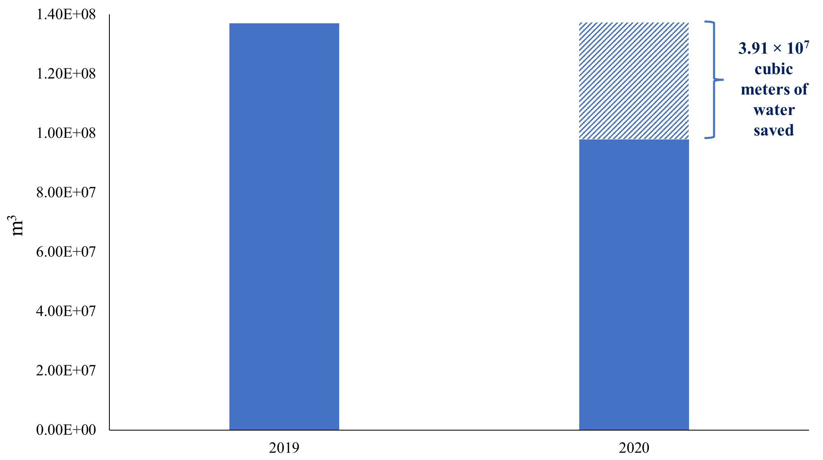
Fig 2. Water Footprint of fruit and vegetable losses in Italy (2019 and 2020)
Finally, regarding CED, the study results show how a reduction in horticultural losses could induce "savings" of 2.25 × 10⁹ MJ eq (‒40%), from 8.94 × 10⁹ (2019) to 6.69 × 10⁹ (2020) (Figure 3).

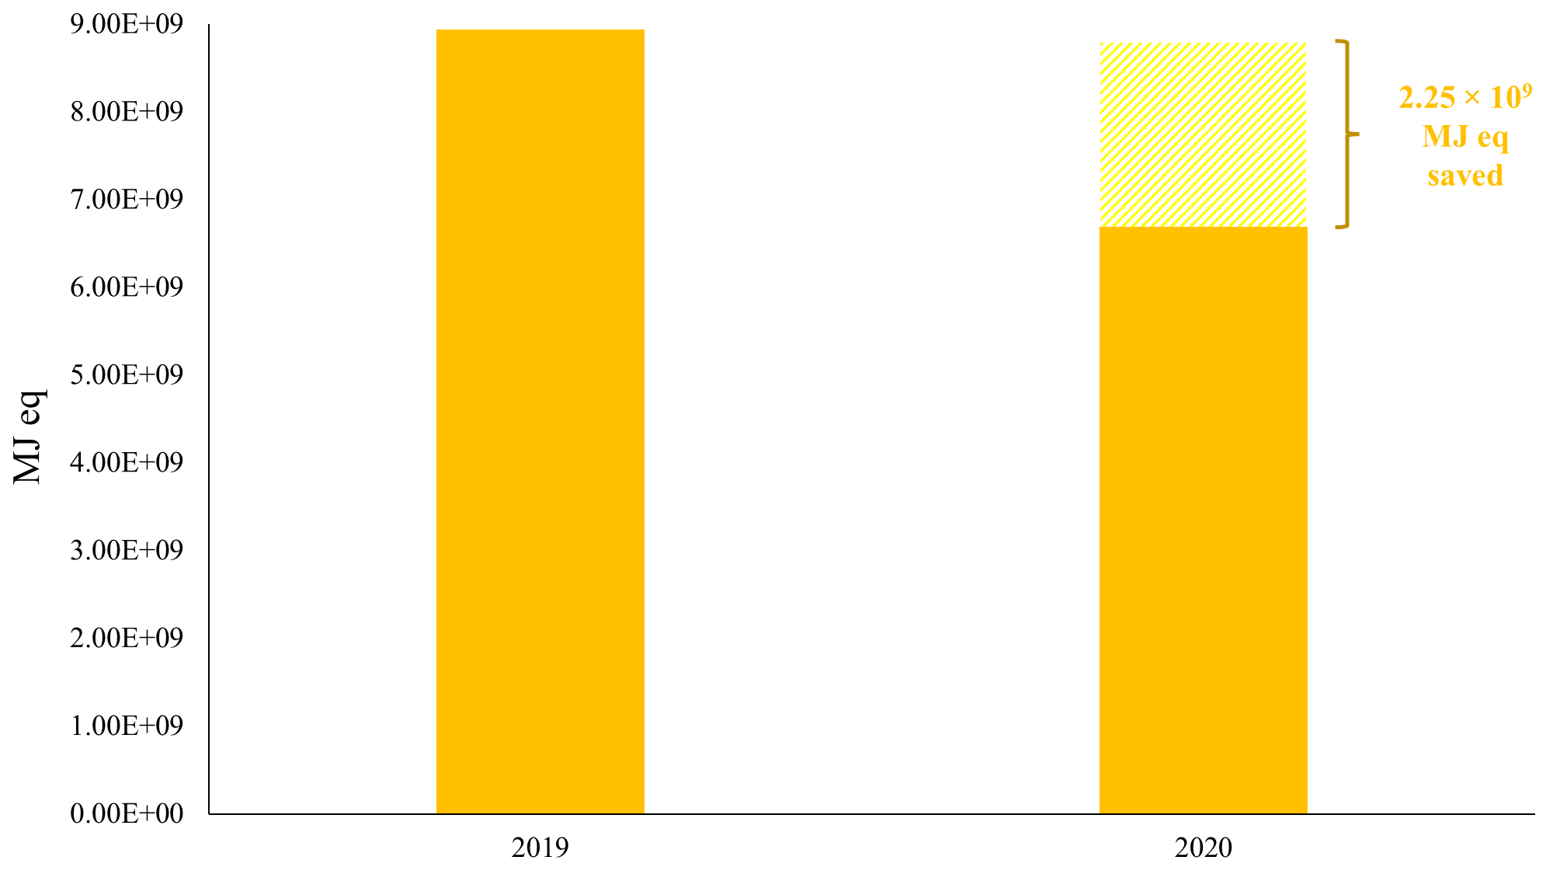
Fig 3. CED of fruit and vegetable losses in Italy (2019 and 2020)
Reducing the CED, expresses, even more, the importance of energy source management, even considering the current period, characterized by the energy crisis following the war in Ukraine and inflated electricity prices that should push countries, even more, to accelerate the green transition. However, already in the aftermath of the Covid-19 pandemic, the transition to renewable energy had slowed down for the first time, and of the €14 trillion spent by G20 Countries on economic stimulus measures, only 6% went to cutting emissions. Moreover, in the European Union, energy production from coal increased by +18% in 2021, the first time in a decade, and in the next 20 years, Russia will most likely continue to export to Europe via the Nord Stream pipeline. At this rate, according to the latest IPCC report, we are heading toward a +3.2°C rise in temperatures by 2100, more than double the 1.5°C that states have repeatedly pledged to achieve. Instead, research and investment will have to move in the opposite direction, through the creation of plants that provide high-density renewable energy, which cannot be obtained 100% from renewables, since the energy they provide is sometimes intermittent. Investment in renewables is, therefore, necessary precisely because high gas prices and inflated hydrocarbon prices make alternative sources economic in the long run, and also because the need for energy security increases the urgency of addressing climate change.

  - Estimation of a social cost: CF and WF
Based on the results, in order to gain an even better understanding of the extent of horticultural losses in Italy, it might be possible to quantify a possible social cost associated with them. The basic idea is to give CO₂ emissions and consumed water a market value that reflects the price they cost society, based on the shadow price theory (the price of a good in the absence of a market but determined on the basis of the impacts on society of that good or on the basis of its scarcity). Regarding CF, recently the European Bank for Reconstruction and Development (EBRD) has theorized a model whereby it suggests that the price of Carbon should be set at 40-80€/ton for 2020 and 50-100€ for 2030. Thus, considering the losses to 2020 and the above shadow prices, if a price were to be applied to the emissions caused by horticultural losses, they would lead to a social cost of between €10.2-20.4 million, with a per capita social cost of between €0.17-0.34 (Table 2).

Table 2. Per capita social cost of fruit and vegetable losses (CF).
 | 2019 | 2020
CF | 316,000 ton CO₂ eq | 255,000 ton CO₂ eq
Shadow price CO₂ | 40-80€/ton
Estimated social cost | 12.6-25.2 mln € | 10.2-20.4 mln €
Estimated per capita social cost | 0.21-0.42 € | 0.17-0.34 €

Regarding water, on the other hand, the shadow price was calculated based on the study by Ligthart and van Harmelen (2019) and is about € 5.17 for m³ of water, as shown in Table 3.

Table 3. Per capita social cost of fruit and vegetable losses (WF).
 | 2019 | 2020
WF | 137 mln m³ water | 97.9 mln m³ water
Shadow price water (€/m³) | 5,17 € for m³ water
Estimated social cost | 708.2 mln € | 506.1 mln €
Estimated per capita social cost | 11.80 € | 8.44 €

Taking losses to 2020 and considering the shadow price of water, they could have induced a social cost of € 506 million, or € 8.44 per capita, down by ‒29 % compared to 2019.

Conclusions
The results of the study show the apparent unsustainability of a share of food losses in Italy. Especially, between 2019 and 2020, the decrease in fruit and vegetable losses could have induced a reduction in CF of ‒24% and WF and CED of ‒40% in both cases. Although with some limitations, this study shows through potential quantification how a reduction in fruit and vegetable losses could "save" and avoid significant amounts of emissions, water and energy, which (in the latter two cases) could be directed elsewhere and could thus fit into a context of achieving some national and international goals (European Green Deal, SDGs, Directive 2000/60/EC). But such reductions could also be of considerable help in relation to the current global commodity crisis induced by the situation between Russia and Ukraine, from the crisis of which a chain effect could be generated related to price volatility, and increased cost of fuels, which would make the production of other commodities and other goods more difficult.

References

Boston Consulting Group (2018). Tackling the 1.6-Billion-Ton Food Loss and Waste Crisis. Available online at: https://www.bcg.com/publications/2018/tackling-1.6-billion-ton-food-loss-and-waste-crisis. Accessed on June 23, 2022.
Dincer I., Bicer Y. (2018). 2.1 Ammonia. Comprehensive Energy Systems, 2–5, 1–39. https://doi.org/10.1016/B978-0-12-809597-3.00201-7
Directive 2000/60/EC of the European Parliament and of the Council of 23 October 2000 establishing a framework for Community action in the field of water policy. Available online at: https://eur-lex.europa.eu/legal-content/EN/TXT/?uri=celex%3A32000L0060. Accessed on June 23, 2022
European Bank for Reconstruction and Development (EBRD) (201 Energy Sector Strategy 2019-2023. As approved by the Board of Directors at their meeting of 12 December 2018. Available online at: https://www.ebrd.com/home. Accessed on June 28, 2022.
European Environment Agency (2021). Greenhouse gas emissions from agriculture in Europe. Available online at: https://www.eea.europa.eu/ims/greenhouse-gas-emissions-from-agriculture. Accessed on June 23, 2022.
Food and Agriculture Organization (2013). Food Wastage Footprint: Impacts on Natural Resources. Rome: FAO. Available online at: http://www.fao.org/3/i3347e/i3347e.pdf. Accessed on June 12, 2022
Forster, P.; Artaxo, P. (2007). Changes in atmospheric Constituents and in Radiative Forcing. In Climate Change 2007: The Physical Science Basis. Contribution of Working Group I to the Fourth Assessment Report of the Intergovernmental Panel on Climate Change; Solomon, S., Qin, D., Manning, M., Chen, Z., Marquis, M., Averyt, K.B., Tignor, M., Miller, H.L., Eds.; Cambridge University Press: Cambridge, UK; New York, NY, USA
Frischknecht R., Jungbluth N. (2004). Implementation of Life Cycle Impact Assessment Methods. Data v1.1; Swiss Centre for Life Cycle Inventories: Dübendorf, 31−38.
Gestore dei servizi energetici (GSE) (2020). Fuel Mix, determinazione Del Mix Energetico Per Gli Anni 2019-2020. Available online at: https://www.gse.it/servizi-per-te/news/fuel-mix-determinazione-del-mix-energetico-per-gli-anni-2019-2020. Accessed on June 20, 2022
Gustavsson J., Cederberg C., Sonesson U., van Otterdijk R., Meybeck A. (2011). Global food losses and food waste: extent, causes and prevention. International Congress: Save Food! Available online at: http://www.fao.org/3/i2697e/i2697e.pdf. Accessed on June 12, 2022
Hoekstra A.Y., Chapagain A.K., Aldaya M.M., Hoekstra M. (2011). The Water Footprint Assessment Manual: Setting the Global Standard. Available online at: https://waterfootprint.org/media/downloads/TheWaterFootprintAssessmentManual_2.pdf. Accessed on June 12, 2022
Intergovernmental Panel on Climate Change (IPCC) (2006). IPCC Guidelines for National Greenhouse Gas Inventories-Volume 3-Industrial Processes. Available online at: https://www.ipcc-nggip.iges.or.jp/. Accessed on June 12, 2022
ISTAT (2018). Prelievo di acqua per uso potabile. Available online at: http://dati.istat.it/Index.aspx?DataSetCode=DCCV_PRELACQ. Accessed on June 20, 2022.
Istituto Nazionale di statistica (2021). Superfici e produzione. Dati in complesso. Available online at: https://dati.istat.it/Index.aspx?QueryId=16821. Accessed on June 12, 2022
Istituto Superiore per la Protezione e la Ricerca Ambientale (ISPRA) (2013). Variazioni e tendenze degli estremi di temperatura e precipitazioni in Italia. Stato dell’Ambiente 37/2013. ISBN 978-88-448-0599-9. Available online at: https://www.isprambiente.gov.it/files/pubblicazioni/statoambiente/SA_37_2013_indici_estremi.pdf. Accessed on June 20, 2022
Ligthart, T. N., & van Harmelen, T. (2019). Estimation of shadow prices of soil organic carbon depletion and freshwater depletion for use in LCA. International Journal of Life Cycle Assessment, 24(9), 1602-1619. doi:10.1007/s11367-019-01589-8
Luo T., R. Young, Reig P. (2015). Aqueduct projected water stress rankings. Technical note. Washington, DC: World Resources Institute, August 215. Available online at http://www.wri.org/publication/aqueduct-projected-water-stress-country-rankings. Accessed on June 20, 2022
Menegat S, Ledo A, Tirado R. (2021). Greenhouse gas emissions from global production and use of nitrogen synthetic fertilizers in agriculture. Research Square, DOI: 10.21203/rs.3.rs-1007419/v1.
Michetti M., Gualtieri M., Anav A., Adani M., Benassi B., Dalmastri C., D’Elia I., Piersanti A., Sannino G., Zanini G., Uccelli R. (2022). Climate change and air pollution: Translating their interplay into present and future mortality risk for Rome and Milan municipalities. Science of The Total Environment, 830, 154680. https://doi.org/10.1016/J.SCITOTENV.2022.154680
Morandini N. P., Petroudi E. R., Mobasser H. R., Dastan S. (2020). Life Cycle Assessment of Crop Rotation Systems on Rice Cultivars in Northern Iran. International Journal of Plant Production, 14(3). https://doi.org/10.1007/s42106-020-00103-7
Notarnicola B., Di Capua R., Astuto F. (2021). Il progetto ILCIDAF di sviluppo di un database italiano di Life Cycle Inventory di prodotti agroalimentari: stato dell’arte degli altri database e avanzamenti metodologici. In: Il Life Cycle Assessment per la valutazione della sostenibilità della filiera e dei prodotti agro-alimentari: sfide e nuove opportunità. Atti di convegno, 173-189, Edizioni Nuova Cultura. ISBN: 978-88-33654-44-7
Spano D., Mereu V., Bacciu V., Marras S., Trabucco A., Adinolf M., Barbato G., Bosello F., Breil M., Chiriacò M. V., Coppini G., Essenfelder A., Galluccio G., Lovato T., Marzi S., Masina S., Mercogliano P., Mysiak J., Noce S., Pal J., Reder A., Rianna G., Rizzo A., Santini M., Sini E., Staccione A., Villani V., Zavatarelli M. (2020). “Analisi del rischio. I cambiamenti climatici in Italia”. DOI: 10.25424/CMCC/ANALISI_DEL_RISCHIO. ISBN 978-88-97666-15-8 © Fondazione CMCC - Centro Euro-Mediterraneo sui Cambiamenti Climatici 2020
Tubiello F.N., Karl K. et al. (2022). Pre-and post-production processes increasingly dominate greenhouse gas emissions from agri-food systems. Earth System Science Data, 14, 1795–1809, 2022 https://doi.org/10.5194/essd-14-1795-2022
VDI (1997). Cumulative energy demand—terms, definitions, methods of calculation. VDI-Richtlinien 4600. Accessed on June 12, 2022

