Chapter 070
THE USE OF UNMANNED AERIAL SYSTEMS IN ENVIRONMENTAL MONITORING

Abstract. Environmental monitoring plays a central role in diagnosing the impacts, on the climate and other environmental receptors. Today, most monitoring and data collection systems are based on a combination of ground measurements, on surveys made by sensors mounted on manned aerial platforms and on satellite observations. Each of these systems has space-time constraints that could be overcome with the use of drones.
In this context, remotely piloted aircraft systems, also called drones or Unmanned Aerial Systems (UAS), have considerable potential to radically improve environmental monitoring.
This paper intends to provide an overview of the various fields of use of UAS in the context of environmental monitoring. The recent advances in sensor technology are highlighted by analyzing the different types of instruments on the market with their characteristics, including their use.
Then, the various applications in which drones can be used are explored, indicating the strengths and limitations encountered so far by the use of this technology.

Keywords. Environmental monitoring, drones, UAS

Introduction
Environmental monitoring plays a central role in diagnosing the impacts on climate and other environmental receptors. Today, most monitoring and data collection systems are based on a combination of ground measurements, on surveys made by sensors mounted on manned aerial platforms and on satellite observations. Each of these systems has space-time constraints that could be overcome with the use of drones. In this context, remotely piloted aircraft systems, also called drones or Unmanned Aerial Systems (UAS), have considerable potential to radically improve environmental monitoring. However, the use of this technology is still not widespread in environmental monitoring since various issues arise on the operational level that limit its application.
At the same time, we can see how the use of drones for the management of industrial sites, with specific reference to companies that deal with waste treatment and disposal, is constantly increasing. Nonetheless, there is still a clear gap if we compare this kind of use to the application of UAS for infrastructure inspection activities in the construction, energy and telecommunications or mining fields, sectors in which drones have been applied more and for a longer time. The use of drones in the field of environmental monitoring is certainly more recent but already shows a considerable variety of applications that require specific intervention protocols.
The aim of this work is to provide a state of the art on the use of drones in environmental monitoring.

Materials and methods
For this research, a selection and analysis of scientific publications was carried out using both the Scopus and the Google Scholar portals and using the following terms both individually and in combination, as keywords useful for finalising the search: "UAV", "environmental monitoring", "remote sensing", "UAS", "drones", "environmental survey", "monitoring of contaminated sites". The time range used refers to the years from 2010 to 2022 in order to exclude any applications prior to 2010, a period in which the sector was still in the experimentation phase using drones as simple vectors without sensors. The publications found and selected, as reported above, were then further screened with respect to the topics of the present research, namely the application of UAS based systems to environmental monitoring. After this last screening, we moved on to an in-depth analysis of the selected publications.

Results
The ever-increasing use of drones applied to environmental monitoring is evidenced by evaluating the number of publications on this topic in the time period from 2010 to 2022. From a first overview of the most popular instruments mounted on drones for the environmental monitoring, we have the use ot optical, multi and hyper spectral devices that acquire data in the visible, thermal and infrared fields. Ample space is dedicated especially from 2019 onwards to the application of LIDAR systems, dedicated to monitoring the territory through the acquisition of high-definition three-dimensional models useful for advanced territorial management. An important operational contribution to the world of surveying through UAS systems is then provided by the use of GPR (Ground Penetrating Radar) and magnetometers, tools frequently applied for monitoring the subsoil, in different scenarios and with various purposes, ranging from archaeological research to the identification of underground infrastructures in order to know their precise positioning, from the search for cavities and tunnels to the identification of ferrous materials buried underground.
Among the main fields of application of UAS systems there is the search for airborne pollutants in the atmosphere through aerosol counting instruments, particle counters and various types of sensors (TDLAS, NDIR, electrochemical sensors, PID) for monitoring a wide range of traceable pollutants in an airborne state especially in certain types of sites (Sliusar et al., 2022).
In addition to these applications extensively dealt with in scientific literature, there are also the monitoring and sampling of water in lakes, maritime or marshy environments, in which the difficult practicability enhances the versatility of drones. For this last class of use there is the presence of scientific literature starting from 2018 onwards, so we could define this last use together with the monitoring of airborne pollutants among the most recent uses in the panorama of applications described so far. The types of applications described above, which differ substantially in the type of sensor used, the type of survey workflow applied and in some cases the type of drone chosen as vector for the sensors, are operationally inserted in scenarios such as:

- Monitoring of air quality in outdoor environments
- Search and localization of illegal landfill sites
- Monitoring of marine, coastal, wooded or any other protected areas
- Monitoring of protected species such as anti-poaching control, observation of movements of animals and so on
- Control of the state of erosion for river or torrential waterways
- Control of coasts in terms of verifying the erosion of the dunes, the advancement of the coastline, etc.
- Monitoring of areas with significant hydrogeological risk, both for mapping reasons and in the phase of emergency situations, for example, to define the extent of a flood or to very quickly estimate the damage caused or procurable from a mudslide.

Each of these applications requires well-defined workflows, based on different phases of approach to the operational situation. Below three application cases will be examined in detail, through the use of different sensors, chosen from the aforementioned applications.

- Optical monitoring for the spatial analysis of landfill sites
A waste collection site, from aggregates to hazardous or non-hazardous special waste, often extends over fairly large surfaces whose orography is not always regular. Sometimes the orographic variations in altitude, that this type of site have, represent an obstacle to the fluid practicability of spaces for monitoring or survey purposes. In this regard, one of the most widespread uses of UAS is the spatial analysis, that is the definition of the spatial properties of a site through orthophoto framing using optical, graphic or photogrammetric media produced via drone.

The spatial properties to be monitored may concern the identification of mass accumulations in areas of definitive or temporary waste abandonment, for which it is essential, for example, to know the volumes; the control of the angles and the state of conservation of the landfill slopes, the control of the conservation state of the capping in areas with definitive coverage, the control of the correct installation of the closing covering for areas with temporary coverage, the optical monitoring for the control of any leachate leak points, the colonization of some areas by animal species, the onset of dangerous situations due to collapses or subsidence (Azimov et al., 2020). All these aspects, whose analysis is defined precisely as spatial analysis, can be framed, studied and correctly managed through high resolution outputs produced via drone. The same concepts are applicable not only to landfills but also to quarries and mining sites, characterized by considerable extensions that can be quickly and precisely monitored via drone. The image below represents a wide view of a specific sector falling within a much larger landfill site. From this photo, taken nadirally, i.e. with the camera forming an angle of 90° with respect to the horizontal axis of the drone, we can evaluate various technical elements for subsequent logistical and operational evaluations.

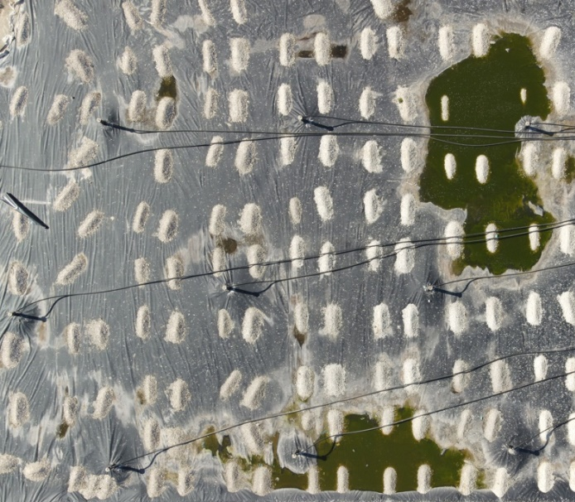
Fig. 1. Nadiral photo for identifying technical elements on a specific landfill sector

- Monitoring of a river bed by scanning with LIDAR system and reconstruction of a three-dimensional model

The LiDAR system (Light Detection And Raging) falls into the category of sensors defined as "active", that is, those sensors whose principle of reading and producing the data consists of a first defined emission phase and a subsequent reading phase of the message in return. LiDARs can be mounted on drones, but also on fixed-wing aircraft, airplanes, helicopters, cars or worn by specialized operators for monitoring roads, tunnels. The opportunity to mount LiDARs on drones derives precisely from the versatility of UAS systems that are able to intervene in inaccessible places if traveled on foot or by car but with management and operating costs generally lower than a classic aircraft such as an airplane or a helicopter. The LiDAR survey maps the environment in the direction in which the emitter is oriented (if downwards the LiDAR will map the environment below the drone) providing what is called a point cloud at the end of the survey.
The point cloud is the representation of an object or a scenario through points. By processing the point cloud using specific management software, it is possible to geo-reference and reconstruct the textures and arrive at a three-dimensional model that is perfectly and totally representative of the real state of the detected places. The survey of the riverbed, conducted in this way, allows to have a three-dimensional model, which can be defined as quoted and whose measurements obtained through specific software correspond to the real measures; this output is useful for monitoring the erosion state of the riverbed or for the calculation of the lowering volumes referring to the debris that the watercourse carries and deposits in the loops or in other specific points (Messinger et al., 2016). This kind of survey also makes it possible to map the depth of the riverbed, the presence of any unauthorized infrastructures, the flow rates and any other element necessary for the targeted and conscious management of that specific portion of the territory in terms of ordinary and predictive maintenance.

- Monitoring aimed at detecting fugitive emissions of methane from landfills

One of the most recent applications of UAS systems dedicated to environmental monitoring is the survey aimed at identifying the presence of airborne pollutants with contextual quantification of the concentrations in which they are present. This activity can be carried out with different types of instrumentation that involve the use of electrochemical sensors, PID, NDIR, TDLAS and more (Allen et al., 2019). The example of use described below consists of measuring the concentrations of methane contained in biogas escaping from fugitive emissions using a sensor with TDLAS technology (Tunable Diode Laser Absorption Spectroscopy), i.e. a technology that uses the emission of a laser beam having a precise frequency and which, by measuring the return laser beam, reflected by the landfill soil, by means of a special receiver, calculates the delta between the emitted and the reflected beam, translating it into methane concentration. Fig. 2 shows the example of a map graphic product created through post production of a dataset obtained from the UAS system and TDLAS sensor containing the methane concentrations detected on a portion of the landfill (Tassielli et al., 2021).

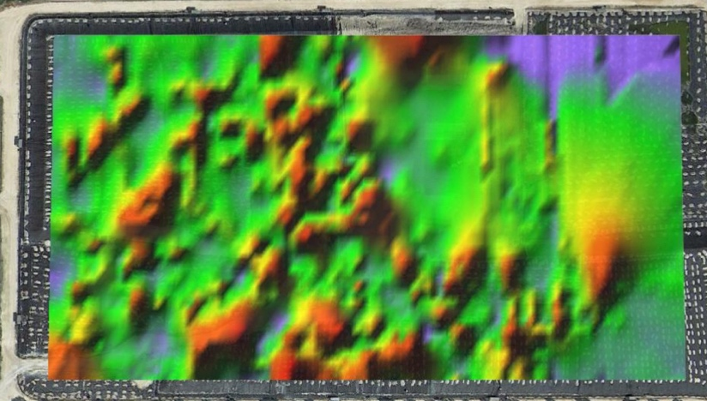

Fig. 2. Graph of the representation of methane concentrations using a chromatic scale on an orthophoto map support

Conclusions
The overview illustrated has highlighted that there are more and more applications of drones (and the monitoring technology they transport) to environmental monitoring.
The increasingly frequent application of various survey methods and the considerable scientific literature is evidence of repeated experimentation activities in the field that are allowing the standardization of certain parameters with a consequent improvement in the monitoring activity via drone as a whole.
The issue mainly highlighted by the overview appears to be the absence of standardized and well-defined protocols that could guide the operators from the preliminary stages of desk study and survey design to the implementation phase of the activity on the field and to post processing and critical analysis of the data produced.

References
Allen, G., Hollingsworth, P., Kabbabe, K., Pitt, J., Mead, M., Illingworth, S., Roberts, G., Bourn, M., Shallcross, D., Percival, C., 2019. The development and trial of an unmanned aerial system for the measurement of methane flux from landfill and greenhouse gas emission hotspots. Waste Manag. 87, 883–892.
Azimov, O., Shevchuk, O., Azimova, K., Dorofey, Y., Tomchenko, O., 2020. Integration of GIS and RSE aiming to the effective monitoring of the surroundings of landfills. Ukrainian J. Remote Sens. 27, 4–12.
Messinger, M., Silman, M., 2016. Unmanned aerial vehicles for the assessment and monitoring of environmental contamination: an example from coal ash spills. Environ. Pollut. 218, 889–894.
Sliusar N., T. Filkin, M. Huber-Humer, M. Ritzkowski, 2022. Drone technology in municipal solid waste management and landfilling: A comprehensive review. Waste Management 139 (2022) 1–16.
Tassielli G., Notarnicola B., Renzulli P.A., Di Capua R., De Molfetta M., 2021. Monitoraggio delle emissioni diffuse di biogas da discarica attraverso sensori di metano montati su UAV. Atti di Ecomondo 2021, Green and circular economy: ricerca, innovazione e nuove opportunità. Rimini, 26-29 ottobre 2021.

