Chapter 073

Environmental accounting for the circularization of the packaged water sector in Italy

**Abstract.** Packaged water is one of the fastest growing commodities on a global scale, with significant repercussions from an environmental, economic and social perspective. Worldwide, the total annual consumption of water is estimated at approx. 390 billion liters, corresponding to over 155 billion euros. In this context, Italy plays an important role, being the eighth country for total consumption, estimated in 2020 at over 14 billion liters, and second for per capita consumption, equal to 222 liters. Under the economic perspective, its value equals approx. 2,800 million euros. In Italy, over 82% of the water is packaged in plastic bottles, while 16% in glass bottles and only 2% in plastic jugs, cardboard briks or aluminium cans. The present research applies the material flow analysis to the national packaged water sector as to measure the material flows associated with the entire packaged water sector in Italy. Although cardboard briks and aluminum cans could represent a more sustainable solution from an environmental point of view in the long term, plastic packaging guarantees numerous socio-economic advantages, namely economic convenience, easy portability and widespread distribution of the product. The research discusses possible circularization strategies in the packaged water sector, providing useful research directions to practitioners and academics.

**Keywords.** Environmental accounting, circular economy, packaged water, material flow analysis, environmental sustainability

# Introduction

Overall, bottled water represents one of the fastest-growing commodities (Etale et al., 2018) and, although tap water is safer, more accessible and cheaper, and its environmental impacts have been assessed as lower than bottled water, packaged water continues to be preferred by consumers (Geerts et al., 2020). Water is the most consumed packaged beverage all around the world, accounting for over 450 billion L (Statista, 2022), due to several reasons, mainly the modified consumption habits, as well as psychological factors and taste (Palomero-González et al., 2022). At the European level, the consumption of bottled water is estimated at 118 L per person per year (Statista, 2022) and Italy represents the leading market, accounting for over 200 L per person per year. Italy has produced more than 14,500 million L (ML) in 2020 (Acquaitalia, 2022), packaged as follows: (a) 11,890 ML in plastic bottles (82%); (b) 2,320 ML in glass bottled (16%); and (c) 290 ML in big bottles, briks and cans (2%). Plastic bottles are mainly composed of polyethylene terephthalate (PET), whereas their size passes from 0.5 L to 1.5 L, with increasing quantities of water sold in 2 L bottles (Lagioia et al., 2012; San Benedetto, 2017; Ferrarelle, 2019, Acquaitalia, 2022). It is estimated that of the entire amount of sorted plastic bottles, over 46% are recycled, whereas 40% are addressed to incineration with energy recovery. As concern water glass bottles consumption, the most widely used size is 1 L bottle, the estimated glass bottle recycling rate reaches over 77% (Consorzio Nazionale Imballaggi, 2020; Fondazione per lo sviluppo sostenibile and FISE UNICIRCULAR, 2021) and in the last years, the returnable bottles practice has recorded remarkable increase (San Benedetto, 2017; Ferrarelle, 2019; Coelho et al., 2020). A marginal but interesting role is played by the so-called plastic jugs (big PET bottles from 3 to 20 L); briks composed on average of 75% paper, 20% of low-density polyethylene (LDPE) and 5% of aluminum (Zawakiak et al., 2018; Schlecht and Wellenreuther, 2020) and Al cans, mainly composed of up to 50% recycled aluminum (Carlsberg Italia, 2020).

In the light of these premises, the present research explores the material flows associated with water packaging in Italy in 2020. The study investigates the Italian packaging separate collection rates, highlighting current challenges and suggesting possible solution to improve the environmental management of water packaging from upstream to downstream stages of the supply chain.

# Materials and methods

The environmental accounting could be defined as the identification, allocation and analysis of material streams in terms of natural resources consumption and waste production (Steele and Powell, 2002). Among different tools and methodologies widely used, the present research applies the material flow analysis described as a “systematic assessment of the state and change of material flows and stock in space and time” (Brunner and Rechberger, 2017) and has been successfully applied in environmental management studies, either at micro, meso and macro level.

The present research investigates the “packaged water sector” in Italy in 2020, assuming a closed economy scenario (i.e., neither imports nor exports of materials have been considered). The functional unit is 1000 L of bottled water and refers to the primary packaging only. All material flows are expressed in Mt. Plastic jugs are out of the analysis. System boundaries encompass materials production, either from virgin or recycled materials, materials use, waste recycling and waste disposal pathways (Luan et al., 2021). The research relies on secondary data collected on national EPDs (San Benedetto, 2017; Cerelia, 2018; Ferrarelle, 2019; Carlsberg Italia, 2020), national reports (Consorzio Nazionale Imballaggi, 2020; Fondazione per lo sviluppo sostenibile and FISE UNICIRCULAR, 2021) and international studies (Lagioia et al. 2012; Schlecht and Wellenreuther, 2020).

# Results and discussion

Figure 1 illustrates a detailed snapshot of the “packaged water sector” in Italy in 2020, based on different packaging typologies, as follows: (a) 0.5 L, 1.5 L and 2 L PET bottles; (b) 1 L glass bottles; (c) 0.33 L briks; and (d) 0.33 L cans.



Fig. 1. Material flow analysis for the “packaged water sector”

Sources: Personal elaboration by the authors.

Figure 2 illustrates the material flow analysis related to the Italian packaged water system, accounting natural resources input and the material recycling rate. It provides estimates and evaluations useful for the sectorial transition towards sustainable and circular models.

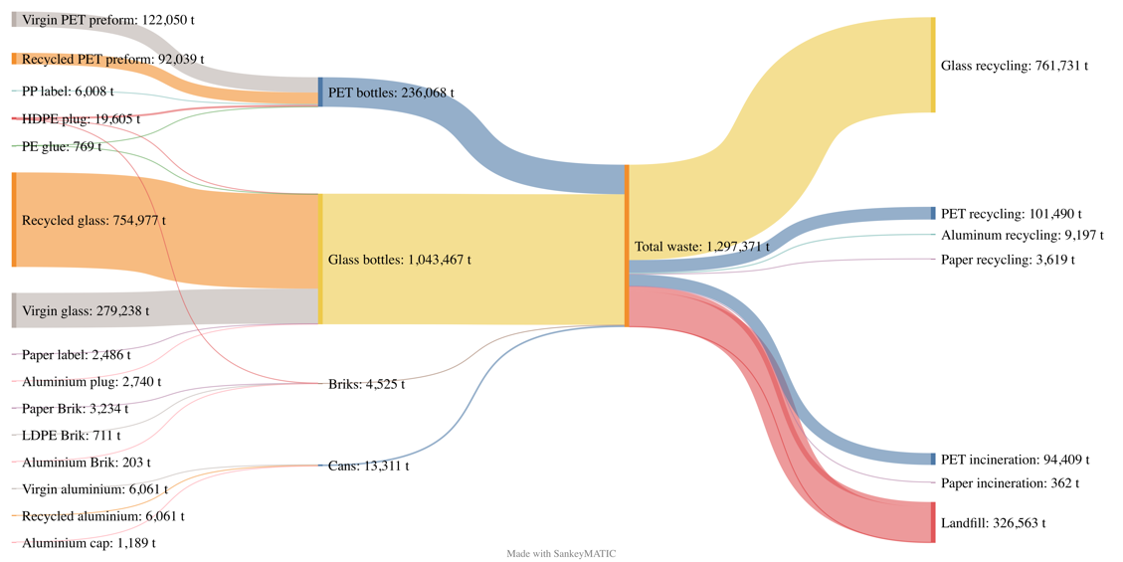

Fig. 2. Material flow analysis for the “packaged water sector” in Italy in 2020

Sources: Personal elaboration by the authors.

Although 1.5 L PET bottles are the most consumed size, in terms of weight, the most used material is glass, for an amount of over 754,977 t of recycled glass and 279,238 t of virgin glass in 2020. Besides, 122,050 t of virgin PET and 92,039 t of recycled PET cross the entire packaged water system. On the disposal pathways side, it results that over 326,563 t of PET and glass bottles, as well as aluminum cans and briks, are still addressed to landfill, whereas the vast majority of recycled materials are composed of glass (approx. 761,731 t) and PET (101,490 t). According to Figure 2, it emerges that aluminium presents good recycling rates, for an amount of 9,197 t (approx. 70% of the entire amount of aluminum cans produced in 2020).

In the light of the glass bottles consumption, it is essential to consider that such packaging represents 16% of domestic consumption, whereas it dominates in the Ho.Re.Ca. (Hotel/Restaurant/Catering) and door-to-door supplies. As a consequence, the returnable end-of-use system must be enhanced to avoid landfilling and reduce recycling by improving reuse technologies. As concern bricks, seldom used for water, several questions are still open, mainly related to their end-of-use system. In 2020 and worldwide, global carton package recycling rate has been 27%, including approximately 170 recycling facilities (Tetra Pak, 2021). If its recycling rate could be boosted, such packaging could substitute PET or glass either in domestic or outdoor consumption. Last, aluminium cans seem to be a good alternative to traditional packaging due to the aluminium physic-chemical characteristics and its attitude to be recycled several times over time. However, one limit to aluminium cans diffusion among consumers is the lack of comfortable caps, which make difficult to preserve water after the opening. Industries might consider the adoption of aluminium bottles, which are more suitable for both domestic and outdoor water consumption.

# Conclusions and future perspectives

The present research illustrates the status quo of the packaged water system in Italy, discussing possible circularization strategies in the packaged water sector. Material flow analysis is essential to enhance circularization in commodities production, since it provides useful insights under either the economic, the environmental or the organizational perspective. The material flow analysis offers transparent and comparable snapshots of several systems in space and time. First, it offers an early recognition of potentially harmful or beneficial stocks. Further, it sets priorities according to environmental protection strategies such as resource preservation (e.g., prevention) and waste management (e.g., separate collection, recycling), as well as priorities to boost eco-design strategies towards environmental sustainability.

One of the best options to reduce resource consumption, either virgin or recycled, regards the use of not disposable water bottles, which can be composed of materials others than plastics, such as stainless steel. It requires several changes in consumers behavior, enlarging the availability of safe and secure tap water on a global scale through sustainable investments and education for sustainable development. As regards the adoption of disposable packaging, the recycling percentages of plastics, glass, paper and aluminium should be increased, reaching higher levels of either closed-loop or open-loop recycling. Last, as concerns aluminium cans, eco-designer should suggest more suitable and comfortable packaging, which can be transported once open through the use of caps. Overall, deposit return systems should be introduced in Italy, at present not yet implemented.

Future research direction are intended to investigate natural resources (i.e., energy, water) associated with packaged water in Italy, and explore the environmental impacts associated with the packaging production, use and disposal through the life cycle assessment, as well as the economic costs by material flow cost accounting.

**References**

Acquitalia (2022) Natural Mineral Water Industry 2021-2022. <https://www.beverfood.com/downloads/acquitalia-annuario-acque-minerali/> (accessed on 8 March 2022)

Brunner PH, Rechberger H (2017) Handbook of material flow analysis. for environmental, resource and waste engineers, 2nd edn. CRC Press, Boca Raton.

Carlsberg Italia (2020) Environmental Product Declaration (EPD) Certified. https://www.carlsbergitalia.it/media/45851/epd-carlsberg_eng_2019.pdf (accessed on 3 May 2022).

Cerelia (2018) Dichiarazione Ambientale di Prodotto dell’acqua minerale naturale Cerelia imbottigliata in PET da 0,5 L, PET da 1,5 L e vetro a perdere da 1 L. <http://www.acquacerelia.com/wp-content/uploads/2019/04/DICHIARAZIONE-AMBIENTALE-DI-PRODOTTO-EPD.pdf> (accessed on 6 May 2022).

Coelho, PM, Corona, B, ten Klooster, R, Worrell, E (2020) Sustainability of reusable packaging–Current situation and trends. Resources, Conservation & Recycling: X, 6, 100037. <https://doi.org/10.1016/j.rcrx.2020.100037>

Consorzio Nazionale Imballaggi (2020) Green Economy Report 2019. <https://www.conai.org/comunicazione/rapporto-di-sostenibilita/> (accessed on 11 March 2022).

Etale, A, Jobin, M, Siegrist, M (2018) Tap versus bottled water consumption: The influence of social norms, affect and image on consumer choice. Appetite, 121, 138-146. <https://doi.org/10.1016/j.appet.2017.11.090>

Ferrarelle (2019) Dichiarazione Ambientale di Prodotto dell’acqua minerale Ferrarelle. <https://www.ferrarelle.it/certificazioni> (accessed on 3 May 2022).

Fondazione per lo sviluppo sostenibile and FISE UNICIRCULAR (2021) L’Italia del Riciclo 2021. <https://www.cial.it/rapporto-italia-del-riciclo-2021/> (accessed on 3 May 2022).

Gallucci, T, Lagioia, G, Piccinno, P, Lacalamita, A, Pontrandolfo, A, Paiano, A (2020) Environmental performance scenarios in the production of hollow glass containers for food packaging: an LCA approach. The International Journal of Life Cycle Assessment. <https://doi.org/10.1007/s11367-020-01797-7>

Geerts, R, Vandermoere, F, Van Winckel, T, Halet, D, Joos, P, Van Den Steen, K, Van Meenen, E, Blust, R, Borregán-Ochando, E, Vlaeminck, SE (2020) Bottle or tap? Toward an integrated approach to water type consumption. Water Research, 173, 115578, <https://doi.org/10.1016/j.watres.2020.115578>

Lagioia, G, Calabrò, G, Amicarelli, V (2012) Empirical study of the environmental management of Italy's drinking water supply. Resources, Conservation and Recycling, 60, 119-130, <https://doi.org/10.1016/j.resconrec.2011.12.001>

Luan, X, Cui, X, Zhang, L, Chen, X, Li, X, Feng, X, Chen, L, Liu, W, Cui, Z (2021) Dynamic material flow analysis of plastics in China from 1950 to 2050. Journal of Cleaner Production, 327, 129492. <https://doi.org/10.1016/j.jclepro.2021.129492>

Palomero-González, JA, Almenar-Llongo, V, Fuentes-Pascual, R (2022) A composite indicator index as a proxy for measuring the quality of water supply as perceived by users for urban water services. Technological Forecasting and Social Change, 174, 121300, <https://doi.org/10.1016/j.techfore.2021.121300>

San Benedetto (2017) Dichiarazione Ambientale di Prodotto dell’acqua minerale naturale oligominerale San Benedetto in bottiglie di PET da 0,5 l – 1,5 l e 2 l della linea EcoFriendly. <https://portal.environdec.com/api/api/v1/EPDLibrary/Files/562ff3ed-421e-413d-a6e4-37f0ec078b18/Data> (accessed on 3 May 2022).

Schlecht, S, Wellenreuther, F (2020) Comparative Life Cycle Assessment of Tetra Pak® carton packages and alternative packaging systems for beverages and liquid food on the Italian market. <https://www.tetrapak.com/content/dam/tetrapak/publicweb/it/it/sustainability/2020-LCA-IT.pdf> (accessed on 9 May 2022).

Statista (2022) Global water industry - statistics & facts. https://www.statista.com/topics/1575/water/ (accessed on 20 May 2022)

Steele, AP, Powell, JR (2022) Environmental Accounting: Applications for Local Authorities to Quantify Internal and External Costs of Alternative Waste Management Strategies. Environmental Management Accounting Network Europe, Fifth Annual Conference, Gloucestershire Business School, February 11-12, 2002.

Tetra Pak (2021) Sustainability report 2021. <https://www.tetrapak.com/content/dam/tetrapak/publicweb/gb/en/sustainability/documents/TP-Sustainability-Report-2021.pdf> (accessed on 10 June 2022)

Zawakiak, J, Wojciechowski, S, Tomasz, P, Krypa, A (2017) Tetra Pak Recycling – Current Trends and New Developments. American Journal of Chemical Engineering, 5(3), 37-42. 10.11648/j.ajche.20170503.12