Chapter 090
Risk assessment and life cycle approach to optimize the sustainability performance of leather products

Abstract. The use of chemicals in tanning companies represents a relevant risk for health and safety (HS) of workers, and the risk assessment (RA) is essential for companies to adopt preventive and protective measures to reduce the risks. At the same time, in market perspective, companies are more and more interested to demonstrate their sustainability through environmental impact reduction: the life cycle (LC) approach permits to consistently quantify the environmental footprint of products. Generally, RA and LC are not integrated by companies. The research aims to define an ad-hoc methodology that integrates LC and RA for the quantification od HS risks related to processes and products. The methodology is tested in assessing the performances of two leather products realized by an Italian company, through identification and evaluation of HS risks associated to LC steps of production. The results demonstrate that the integrated use of RA and LC is effective both to punctually know the HS risks associated to the production activities, both to compare the performances of different products in terms of dangerousness of substances and processes used.

Keywords. Life cycle approach; Risk assessment; Leather products; Dangerous chemicals; Environmental performance; Health and safety performance.

Introduction
In the last decades, companies are more and more interested to reduce the impacts of products with the life cycle approach and to prevent accidents through the risk management. Life Cycle Assessment (LCA) and the Risk Assessment (RA) represent the main methodologies to support companies in analyze and evaluate respectively the environmental impacts associated to products and health&safety risks associated to processes (Karanikas et al., 2020). International community has defined ad-hoc standards to guide organizations to implement LCA and RA. ISO 14040 defines four steps to conduct an LCA study: goal and scope, life cycle inventory, life cycle impact assessment, and interpretation of results (ISO, 2006). To conduct RA, three steps are defined by the ISO 31000 standard: risk identification, risk analysis, and risk evaluation (ISO, 2018).
Even if LCA and RA refer to different aspects of business management, their integrated use is recommended by standards and scientists to reduce at the same time the environmental, health and safety (EHS) risks associated to processes (Mazzi et al., 2017). The solutions to integrate LCA with RA are the following (Flemström et al., 2004; Barberio et al., 2010):
- RA to support LCA: RA can be used as a subset of LCA, to support inventory or impact assessment step.
- LCA to support RA: alternatively, LCA can be realized as a subset of RA, to support risk identification or analysis.
- Integrated discussion of results: LCA and RA are carried out in an independent way, and their results are compared in final discussion.
The research aims to design and test an innovative methodology to integrate LCA and RA, to obtain evaluation of EHS risks associated with products along LC stages of production.

Material and methods

New methodology to integrate LCA and RA
In this research, a new methodology is designed, in which the integration between LCA and RA is obtained by an integration of each LCA phase and RA step, though the adoption of LCA as framework and RA as algorithm.
Named “Life Cycle Risk Assessment” (LC-RA), the methodology integrates the steps of the LCA and RA, in one assessment method, in which RA support LCA and LCA completes RA, to obtain a complete EHS risk assessment and consequently to improve EHS performance of processes.
LC-RA methodology includes 4 steps:
- the LC-R goal and scope defines the expected results of the study and the life cycle stages to be included and EHS risks to be considered;
- the LC-R identification of risks during the life cycle stages takes inventory potential EHS risks of raw materials and manufacturing processes;
- the LC-R analysis consists in quantification of effects of each EHS risk, through ad-hoc RA equations;
- the LC-R performance evaluation concludes the analysis, through the assignment of the EHS risk index for each LC stage of products.

Case study
To apply our research, the case study is an Italian tanning company, leader in leather products market. Located in the north of Italy, it has 4 production sites, and 90% of its production is destined to export. The tanning processes recover and transform rotting skin of animals into a hygienic, breathable and resistant product.
To test the methodology, 2 products are selected: they’re top-quality leather products, realized by the Italian company and sold to luxury automotive market, processed with two main important tanning procedures.
- Product A is realized with Wet Blues leather, made from chrome tanning processes;
- Product B is realized with Wet White leather, made from vegetable tanning processes.

Application of LC-RA methodology at the case study
The LC-RA methodology includes the following key-aspects:
- The equivalence of product systems for product A and B is needed, to assure results comparison;
- Chemical risks associated to internal activities in tanning processes have to be quantified to permit consistent results;
- Legislative requirements and limits must be considered in EHS risk evaluation through cause-effect analysis.
The goal of the LC-RA study is the comparison of LC-R performances of products A and B, based on EHS risks associated to internal activities with chemical substances and mixtures. To assure the equivalence in comparison, the functional unit is defined as the production of one square meter of finished product in black color. Coherently with the goal and functional unit of LC-RA, internal processes using chemicals are considered in LC-RA scope. To define the boundaries of LC-R study, the operations of manufacturing, transformation, transport, and storage of products are considered. As represented in figure 1, internal processes are included in the boundaries, while external processes – of suppliers or in outsourcing – are excluded. Moreover, all processes using chemicals are included in the study, while mechanical processes without chemical risks are excluded because not relevant for the goal.

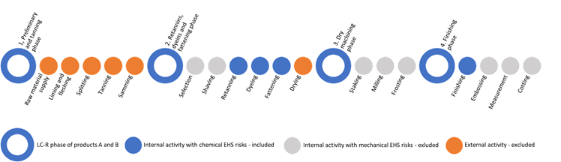
Figure 1: System boundaries of the LC-RA study

To identify and quantify the EHS risks, through an in-depth analysis of processes, the framework represented in figure 2 is adopted. The risks of each LC phase derive by risks of processes included in the phase. In turn, the risk of each process derives by risks of activities carried out in processes. The risk index of activity depends on risks associated to substances and mixtures, that in turn depends on hazard of substances and exposure level.
In LC-R identification and analysis, the algorithms reported in Table 1 are applied to quantify, for each substance/mixture, the hazard and exposure, and to obtain for each activity and process the final EHS risk index.

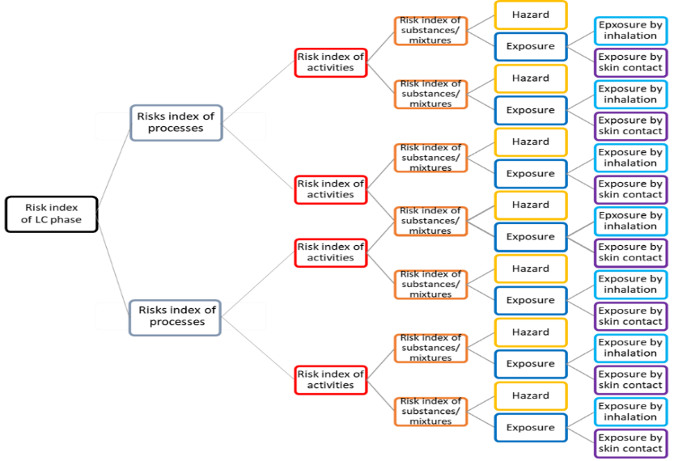
Figure 2: Framework for LC-R identification and analysis in the case study

Table 1. Algorithms adopted to quantify the risk index in the case study
Component of LC-R index | Algorithm
Risk index of LC phase | $$R_{LC phase}=\sum{R_{LC processes}}$$
Risk index of LC process | $$R_{LC process}=\sum{R_{activities}}$$
Risk index of activity | $$R_{activity}=\sum{R_{substance/mixture}}$$
Risk index of substance/mixture | $$R_{substance/mixture} =H×E$$
Hazard index | H = f₁ (hazard factors)
Exposure index | E$=\sqrt{{E_{inal}}^{2}+{E_{skin}}^{2}}$
Exposure index by inhalation | Einal = f₂ (substances factors)
Exposure index by skin contact | Eskin = f₃ (substances factors)
f₁ (hazard factors)  (EC, 2003) | acute toxicity, skin corrosion or irritation, serious eye damage or eye irritation, respiratory or skin sensitization, specific target organ toxicity, dangers for aquatic environment
f₂ (substances factors)  f₃ (substances factors)  (Regione Toscana et al, 2018) | chemical-physical characteristics, quantities and concentration in use, conditions and procedures of use, possibility of dispersion, protective measures adopted, exposure time, distance from source

In the fourth step, the EHS performance of products is evaluated by using the evaluation matrix in figure 3, in which the EHS risk index values are distinguished in 5 categories with related risks evaluation.

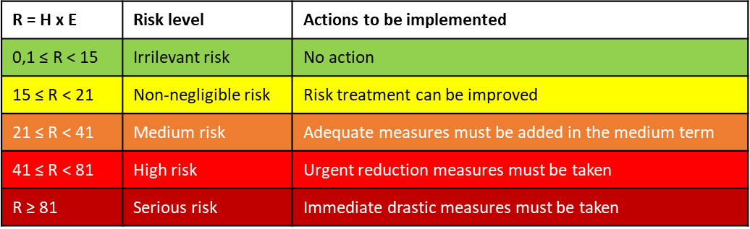
Figure 3: LC-RA matrix

Results

Table 2 summarizes the results obtained by LC-R identification and analysis related products A and B. The activities using dangerous substances are more numerous in LC of product B than in LC of product A. The risks associated to activities in LC of product B are more relevant than those in LC of product A. Few activities have achieved a medium risk index (orange) both in product A and B, and no activity achieved high or serious evaluation. In general, product A has better performance, since compared to product B, and finishing phase has several dangerous activities.

Table 2: Results of LC-RA related to products A and B
 |  | Product A |  | Product B
N. of activities with substances/mixtures | N. Rsubstances/mixtures quantified | 277 | 100% | 379 | 100%
N. activities with “irrelevant risk”  (green level) | N. Rsubstances/mixtures < 15 | 244 | 88,1% | 315 | 83,1%
N. activities with “Non-negligible risk”  (yellow level) | N. 15 ≤ Rsubstances/mixtures < 21 | 30 | 10,8% | 39 | 10,3%
N. activities with “Medium risk”  (orange level) | N. 21 ≤ Rsubstances/mixtures < 41 | 3 | 1,1% | 25 | 6,6%
N. activities with “High risk” & “Serious risk”  (red and amaranth levels) | N. Rsubstances/mixtures ≥ 41 | 0 | 0% | 0 | 0%

In comparing the number of activities with non-negligible risks (yellow level), and medium risks (orange level), as represented in figure 4, both in product A and B, most of the non-negligible risks are in finishing, related to processes “Loading in pirovan”, “Mixing”, and “Mixture preparation”. In terms of medium risks, product B has the worst performance: most of medium risks are in phase 2, as “Weighing of chemicals” and “Introduction of chemicals into drum”.

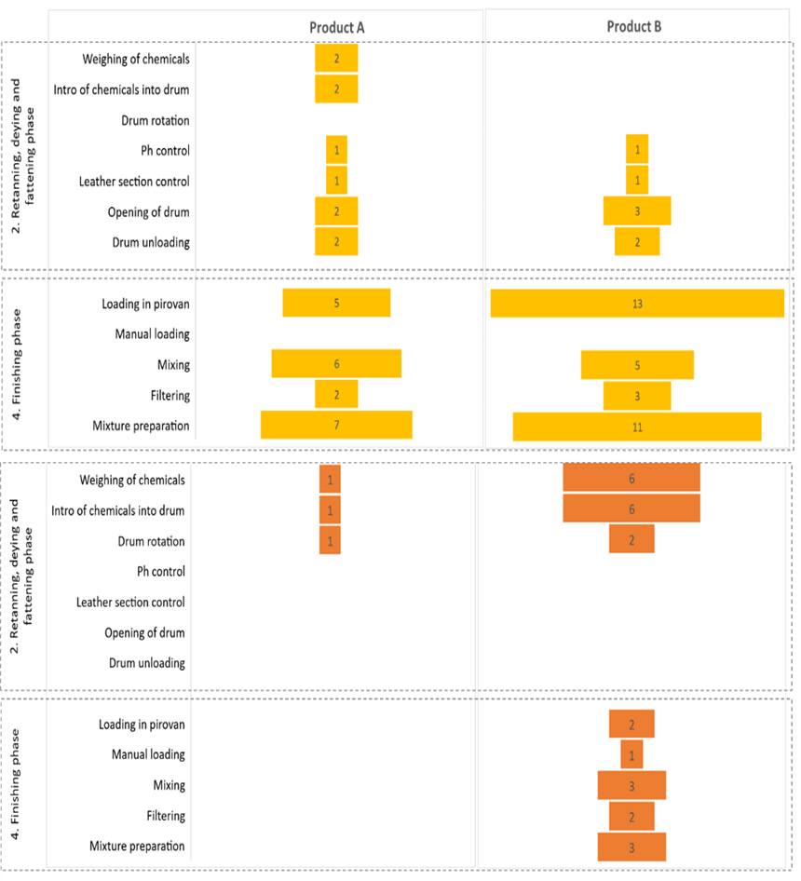
Figure 4: Comparison of LC-RA results: number of activities with non-negligible risk (yellow) and medium risk (orange) per product

Discussion and conclusion

The research demonstrates the possibility and relevance to integrate LCA and RA, through the adoption of LCA as framework and RA as equations. The LC-RA methodology designed in this research seems able to compare HS performance of products and their LC stages, highlighting most critical activities and most dangerous final products. Moreover, results of the LC-R performance evaluation support the company in reviewing risk treatment measures and improve consciousness of safe behavior.
The adoption of LC approach in risk evaluation is convenient because it allows to understand the dangerousness of activities during the processing phases. In turn, the RA is useful in a LC perspective, to compare products in terms of EHS performances, and motivates both management and workers to increase the commitment to reduce the risks.
On the other hand, our research suffers two main limits. First, only chemical risks are quantified in LC-RA, while mechanical processes not at all. Besides, only internal processes are included in the boundaries of our case study, while outsourced processes are excluded.
Other research perspectives can be suggested. LC-RA methodology must be integrated by mechanical risks. Moreover, the boundaries of LC-RA study should be expanded to include also external dangerous processes.
Next research includes also testing of this methodology in other industrial sectors, with the aim to verify its validity in more complex products and more dangerous processes.

References and Citations

Barberio, G., Buttol, P., Righi, S., Andretta, M., 2010. Combined approach of Risk Assessment and Life Cycle Assessment for the environmental evaluations: an overview. Atti di Ecomondo, Maggioli Editore
Flemström K, Carlson R, Erixon M (2004) Relationships between Life Cycle Assessment and Risk Assessment , Potentials and Obstacles. Industrial Environmental Informatics (IMI), Chalmers University of Technology, Report 5379, June 2004
ISO (2018) ISO 31000:2018: Risk management — Guidelines. ISO, Geneva.
ISO (2006) ISO 14040:2006: Environmental management — Life cycle assessment — Principles and framework. ISO, Geneva.
Karanikas N, Popovich A et al (2020) Symbiotic types of systems thinking with systematic management in occupational health & safety. Safety Science 128, 104752
Mazzi A, Toniolo S, Catto S, De Lorenzi V, Scipioni A (2017) The combination of an environmental management system and life cycle assessment at the territorial level. Environmental Impact Assessment Review 63, 59-71

