Chapter N 110

Carob Pods as Source of Bioactive Molecules in the Preparation of Functional Jelly

Abstract. The aim of this research was to employ the unripped pod of the carob tree (Ceratonia siliqua L.) as source of molecules with remarkable healthy and nutraceutical properties. The extractions were carried out by ultrasound extraction method, an eco-friendly procedure that, employing low temperatures, allows to preserve bioactive molecules. The optimization of the extraction methods, performing on Selvatica cultivars pods allowed the recovering of several fractions with different polyphenolic content, deeply characterized in term of antioxidant properties, as well as chemical composition. The extract that provided the best performance was involved in a radical reaction on gelatin backbone, a natural polymeric matrix widely employed as food ingredient. Grafting reaction was performed by a totally eco-friendly synthetic methodology, involving ascorbic acid and hydrogen peroxide as initiator system. The polymeric conjugate, showing remarkable antioxidant features, can be potentially used as a gelling agent in the preparation of jellies and/or candies with an added nutritional value, as well as prolonged shelf life compared to the conventional one, mainly attributable to the bioactive molecules coming from the carob pod extract.
Keywords. Carob pod, Eco-friendly extraction, Antioxidant properties, Gelatin conjugate.

  - Introduction
The carob tree is generally grown and evergreen in the coastline of the Mediterranean region (Stavrou et al., 2018). The average world production of carob from 2010 was variable and in the last years underwent a significant decrease (Fig. 1A), ranging from 127,998 (2010) to 49943 (2020) tonnes (FAOSTAT, 2021).
A | B
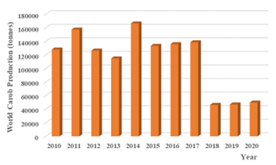 | 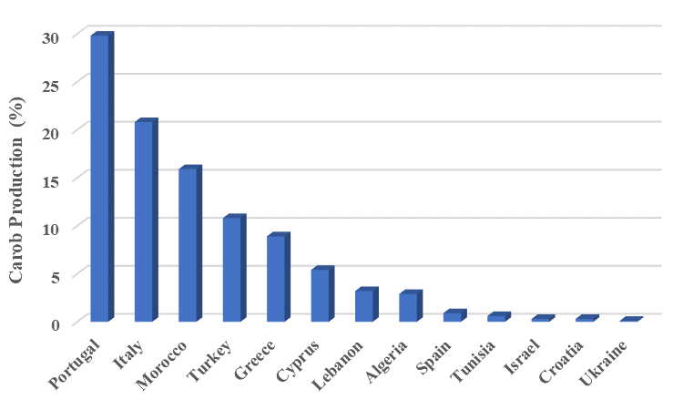
Fig. 1 Trend of the world production of carob from 2010 to 2020 (A) and production of carob for country (year 2017) (B).

The main producers are Portugal (29.8%), Italy (20.8%), Morocco (15.9%), Turkey (10.8%), Greece (8.9%), and Cyprus (5.4%) (FAOSTAT, 2021) (Fig. 1B). According to the literature data, Italy is one of the mayor producers of carob in the world both for total production (28910 tonnes) and harvested area (5576 ha), with a yield of 51847 hg/ha. The carob is mainly widespread in the southern regions, mostly in Sicily and Apulia. The carob pod can be classified in two parts; the kibble (80-90% w/w) and the seeds (10-20% w/w) (Oziyci et al., 2014). The seeds are generally used to produce locust bean gum which is a special gum for food and other industries. The kibbled pod is mainly used to produce carob powder by roasting and milling processes. Carob powder is generally employed as a substitute for cocoa because of its rich nutritional content (Yousif and Alghzawi, 2000). Carob pod represents then a valuable source of bioactive molecules, potentially useful for the preparation of functional food. In this regard, eco-friendly extraction procedures were exploited to achieve extracts with remarkable antioxidant properties. Active compounds were then involved in a green radical process for the synthesis of a macromolecular conjugate able to be employed as additive in the food industry. Gelatin was chosen as polymeric system that was conveniently functionalized with the polyphenols moieties of the extracts, carrying on to a high molecular weight conjugate with significant antioxidant features.

  - Materials and methods
1.2.1 Carob pods extraction
Samples |  | Extraction condition |  |  |  | Yield
Code | SPC (g) | Solvent | Volume (ml) | T (ºC) | t (min) | Mass (g) | %
CP1 | 1.0 | Water | 100 | 40 | 30 | 0.38±0.02 | 38±2
CP2 | 1.0 | Water/Acetone | 100 | 40 | 30 | 0.37±0.02 | 37±1
CP3 | 1.0 | Water/Ethanol | 100 | 40 | 30 | 0.16±0.01 | 16±1
The pods used in this study were from Selvatica Carob tree (SCP). The extractions were performed by Ultrasound Assisted Method (UAE), employing water (1), water/acetone (50/50 v/v) (2) and water/ethanol (50/50 v/v) (3) as extraction solvents (Table 1).

Table 1. Ultrasound assisted extraction of Selvatica unripped carob pods.
SPC = Selvatica Carob tree; CP1 = Pod of Selvatica Carob in water; CP2 = Pod of Selvatica Carob in Water/Acetone 50/50 (v/v); CP3 = Pod of Selvatica Carob in Water/Ethanol 50/50 (v/v).
In a standard procedure, 1.0 g of freeze-dried SPC was suspended in 100 mL of solvent and sonicated for 30 min, at 40 KHz and 40°C. The extracts were filtered and freeze-dried until constant weight. Each extraction was performed in triplicate and data was expressed as means (±SD). All the extracts were stored at -20 °C before the analysis.

1.2.2 Characterization of the extracts by HPLC-DAD
Polyphenols analysis was carried out by HPLC-DAD at 360, 330, and 280 nm. The extracts (3 μL) were injected onto a reversed stationary phase column, Zorbax SB-C₁₈ (3.5 μm; 150 x 4.6 mm i.d.), protected by a pre-column at 40°C. Water/formic acid (99.9:0.1, v/v) and acetonitrile were adopted as mobile phase through a binary gradient (Clodoveo et al., 2022). Stop time to 35 min. The flow was maintained at 0.8 mL min⁻¹. Positions of absorption maxima (λ_{max.}), absorption spectra profile, and retention times (RT) were matched with pure standards: gallic acid, 4-hydroxy-coumaric acid, Procyanidin B1, Procianidin B2, quercetin and myricitrin (Table 2).

Table 2. Chemical characterization of the extracts by HPLD-DAD.
Compound | CP1 | CP2 | CP3
Gallic Acid | 3.30±0.16 | 3.35±0.02 | 3.58±0.18
Procianidin B1 | 1.25±0.06 | 1.19±0.02 | 1.53±0.08
Procianidin B2 | 0.72±0.09 | 0.11±0.02 | 0.90±0.07
Myricitrin | 0.53±0.06 | 0.11±0.02 | 0.57±0.07
Quercetrin | 1.24±0.06 | 1.29±0.03 | 1.60±0.08
PSC1 = Pod of Selvatica Carob in water; PSC2 = Pod of Selvatica Carob in Water/Acetone; PSC3 = Pod of Selvatica Carob in Water/Ethanol.
1.2.3 Polyphenols’ total content
The amount of total phenolic content (TPC) in the extracts, expressed in milligrams of catechin (CT) per gram of extract (mg CT/g extract), was determined using the Folin-Ciocalteu reagent, by following literature protocols with some changes (Spizzirri et al., 2021) (Table 3).

Table 3. Total phenolic content and antioxidant activity of the extracts from Selvatica Carob pods.
Samples | TPC (mg CT g⁻¹ extract) | ABTS Radical IC₅₀ (mg mL⁻¹)
CP1  CP2  CP3 | 185.2±2.5  311.5±3.0  275.6±2.4 | 0.0136±0.0011  0.0094±0.0003  0.0420±0.0011
PSC1=Pod of Selvatica Carob in water; PSC2=Pod of Selvatica Carob in Water/Acetone; PSC3=Pod of Selvatica Carob in Water/Ethanol; TPC = Total Phenolic Content; CT = Catechin; ABTS = (2,2’-azinobis (3-ethylbenzothiazoline-6-sulphonic acid)).

1.2.4 Antioxidant performances
Free radical scavenging properties of the extracts were estimated towards ABTS (2,20-azinobis (3-ethylbenzothiazoline-6-sulphonic acid)) radicals, by following literature protocols with some changes (Carullo et al., 2020). The scavenging activity was expressed in terms of IC₅₀ (Table 3).

1.2.5 Synthesis of the conjugate
The synthesis of the gelatin conjugate has been assessed following the general procedure according to a literature method, with some modifications (Spizzirri et al., 2021). Briefly, 500 mg of gelatine reacted with an amount of PCS2 equivalent to 70 mg of CT providing the macromolecular conjugate GPSC2. Additionally, BG (Blank gelatine), exploited as a control, was prepared when grafting process was carried out in absence of the extracts.

1.2.6 Characterization of gelatine-based polymers
TPC and scavenger activity against ABTS radical of GCP2, BG and commercial gelatine (CG) were evaluated, by following literature protocols with some changes (Restuccia et al., 2019) and the results are in table 4.

Table 4. Total phenolic and antioxidant activity of gelatine-based polymers.
Code | TPC  (mg CT g⁻¹ polymer) | IC₅₀ (mg mL⁻¹)
 |  | ABTS Radical
GCP2  BG  CG | 36.02±2.11  5.53±0.19  2.36±0.94 | 0.0212±0.0190  -  -

GPSC2=Conjugate of gelatine and pod of Selvatica Carob in Water/Acetone; BG=Blank Gelatine; CG=Commercial Gelatine; TPC = Total Phenolic Content; CT=Catechin; ABTS = (2,2’-azinobis (3-ethylbenzothiazoline-6-sulphonic acid)). (-) Not detected or under the LOQ of the assay.

  - Results and Discussion
Selvatica unripped Carob pods underwent eco-friendly extraction processes based on the use of environmentally sustainable solvent mixtures, consisting of ethanol/water, acetone/water and water, as reported in Table 1. To avoid the employment of high temperatures, the extraction procedures were assisted by ultrasounds. In a liquid medium, the collapse of the bubbles generate by ultrasounds has a strong impact on the solid surface and causes the penetration of the solvent, thus triggering the release of the bioactive molecules (Arun et al., 2020). The yields of the extractions appear quite similar by employing water or acetone/water as solvents (about 37% w/w), while the performance of the mixture water/ethanol is significantly reduced (16% w/w). A more detailed characterization of the extracts was performed by HPLC-DAD and by evaluation of the total phenolic content (TPC) and antioxidant performances (scavenger activity against ABTS radical).
HPLC-DAD analyses (Table 2) displayed relevant amounts of gallic acid and quercetin, while procyanidins B1 and B2 and myricitrin were also detected. The amount of these compounds was quite similar in all the extracts, while gallic acid is the more abundant molecule.
TPC value of carob pod extracts are reported in Table 3, and CP2 extract displayed the highest amount (311 mg of CT per gram of extract), respect to CP3 and CP1. These data were confirmed by the experiments performed to determine the scavenger activity against hydrophilic ABTS radical. Specifically, a significant reduction of IC₅₀ value was recorded for CP2 highlighting the remarkable antioxidant performances of this extract in an aqueous medium. (Fig. 3).
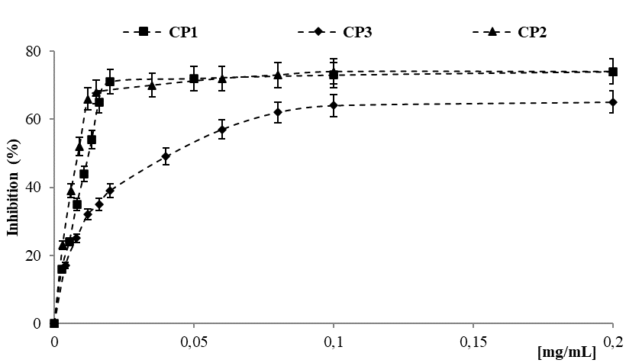
Fig. 3 Scavenger activity against ABTS radical of Selvatica carob pod.

This feature can be useful exploited to perform the chemical conjugation of active molecules in the extract on a suitable macromolecular system. In this regard, gelatin was chosen as polymeric backbone and the grafting reaction was performed by an eco-friendly synthetic procedure (Spizzirri et al., 2009). Antioxidant conjugates are systems with a remarkable chemical stability and a lower degradation rate compared to the lower molecular weight molecules (Kurisawa et al., 2003) and therefore are very suitable for application in the biomedical, cosmetic and food. Specifically, to synthesize polypeptide conjugates with antioxidant activity, the reactive species present in the extract were linked to the gelatin chains, using a water soluble and biocompatible redox pair (H₂O₂/ascorbic acid) as initiator system, showing several advantages including the possibility of inducing polymerization processes at lower temperatures, thus reducing the risks of degradation of phenolic compounds and avoiding the generation of any type of toxic reaction product (Toti & Aminabhavi, 2004). A specific CP2/ polypeptide weight ratio was used in the polymerization mixture. A quantity of CP2 equivalent to 70 mg of catechin (calculated by TPC value) for each gram of gelatin was employed. Two polymers were thus synthesized: GCP2, obtained using the CP2 extract, and a control polymer (BG), prepared under the same conditions, but in the absence of the extract. TPC and scavenger activity against ABTS radical were evaluated and the results are reported in Table 4. GCP2 showed a remarkable amount of disposable phenolic groups (36 mg of CT per gram of polymer) able to confer it significant antioxidant performances (IC₅₀ value equal to 0.0212 mg mL⁻¹). This activity was not recorded in BG, as well as in the commercial gelatine (CG).

1.4 Conclusions and future perspectives
Sustainable exploitation of unripped Selvatica carob pods can represent, in addition to being a viable system to reduce the environmental impact of the entire production process, a significant starting point for increasing the economic value of this product. The proposed eco-friendly extraction procedure allowed to obtain phenolic fractions displaying remarkable antioxidant activities in an aqueous environment, thus offering new horizons for the implementation of industrial food production. The conjugation of the phenolic compounds of the extracts into the gelatin chains was a valuable strategy for developing a product able of meeting the high quality and organoleptic standards required by the consumer. Gelatin, being an integral part of the daily diet as a constituent of meat and fish, is naturally suitable to act as a carrier in the conveyance of bioactive compounds so it offers the eco-sustainable approach necessary to justify the use of the products extracted from the pod. The results of the antioxidant assays confirmed that grafting reaction produced a protein bearing antioxidant moieties covalently bounded to the gelatin sidechains and clearly showed that the synthetic strategy allows to improve the properties of the natural polymer, introducing in the protein new features for specific applications in the food industry. Our challenge will be to employ this functional polymer as starting material for the preparation of jellies with significant chemical-physical, nutraceutical and biological features. The substantial gap in terms of antioxidant activity between enriched jellies and a conventional ones, should confer considerable added value to the functional product, to make it immediate to be placed on the market.

References
Arun KB, Madhavan A, Sindhu R, Binod P, Pandey A, Reshmy R, Sirohi R (2020). Remodeling agro-industrial and food wastes into value-added bioactives and biopolymers. Ind Crop Prod, 154:112621.
Carullo G, Scarpelli F, Belsito EL, Caputo P, Oliviero Rossi C, Mincione A, Leggio A, Crispini A, Restuccia D, Spizzirri UG, Aiello F (2020) Formulation of New Baking (+)-Catechin Based Leavening Agents: Effects on Rheology, Sensory and Antioxidant Features during Muffin Preparation Foods 9:1569.
Clodoveo ML, Crupi P, Muraglia M, Corbo F (2022) Ultrasound Assisted Extraction of Polyphenols from Ripe Carob Pods (Ceratonia siliqua L.): Combined Designs for Screening and Optimizing the Processing Parameters. Foods 11:284.
FAOSTAT, 2021. https://www.fao.org/faostat/en/#data/QCL
Kurisawa M, Chung JE, Uyama H, Kobayashi S (2003). Enzymatic synthesis and antioxidant properties of poly(rutin). Biomacromolecules, 4(5):1394-1399.
Oziyci HR, Tetik N, Turhan I, Yatmaz E, Ucgun K, Akgul H, Gubbuk H, Karhan M (2014) Mineral compositions of pods and seeds of wild and grafted carob (Ceratonia siliqua L.) fruits. Sci Hortic -Amst 167:149-152.
Restuccia D, Giorgi G, Spizzirri UG, Sciubba F, Capuani G, Rago V, Carullo G, Aiello F (2019) Autochthonous white grape pomaces as bioactive source for functional jams. Int. J. Food Sci. Technol. 54:1313-1320.
Spizzirri UG, Carullo G, Aiello F, Paolino D, Restuccia D (2021) Valorisation of olive oil pomace extracts for a functional pear beverage formulation. Int. J. Food Sci. Technol. 56:5497-5505.
Spizzirri UG, Iemma F, Puoci F, Cirillo G, Curcio M, Parisi OI, Picci N (2009) Synthesis of antioxidant polymers by grafting of Gallic acid and Catechin on gelatine. Biomacromolecules, 10:1923-1930.
Stavrou IJ, Christou A, Kapnissi-Christodoulou CP (2018) Polyphenols in carobs: A review on their composition, antioxidant capacity and cytotoxic effects, and health impact. Food Chem. 269:355-374.
Toti US, Aminabhavi TM (2004). Synthesis and characterization of polyacrylamide grafted sodium alginate membranes for pervaporation separation of water/isopropanol mixtures. J App Polym Sci 92:2030-2037.
Yatmaz E, Turhan I (2018) Carob as a carbon source for fermentation technology. Biocatal Agric Biotechnol 16:200-208.
Yousif AK, Alghzawi HM (2000) Processing and characterization of carob powder. Food Chem 69: 283-287.

