Chapter N 131

Reshoring and nearshoring of resource for more resilient and sustainable manufacturing chains

Abstract. The combined action of pandemic first and geopolitical tensions later have highlighted the fragility of many global supply chains. An unexpected event in a totally interconnected world requires companies to react quickly to respond to change. This chapter analyzes critical issues emerging in the Italian ceramic industry supply chain, which is characterized by a high intensity of natural and energy resource use and a sourcing system with high geopolitical risk. Using the methodological approach of transdisciplinarity as a perspective for solving complex problems in manufacturing, alternative supply chain scenarios are outlined in order to identify nearshoring and reshoring strategies for a more resilient and sustainable supply for the Italian ceramic industry.

Keywords. Supply Chains Disruptions, Manufacturing, Reshoring, Nearshoring, Resilience, Sustainability

Introduction
After years of globalization, world economic integration is slowing down due to the consequences of the crisis caused by the pandemic and global geopolitical tensions that push nations towards forms of protectionism (Hameiri, 2021). In this context of global crisis, with disruptions in the supply chains of natural and energy resources, it becomes imperative for manufacturing companies to optimize the use of production factors and reconfigure supply chains with reshoring and nearshoring strategies (van Hoek and Dobrzykowski, 2021). This implies a major effort by industries to innovate processes, organizational models, products and business models because the system of value creation and capture has radically changed (Magableh, 2021). Therefore, diversification of supply sources and building new supply chains that are more resilient, agile and flexible to respond to sudden market disruptions is necessary (Miceli et al., 2021). The management of this change can be effectively supported by the use of appropriate design tools and a cross-disciplinary approach to innovation, namely no longer the mere overlap of technical and managerial knowledge, but their effective integration (Khanuja and Jain, 2021).

General overview on recent reshoring/nearshoring trends
In manufacturing, industrial location represents the geographic place where the company decides to source the factors of production (inputs) to process them and transform them into products (outputs) to be sold to its customers (Bogataj et al., 2011). It follows that localization is an integral part of the company's strategic planning process and helps determine its competitive strategy. The optimal plant location is closely related to the type of business the company develops and therefore must be identified taking into account the needs of all company areas, not just manufacturing ones (Gothwal and Saha, 2015). Especially since the late 21st century, there has been a tendency for manufacturing firms to shift their production from developed to developing or emerging countries to reduce costs or to take advantage of sales opportunities offered by rapidly expanding markets. This phenomenon is known as offshoring and is related to the opening of nations to international trade, economic integration and globalization (Krieger-Bode and Soltwedel, 2013). Stated another way, manufacturing offshoring is a strategy that responds to changes in the competitive environment of firms seeking greater competitiveness through the achievement of new comparative advantages. Offshoring can save on production costs in the short term, but over a longer time horizon it carries the risk of losing control of operations due to distance from the parent company, cultural and legal differences, language barriers that make communication more difficult, and even geopolitical scenarios that can sometimes hinder performance (Baldwin and Venables, 2013).
Nowadays, however, the reasons that initially prompted manufacturing firms to relocate are no longer as pronounced. In fact, the labor cost gap between the West and emerging countries has rebalanced over time, and in addition, labor and environmental protection regulations in these countries have evolved closer to those of more developed ones. These causes have led to the rise of an opposing phenomenon known as reshoring, which consists of rethinking the location of a previously offshored industry (Johansson et al., 2019). This is an operational model in which manufacturing firms return to domestic production in response to the need to re-industrialize developed economies to mitigate the risks and fragility of supply chains (Fratocchi et al., 2014; Barbieri et al., 2020). However, it is not always possible to bring business back home, this happens because some sectors need raw materials that are absent at home, and in others because replicating manufacturing infrastructure would be too costly. In such cases, one option companies can undertake is friend-shoring, which is the relocation of industrial operations to friendly, albeit distant, countries that nonetheless share the value system and political alignment (Ciravegna and Michailova, 2021). This minimizes the exposure of manufacturing operations to geopolitical risks. If this alternative is not viable either, firms can opt instead for nearshoring, a variant of offshoring that can be alternative or complementary to reshoring in that it involves a manufacturing firm relocating (or reapproaching from afar) its operational processes to countries close to its business headquarters (Piatanesi and Arauzo‐Carod, 2019). Moreover, starting in 2020, the Covid-19 pandemic and subsequent geopolitical tensions related to regional conflicts disrupted many supply chains, highlighting their fragilities and raising the question of a paradigm change in globalization. All this has accelerated the phenomena of reshoring and/or nearshoring of production by many companies in more advanced economies (Colamatteo et al., 2021).
Although there is a large body of literature on reshoring and nearshoring strategies related to manufacturing processes (Merino et al., 2021), scholars have not yet sufficiently explored the same strategic options for input sourcing procedures (van Hoek and Dobrzykowski, 2021). The raw material supply network represents one of the most critical elements of the production process in natural resource-intensive industries, such as the construction, concrete, glass, ceramics, metals, etc. industries are (Appolloni at al., 2022). The globalization process over the past three decades has allowed access to new markets for natural raw materials, and offshoring of sourcing has emerged as the best option for manufacturing firms to have resources in large quantities and good quality at affordable prices (Matyushok et al., 2021). However, the complexity of supply logistics became evident during the pandemic (Ikram et al., 2021) highlighting to manufacturing firms the need to equip themselves with appropriate systems for optimal management of the resources deployed from a perspective of operational excellence (Ma et al., 2021). Therefore, managing the increasing complexity of value chains in times of disruption requires the coexistence of a plurality of both engineering and socio-economic skills. However, a single multidisciplinary approach in which multiple disciplines operate simultaneously, and which therefore merely juxtaposes knowledge with an additive logic without fostering dialogue between different domains, does not solve the problem of complexity (Gligor et al., 2013). The first step toward more effective problem solving could be the integrated approach that characterizes interdisciplinarity, which occupies the space between knowledge domains where disciplines can combine concepts, methodologies or tools (Xu, 2020). This contamination of knowledge, however, occurs only among disciplines that are culturally close to each other and by their very nature have points of connection. The real paradigm shift for complexity analysis is the epistemological approach of transdisciplinarity, which instead aspires to develop new knowledge by going beyond and interweaving concepts and methods of individual disciplines, even if they are far apart (Broo, 2022). This holistic and systemic view based on both engineering and socio-economic expertise may prove to be the most appropriate for interpreting the complexity of supply chains and for identifying solutions in response to sudden changes in the operating environment (Peruzzini and Stjepandić, 2018). There are few examples in the literature of the application of transdisciplinarity in an operational environment as a perspective for solving complex problems in industry (Peruzzini et al., 2020). This study aims to fill this gap, analyzing the criticalities emerging in the Italian ceramic industry, which is characterized by a high intensity of use of natural and energy resources and by a supply system with a high geopolitical risk.

Research context and methodological approach
The ceramic industry, which produces floor and wall coverings for buildings, is also among the natural resource- and energy-intensive industries (García-Muiña et al., 2020). In this context, the Italian and Spanish ceramic industries with the two production hubs of Sassuolo and Castellón are the most important clusters in the European ceramic supply chain (Appolloni et al., 2021) since together, both domestic industries have a turnover of about 11,000 million euros in 2021, generating direct employment for more than 36,000 employees (Table 1).

Table 1. Key figures of the Italian and Spanish ceramic industry relative to the year 2021.
CERAMIC INDUSTRY | Tiles Production (millions of m²) | Turnover  (€ million) | Exports  (%) | No. of employees
Italy: Sassuolo Cluster | 458 | 6,100 | 84 | 19,000
Spain: Castellón Cluster | 587 | 4,855 | 75 | 17,180
Sources: Values estimated for the year 2021 by industry associations in the two countries, Confindustria Ceramica (Italy) and ASCER (Spain).

Sectoral numbers also show how the two clusters are strongly export-oriented: 84 percent of turnover for Italy and 75 percent for Spain. On average, to manufacture one square meter of ceramic tiles requires about 21 kilograms of natural raw materials, which are currently also largely imported into Italy and Spain from foreign countries, including non-European ones. It follows that the total requirement of natural raw materials of the two industries in the year 2021 was about 9.6 million tons for Italy and 12.3 million tons for Spain. For both clusters Dondi et al. (2021), highlighted the complexity of the raw material supply chains and emphasized the high concentration in the supply of sodium feldspars from Turkey and ball clays from Ukraine. This dependence on two main raw material sources caused the supply chain disruption following the war that broke out in Ukraine in early 2021.
Based on these premises, a preliminary feasibility study is presented in this chapter to identify the most resilient and sustainable sourcing strategies for the Italian ceramic industry. The methodological approach is transdisciplinary oriented, integrating and combining different technical and managerial analysis tools: sectoral scenario analysis, strategic design of alternative scenarios, environmental impact assessment, and technological performance analysis. The study focuses on the Italian cluster because of the greater availability of sectoral data compared to the Spanish cluster. This difference in information between the two industries prevented a comparative analysis with the same degree of detail.

Results of the transdisciplinary analyses

Sectoral scenario analysis
The ceramic tile manufacturing process consists of several production steps and the sequence of operations is shown in the flowchart in Figure 1 (Ros-Dosdá et al., 2018). Raw materials, extracted from the mines are transported to the factories by employing different means also in combination with each other (ship, train, truck) and depending on the origin: foreign (mainly Ukraine, Turkey, Germany) or domestic (mainly Tuscany, Sardinia, Piedmont, Calabria, Emilia Romagna) (Vacchi et al., 2021). After storage in warehouses, raw materials are introduced into rotary mills for their water milling using silica pebbles and/or sintered alumina spheres as grinding bodies. At the end of milling, a semi-finished product called slurry is obtained, consisting of a suspension of solid (66 %) in water (33 %) that is subsequently dried in a vertical spray dryer to obtain a granular powder with a residual humidity of about 6-7 % The spray-dried powders are then pressed with hydraulic presses to form ceramic manufacturers, which after drying (to remove residual humidity), are digitally glazed and decorated. The glazed and decorated tiles are then transferred to roller kilns for firing, which takes place at a maximum temperature of 1200-1230 °C with cycles of 30-50 minutes. After firing, the tiles can undergo further finishing processes (cutting and squaring), or be transferred directly to the quality selection, packaging and palletizing department for the finished product, which is then ready to be sold to distributors or consumers.
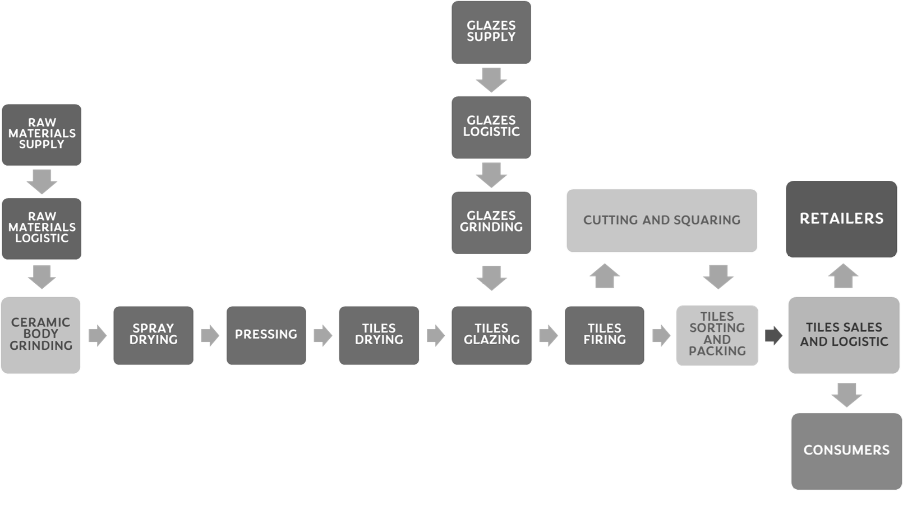
Fig. 1. Flow chart of the steps of the ceramic tile manufacturing process. Sources: Adapted from Garcia-Muiña et al., (2018).

The leading type of tiles manufactured by Italian producers is porcelain tile whose body is mainly composed of three main categories of raw materials: (1) kaolinitic or illitic-kaolinitic clays (ball calys), which provide the plasticity necessary for tile forming; (2) sodic, potassium or sodium-potassium feldspars, which melt during firing to form a glassy phase of adequate viscosity for complete sintering of the product; and (3) feldspathic or quartz sands with a structural function necessary to limit dimensional changes in drying and firing (Dondi et al., 2014).
With the disruption of the supply chain due to the war in Ukraine, clay supplies from the Donbass region were suddenly disrupted in the first half of 2022, causing serious problems for ceramic companies. This event dramatically highlighted how risk analysis and management have not yet fully entered the corporate culture as an integral part of the corporate sustainability assessment system. Had geopolitical risk been considered as early as 2014 with the Crimean crisis, ceramic companies today would have had strategic plans and alternative sourcing scenarios for Ukrainian clays. As with all complex problems, a possible solution can be found through functional decomposition, that is, separating the complex problem into several elementary subproblems (Guo et al., 2021). Following this logic, Figure 2 shows the functional decomposition scheme of the main complex problem into subproblems and three possible solution assumptions.
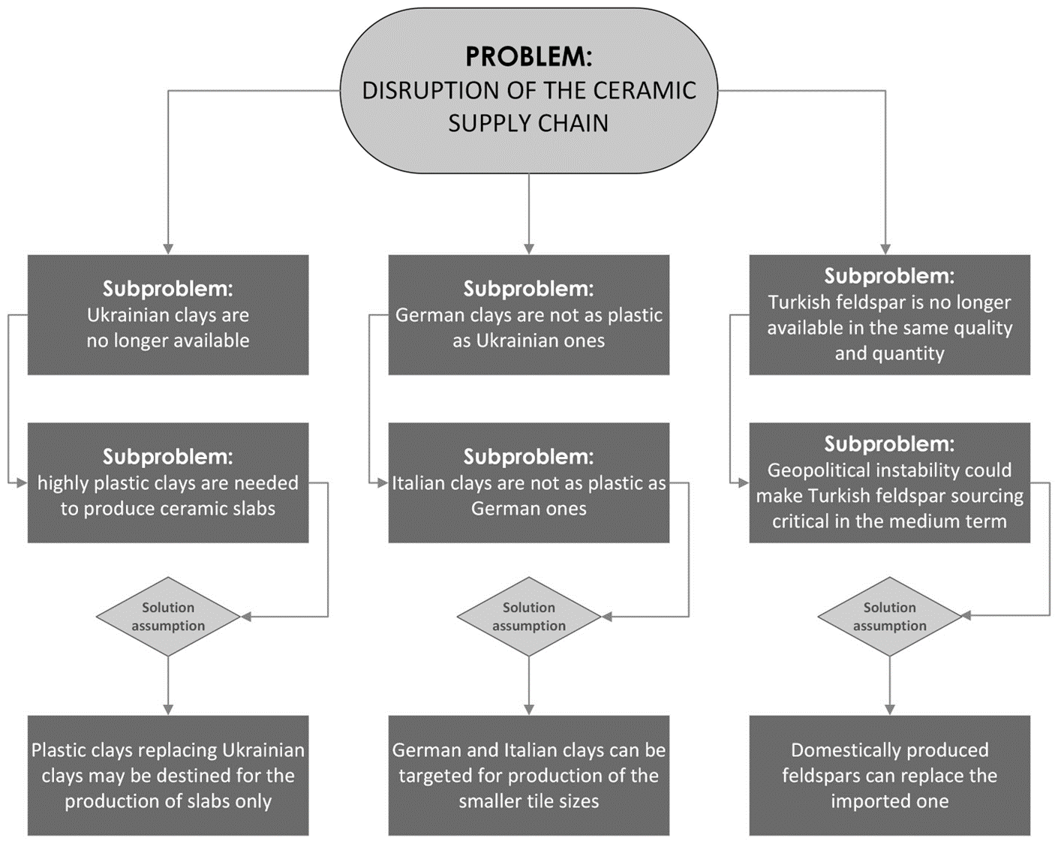
Fig. 2. Framework for the functional decomposition of critical issues in the Italian ceramic industry sourcing system. Sources: own elaboration.

In the case of the ceramic industry, the main problem is the disruption of the supply chain of imported extra-EU raw materials, which can be decomposed into three main sub-problems: (1) Ukrainian clays are no longer available, (2) German clays are not as plastic as Ukrainian clays, and (3) Turkish feldspar is no longer available in the same quantities with the same quality. Corresponding to these are three other sub-problems, respectively: (1) very plastic clays are needed to produce the large ceramic slabs, (2) Italian clays are not as plastic as German clays, and (3) regional geopolitical tensions could make the Turkish feldspar sourcing system critical in the medium term. Following the logic of abductive inference already adopted in other managerial studies (Zucchella and Previtali, 2019; Settembre Blundo et al., 2019) the following three corresponding explanatory hypotheses were assumed for each of the three subproblem categories, respectively: (1) alternative plastic clays to Ukrainian clays, given their low availability in terms of quantity, could be destined exclusively for the production of the large slabs; (2) Italian and German clays, of lower plasticity than Ukrainian ones and available in larger quantities, could be destined for the production of the smaller sizes of ceramic tiles; and (3) sodium, sodium-potassium and potassium feldspars could be more widely used for at least partial replacement of imported ones.

Strategic design of sourcing alternative
Following the criticality functional decomposition scheme (Figure 2) and abductive inference, five possible ceramic body compositions (S1÷S5) were hypothesized as alternatives to the sector average (S0), shown in Table 2.

Table 2. Overview of ceramic body compositions corresponding to different sourcing scenarios.

RAW MATERIALS | SOURCING CRITICISMS | S0 | S1 | S2 | S3 | S4 | S5
High plasticity ball clay (Ukraine) | 5 | 25% | 10%
Medium plasticity ball clay (Germany) | 2 | 10% | 25% | 30% | 30% | 25% | 20%
Low plasticity kaolinitic clay (Italy) | 1 | 10% | 10% | 15% | 30% | 25% | 30%
Medium plasticity red beds clays (Italy) | 3 |  |  |  |  | 10% | 15%
Sodium feldspar (Turkey) | 4 | 35% | 35% | 35% | 20% | 20% | 15%
Potassium feldspar (Italy) | 1 | 10% | 10% | 10% | 15% | 10% | 10%
Quartz sand (Italy) | 1 | 10% | 10% | 10%
Feldspathic sand (Italy) | 1 |  |  |  | 5% | 10% | 10%
Sources: own elaboration.

The S0 composition represents the average for the entire industry, obtained by cross-referencing data on raw material arrivals by ships at the port of Ravenna and trains directly to the Sassuolo ceramic district, during 2019. This is in fact a full and regular production year for the Italian ceramic industry, before the spread of the pandemic and the war in Ukraine.
Composition S1 is in response to the first assumption, which is to minimize the use of high plasticity clays from Ukraine by allocating them to the large ceramic slab production segment. Composition S2 offers a solution to the second assumption because it proposes a composition without high supply criticality clays, employing less plastic clays from Germany and Italy. Composition 3, on the other hand, aims to address the third assumption, which is to reduce the amount of imported feldspar in favor of domestic ones. Compositions S4 and S5, on the other hand, go beyond the previous three assumptions because they consider a type of raw material not currently considered in ceramic tile production: red beds clays (Fiori et al., 2011; Vázquez and Jiménez-Millán, 2004). These are clay materials that are very rich in iron oxide, but plastic and quite melting, once mined in large quantities in the area of both the Sassuolo ceramic district in Italy and the Castellón ceramic district in Spain. In both countries they were used as the main raw material for tile production until the early 1990s in Italy and the 2000s in Spain, giving the ceramic body a characteristic red color. Later they were replaced with imported clay materials with low iron content to meet the growing market demand for tiles that no longer had a red body but a clear one. With the S4 and S5 compositions, ancient materials are recovered for a new need: to reduce the criticality of the ceramic industry's supply chain. The plasticity property of these clays is given by their illitic nature while fusibility is given by their high iron oxide content. Therefore, with their use, the aim was to rebalance the clay component of the ceramic body to the advantage of a local raw material (S4) and also reduce the amount of imported feldspar due to the iron acting as a melting agent (S5). Table 2 Also provides an estimate of the level of supply criticality for each raw material considered and expressed on a scale of 1 to 5: [1] very low, [2] low, [3] medium, [4] high, and [5] very high. The highest criticality is attributed to Ukrainian clay due to supply disruption, followed by Turkish sodium feldspar due to quality problems and regional geopolitical instability. German clay and domestic raw materials are assigned low or very low criticality, respectively. The exception is red beds clays, which are given a medium criticality due to the fact that the mines where these materials were mined have been closed, and restoring mining operations to meet potential demand could take quite some time for the necessary permissions, which could also be refused by the regulatory authorities.

Table 3. Chemical composition and criticism level of ceramic body sourcing.

wt% | S0 | S1 | S2 | S3 | S4 | S5
SiO₂ | 67.70 | 68.76 | 69.73 | 69.79 | 69.02 | 68.82
Al₂O₃ | 19.42 | 18.40 | 17.46 | 17.35 | 17.46 | 17.24
Fe₂O₃ | 0.85 | 0.89 | 0.91 | 1.09 | 1.67 | 2.03
TiO₂ | 0.64 | 0.64 | 0.59 | 0.56 | 0.57 | 0.54
MgO | 0.44 | 0.42 | 0.40 | 0.,38 | 0.57 | 0.65
CaO | 0.87 | 0.86 | 0.86 | 0.61 | 0.56 | 0.53
Na₂O | 3.99 | 3.94 | 3.97 | 2.60 | 2.72 | 2.34
K₂O | 2.47 | 2.37 | 2.44 | 3.22 | 3.14 | 3.41
Loss On Ignition | 3.70 | 3.75 | 3.65 | 4.36 | 4.25 | 4.34
Criticism level | 3.15 | 2.70 | 2.35 | 1.90 | 2.05 | 1.95

Table 3 shows the chemical analysis and criticism level of the alternative compositions (S1÷S5) to the one before the supply problems occurred (S0). The replacement of Ukrainian clay with less plastic ones causes a gradual decrease in the amount of aluminum oxide, and the introduction of red beds clays instead causes an increase in the amount of iron oxide. As a result, the new compositions should have less plasticity and a darker color in firing than the S0 body. On the other hand, with regard to souring criticism, the weighted level progressively changes from medium to low. The technological feasibility of these compositional assumptions will then need to be confirmed by empirical evidence.

Environmental assessment of sourcing alternative
In order to verify the potential environmental performance of alternative sourcing scenarios, Life Cycle Assessment (LCA) methodology was used following the midpoint analysis approach to determine Global Warming Potential (GWP) as an impact category (Saracevic et al., 2019).

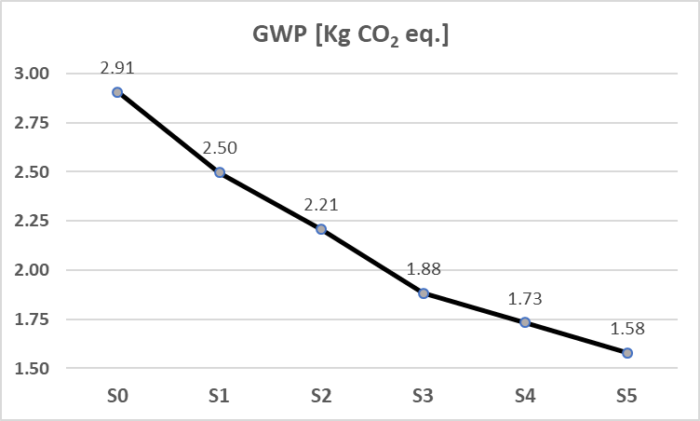
Fig. 3. Global Warming Potential (GWP) of 1 m² of porcelain tiles, referring to the phase of extraction and transportation to factories of different compositions of ceramic bodies.

The LCA analysis was conducted following the ISO 14040 and ISO 14044 standards, adopting. 1 m² of porcelain tiles as a functional unit with a mass of 21 kg/m² corresponding to the average value of the Italian ceramic industry. Instead, system boundaries were set from the cradle to the factory gate to include only the stages of raw material extraction and transportation to the manufacturing units (Cucchi et al., 2022). For the purpose of this study, the entire product life cycle was not considered, i.e., including the manufacturing, use and end-of-life phases (cradle-to-grave), because it was assumed that these phases would remain constant by varying the raw material sourcing strategy and, as a consequence, the composition of ceramic bodies changed. Furthermore, in this predictive environmental assessment, it was decided to consider only GWP as an impact category because it is a key indicator directly related to the use of fossil fuels in the logistics of transporting raw materials from mines to factories. Figure 3 shows the results of the environmental impact assessment clearly showing that the new strategies of reshoring (compositions S1÷S3) and nearshoring (compositions S4 and S5) for raw material sourcing, results in a drastic and progressive reduction of CO₂ emissions compared to the current system (composition S0).

Technological performance analysis
The hypotheses of different sourcing scenarios were tested in a pilot laboratory environment to verify their actual industrial feasibility. For this purpose, the six body compositions were processed following a laboratory protocol capable of reproducing industrial operating conditions. The 646×646 mm prototypes were fired in an industrial roller kiln at a maximum temperature of 1220°C with a 40-minute cycle. Table 4 shows the results obtained through the test.

Table 4. Technological properties of the ceramic bodies.

Technological Performance | Composition of Ceramic Bodies
 | S0 | S1 | S2 | S3 | S4 | S5
Sourcing strategy | Start point | Reshoring |  |  | Nearshoring
Length  (Nominal L = 604 mm) | 603.8 | 603.5 | 603.1 | 602.9 | 602.5 | 601.9
Dimensional conformity (ISO 10545-2) | L ± 2.0 mm | L ± 2.0 mm | L ± 2.0 mm | L ± 2.0 mm | L ± 2.0 mm | L ± 2.0 mm
Water absorption (%) | 0.29 | 0.31 | 0.35 | 0.41 | 0.28 | 0.18
Water absorption conformity (ISO 10545-3) | ≤ 0.5% | ≤ 0.5% | ≤ 0.5% | ≤ 0.5% | ≤ 0.5% | ≤ 0.5%
Bending strength (N) | 1780 ± 1 | 1759 ± 1 | 1734 ± 1 | 1691 ± 1 | 1682 ± 1 | 1715 ± 1
Bending strength conformity (ISO 10545-4) | ≥ 1300 N | ≥ 1300 N | ≥ 1300 N | ≥ 1300 N | ≥ 1300 N | ≥ 1300 N

In accordance with current ISO standards for ceramic tiles, the following technological parameters were checked: dimensional compliance, measured by comparing the actual length with the nominal one (ISO 10545-2); water absorption compliance, measured under vacuum (ISO 10545-3); and bending strength (ISO 10545-4). All compositions comply with regulatory standards, only composition S5, which is particularly rich in red beds clays, is dimensionally slightly below acceptable thresholds. To solve this problem without intervening in the formulation of the body, it would be sufficient to reduce the nominal length that is set by each individual manufacturer. In fact, an average length, representative of the entire industry, was adopted for this study. These tests allowed to demonstrate through a laboratory protocol, the technological feasibility of alternative sourcing scenarios whether (compositions S1÷S3) or nearshoring (compositions S4 and S5) without intervention on the production process.

Conclusions

In this study, the functional decomposition technique was applied to analyze the complexity of the material supply chain for the Italian ceramic tile manufacturing industry, and identify some possible solutions to the critical issues that the pandemic and geopolitical tensions have generated in this industry since the year 2020. The research also highlighted that complex problems need to be analyzed from different perspectives, which is why the transdisciplinary approach was adopted, which, thanks to the support of different disciplines (both technical and managerial) is, better than any other procedure, able to capture the interdependencies between the variables at stake. The context analysis allowed three assumptions to be formulated as possible solutions to the sudden interruption of plastic clay supplies from Ukraine. In one case, for large ceramic slabs that represent a niche (albeit an important one) in terms of volume of total production, the use of the few very plastic clays that may still arrive from Ukraine or other places being identified may be envisaged. In the case of conventional format ceramic tiles, on the other hand, for which very plastic clays are not as essential as for slabs, strategies of nearshoring and reshoring of sourcing systems are options that ceramic industries might consider.
These scenario assumptions then found empirical validation in a laboratory pre-pilot environment to demonstrate their technical feasibility. Five porcelain ceramic bodies were formulated and tested from both technical and environmental impact perspectives. Making use of European and local clays and feldspars, compositions were proposed that were less critical from a sourcing system viewpoint than the average industry composition in use before the pandemic and geopolitical crisis. Laboratory tests have shown that all solutions are potentially industrializable and comply with international ISO standards for ceramic tiles. Finally, the environmental assessment, focusing on Global Warming Potential (GWP) as an impact factor of Life Cycle Assessment (LCA) analysis, showed how moving mining sources closer to production factories significantly reduces CO₂ emissions to the atmosphere from transportation.
From the perspective of managerial analysis, this research makes a further contribution to the knowledge of the effects of the combination of pandemic and geopolitical tensions on production chains, applying the transdisciplinary approach The analysis of the ceramics industry, as an example of a raw material-intensive sector, also shows that the implementation of nearshoring and reshoring strategies not only reduce sourcing risk, but also decrease environmental impact with direct benefits on the overall production process and indirectly on the finished product. These results also offer important implications for practitioners, because the empirical analysis of a major European manufacturing industry demonstrates that the complexity of the business environment can be most successfully addressed by a holistic and synergistic approach between engineering and management skills.
Finally, the limitations of this research must be emphasized. First of all, the analysis conducted on the Italian ceramic industry would like to replicate to the Spanish one because of its relevance at the European industry level and the commonality of problems. The unavailability of primary data prevented conducting a parallel study. Then, the strategic scenario analysis lacks the economic assessment that is fundamental to any business decision. This research was conducted at a time of great uncertainty and volatility in the prices of raw materials and other production inputs, making any economic forecast totally unrepresentative.

References and Citations
- Appolloni, A., D'Adamo, I., Gastaldi, M., Yazdani, M., & Settembre-Blundo, D. (2021). Reflective backward analysis to assess the operational performance and eco-efficiency of two industrial districts. International Journal of Productivity and Performance Management. https://doi.org/10.1108/IJPPM-08-2021-0442
- Appolloni, A., Jabbour, C. J. C., D'Adamo, I., Gastaldi, M., & Settembre-Blundo, D. (2022). Green recovery in the mature manufacturing industry: The role of the green-circular premium and sustainability certification in innovative efforts. Ecological Economics, 193, 107311. https://doi.org/10.1016/j.ecolecon.2021.107311
- Baldwin, R., & Venables, A. J. (2013). Spiders and snakes: Offshoring and agglomeration in the global economy. Journal of International Economics, 90(2), 245-254. https://doi.org/10.1016/j.jinteco.2013.02.005
- Barbieri, P., Boffelli, A., Elia, S., Fratocchi, L., Kalchschmidt, M., & Samson, D. (2020). What can we learn about reshoring after Covid-19?. Operations Management Research, 13(3), 131-136. https://doi.org/10.1007/s12063-020-00160-1
- Bogataj, M., Grubbström, R. W., & Bogataj, L. (2011). Efficient location of industrial activity cells in a global supply chain. International journal of production Economics, 133(1), 243-250. https://doi.org/10.1016/j.ijpe.2010.09.035
- Broo, D. G. (2022). Transdisciplinarity and three mindsets for sustainability in the age of cyber-physical systems. Journal of Industrial Information Integration, 27, 100290. https://doi.org/10.1016/j.jii.2021.100290
- Ciravegna, L., & Michailova, S. (2021). Why the world economy needs, but will not get, more globalization in the post-COVID-19 decade. Journal of International Business Studies, 1-15. https://doi.org/10.1057/s41267-021-00467-6
- Colamatteo, A., Cassia, F., & Sansone, M. (2021). Near-shoring versus far-shoring: effects on customer perceived quality and purchase intention. The TQM Journal. https://doi.org/10.1108/TQM-05-2021-0132
- Cucchi, M., Volpi, L., Ferrari, A. M., García-Muiña, F. E., & Settembre-Blundo, D. (2022). Industry 4.0 real-world testing of dynamic organizational life cycle assessment (O-LCA) of a ceramic tile manufacturer. Environmental Science and Pollution Research, 1-20. https://doi.org/10.1007/s11356-022-20601-7
- Dondi, M., Garcia-Ten, J., Rambaldi, E., Zanelli, C., & Vicent-Cabedo, M. (2021). Resource efficiency versus market trends in the ceramic tile industry: Effect on the supply chain in Italy and Spain. Resources, Conservation and Recycling, 168, 105271. https://doi.org/10.1016/j.resconrec.2020.105271
- Dondi, M., Raimondo, M., & Zanelli, C. (2014). Clays and bodies for ceramic tiles: Reappraisal and technological classification. Applied Clay Science, 96, 91-109. https://doi.org/10.1016/j.clay.2014.01.013
- Fiori, C., Vitali, D., Camurri, E., Fabbri, B., & Gualtieri, S. (2011). Archaeometrical study of Celtic ceramics from Monte Bibele (Bologna, Italy). Applied clay science, 53(3), 454-465. https://doi.org/10.1016/j.clay.2010.11.008
- Fratocchi, L., Di Mauro, C., Barbieri, P., Nassimbeni, G., & Zanoni, A. (2014). When manufacturing moves back: Concepts and questions. Journal of Purchasing and Supply Management, 20(1), 54-59. https://doi.org/10.1016/j.pursup.2014.01.004
- Garcia-Muiña, F. E., González-Sánchez, R., Ferrari, A. M., & Settembre-Blundo, D. (2018). The paradigms of Industry 4.0 and circular economy as enabling drivers for the competitiveness of businesses and territories: The case of an Italian ceramic tiles manufacturing company. Social Sciences, 7(12), 255. https://doi.org/10.3390/socsci7120255
- García-Muiña, F. E., Medina-Salgado, M. S., Ferrari, A. M., & Cucchi, M. (2020). Sustainability transition in industry 4.0 and smart manufacturing with the triple-layered business model canvas. Sustainability, 12(6), 2364.https://doi.org/10.3390/su12062364
- Gligor, D. M., Holcomb, M. C., & Stank, T. P. (2013). A multidisciplinary approach to supply chain agility: Conceptualization and scale development. Journal of business logistics, 34(2), 94-108. https://doi.org/10.1111/jbl.12012
- Gothwal, S., & Saha, R. (2015). Plant location selection of a manufacturing industry using analytic hierarchy process approach. International Journal of Services and Operations Management, 22(2), 235-255 .https://doi.org/10.1504/IJSOM.2015.071531
- Guo, X., Liu, Y., Zhao, W., Wang, J., & Chen, L. (2021). Supporting resilient conceptual design using functional decomposition and conflict resolution. Advanced Engineering Informatics, 48, 101262. https://doi.org/10.1016/j.aei.2021.101262
- Hameiri, S. (2021). COVID-19: Is this the end of globalization?. International Journal, 76(1), 30-41. https://doi.org/10.1177/0020702020985325
- Ikram, M., Shen, Y., Ferasso, M., & D’Adamo, I. (2021). Intensifying effects of COVID-19 on economic growth, logistics performance, environmental sustainability and quality management: evidence from Asian countries. Journal of Asia Business Studies, 16(3), 448-471 https://doi.org/10.1108/JABS-07-2021-0316
- Johansson, M., Olhager, J., Heikkilä, J., & Stentoft, J. (2019). Offshoring versus backshoring: Empirically derived bundles of relocation drivers, and their relationship with benefits. Journal of Purchasing and Supply Management, 25(3), 100509. https://doi.org/10.1016/j.pursup.2018.07.003
- Khanuja, A., & Jain, R. K. (2021). The conceptual framework on integrated flexibility: an evolution to data-driven supply chain management. The TQM Journal. https://doi.org/10.1108/TQM-03-2020-0045
- Krieger-Boden, C., & Soltwedel, R. (2013). Identifying European economic integration and globalization: a review of concepts and measures. Regional Studies, 47(9), 1425-1442.https://doi.org/10.1080/00343404.2013.834319
- Ma, Q., Zhang, M., Ali, S., Kirikkaleli, D., & Khan, Z. (2021). Natural resources commodity prices volatility and economic performance: Evidence from China pre and post COVID-19. Resources Policy, 74, 102338. https://doi.org/10.1016/j.resourpol.2021.102338
- Magableh, G. M. (2021). Supply chains and the COVID‐19 pandemic: A comprehensive framework. European Management Review, 18(3), 363-382. https://doi.org/10.1111/emre.12449
- Matyushok, V., Krasavina, V., Berezin, A., & García, J. S. (2021). The global economy in technological transformation conditions: A review of modern trends. Economic Research-Ekonomska Istraživanja, 34(1), 1471-1497. https://doi.org/10.1080/1331677X.2020.1844030
- Merino, F., Di Stefano, C., & Fratocchi, L. (2021). Back-shoring vs near-shoring: a comparative exploratory study in the footwear industry. Operations Management Research, 14(1), 17-37. https://doi.org/10.1007/s12063-020-00173-w
- Miceli, A., Hagen, B., Riccardi, M. P., Sotti, F., & Settembre-Blundo, D. (2021). Thriving, not just surviving in changing times: How sustainability, agility and digitalization intertwine with organizational resilience. Sustainability, 13(4), 2052. https://doi.org/10.3390/su13042052
- Peruzzini, M., & Stjepandić, J. (2018). Editorial to the special issue “Transdisciplinary analytics in supply chain management”. Journal of Management Analytics, 5(2), 75-80. https://doi.org/10.1080/23270012.2018.1443405
- Peruzzini, M., Wognum, N., Bil, C., & Stjepandic, J. (2020). Special issue on ‘transdisciplinary approaches to digital manufacturing for industry 4.0’. International Journal of Computer Integrated Manufacturing, 33(4), 321-324. https://doi.org/10.1080/0951192X.2020.1752071
- Piatanesi, B., & Arauzo‐Carod, J. M. (2019). Backshoring and nearshoring: An overview. Growth and Change, 50(3), 806-823. https://doi.org/10.1111/grow.12316
- Ros-Dosdá, T., Fullana-i-Palmer, P., Mezquita, A., Masoni, P., & Monfort, E. (2018). How can the European ceramic tile industry meet the EU's low-carbon targets? A life cycle perspective. Journal of Cleaner Production, 199, 554-564. https://doi.org/10.1016/j.jclepro.2018.07.176
- Saracevic, E., Koch, D., Stuermer, B., Mihalyi, B., Miltner, A., & Friedl, A. (2019). Economic and global warming potential assessment of flexible power generation with biogas plants. Sustainability, 11(9), 2530. https://doi.org/10.3390/su11092530
- Settembre Blundo, D. S., Politi, A. L. M., del Hoyo, A. P. F., & Muiña, F. E. G. (2019). The Gadamerian hermeneutics for a mesoeconomic analysis of Cultural Heritage. Journal of Cultural Heritage Management and Sustainable Development, 9(3), 300-333. https://doi.org/10.1108/JCHMSD-09-2017-0060
- Vacchi, M., Siligardi, C., Cedillo-González, E. I., Ferrari, A. M., & Settembre-Blundo, D. (2021). Industry 4.0 and smart data as enablers of the circular economy in manufacturing: Product re-engineering with circular eco-design. Sustainability, 13(18), 10366. https://doi.org/10.3390/su131810366
- van Hoek, R., & Dobrzykowski, D. (2021). Towards more balanced sourcing strategies–are supply chain risks caused by the COVID-19 pandemic driving reshoring considerations?. Supply Chain Management: An International Journal. https://doi.org/10.1108/SCM-09-2020-0498
- van Hoek, R., & Dobrzykowski, D. (2021). Towards more balanced sourcing strategies–are supply chain risks caused by the COVID-19 pandemic driving reshoring considerations?. Supply Chain Management: An International Journal 26(6), 689-701. https://doi.org/10.1108/SCM-09-2020-0498
- Vázquez, M., & Jiménez-Millán, J. (2004). Clay raw materials from the Triassic Red Beds (Northern Jaen, Spain) for making ceramic construction materials. Materiales de Construcción, 54(273), 5-20. https://doi.org/10.3989/mc.2004.v54.i273.219
- Xu, L. D. (2020). The contribution of systems science to industry 4.0. Systems Research and Behavioral Science, 37(4), 618-631. https://doi.org/10.1002/sres.2705
- Zucchella, A., & Previtali, P. (2019). Circular business models for sustainable development: A “waste is food” restorative ecosystem. Business Strategy and the Environment, 28(2), 274-285. https://doi.org/10.1002/bse.2216

