Chapter N 303
A new approach to improve sustainability: the role of Organizational Life Cycle Assessment (O-LCA)

Abstract. When preparing an emissions assessment report, life cycle assessment, originally defined for products, can be extended to organizations, under the name Organizational Life Cycle Assessment (O-LCA). This is a methodology for identifying the environmental impacts of activities associated with an organization using a life cycle approach, and compared to LCA, which is generally seen as an isolated assessment at the product level, it has greater transferability to the company because it considers the company's entire production range rather than just one product. However, assessing the impact of organizations can be complex because it considers a network of relationships with partners and suppliers related to the organization whose data is not always available. Thus, a detailed understanding of GHG-emitting activities is essential for the development of an effective corporate sustainable strategy, as value chain emissions can be used to guide overall policy, implement sectoral allocation, or initiate engagement with companies. Therefore, based on these considerations, O-LCA could be a useful tool for investigating emissions at the organizational level and thus aid in the pursuit of corporate objectives. In light of this, the goal of this paper is to present a general overview of O-LCA and how it could serve as a sustainability tool in order to intersect different interests between companies and stakeholders.

Keywords. O-LCA, SO-LCA, Organizations, Materiality matrix

- Introduction
According to the Intergovernmental Panel on Climate Change (IPCC), the average global temperature has increased by +1.53°C compared to pre-industrial levels, inducing climate warming that is leading to an increase in the frequency of extreme events, including heat waves and droughts (IPCC, 2021). Given this, the international community has identified a number of goals for the decarbonization of the economic-industrial system, such as climate neutrality by 2050 (Horowitz, 2016). In addition, as also emphasized by the World Resources Institute and the World Business Council for Sustainable Development, in order for the global average temperature increase to be limited to 2°C above pre-industrial levels by 2050, it will be essential to reduce CO₂ emissions by 85% from 1990 levels (WRI and WBCSD, 2011). So, organizations should take steps to reduce and prevent the production of greenhouse gases (GHGs), and in this context, adopting a holistic, multi-impact approach in assessing value chain impacts could help. In preparing an emissions assessment report, life cycle analysis, originally defined for products, can be extended to the assessment of organizations, under the name Organizational Life Cycle Assessment (O-LCA) (ISO, 2014). O-LCA is a methodology for identifying the environmental impacts of activities associated with an organization using a life-cycle approach (Martinez Blanco et al., 2015). However, assessing the impact of organizations could be complex because it considers a network of relationships with partners related to the organization whose data is not always available. Therefore, a detailed understanding of the activities that produce GHG emissions is critical for the establishment of an effective organization’s sustainable strategy. In this regard, it is possible to distinguish between direct emissions (those directly produced by the organization) and indirect emissions (those associated with the inputs of the production activity and the organization) (Hertwich & Wood, 2018). Emissions are in turn further categorized into Scope 1 (those produced directly from sources owned by the organization), Scope 2 (those associated with the purchase of electricity, steam, heat, or cooling), and Scope 3 (those associated with activities and assets not controlled by the organization, but which nevertheless indirectly impact the organization) (Figure 1).
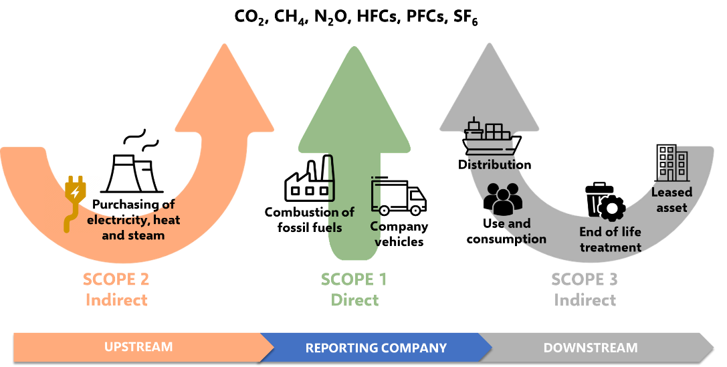
Figure 1. Overview of GHG Protocol scopes and emissions across the value chain
Until recently, many companies have mainly focused their attentions on emissions from their own operations, managing to keep operational (Scope 1 and Scope 2) emissions under control, but sometimes encountering difficulties in controlling those related to the supply chain and product use (Scope 3) (Martínez-Blanco et al., 2020). Currently, organizations are trying to find ways to reduce Scope 3 emissions, especially those related to the purchase of goods and services and product use, which account for a significant share of Scope 3 emissions (CDP, 2018), while still protecting the pursuit of profitability and value creation. Value chain emissions, therefore, represent an important source of impacts, which organizations can be incentivized to reduce, and their consideration can improve the assessment of risks and opportunities for transition, although emissions reporting remains voluntary and is low (Ducoulombier, 2021). Value chain emissions can be used to guide overall policy, implement sector allocation, or initiate engagement with companies. So, value chain considerations can be included in asset selection through specific security-level performance metrics and/or corporate commitment to decarbonization, such as through a materiality matrix. Therefore, O-LCA could be a useful tool for investigating emissions at the organizational level and thus aid in the pursuit of Scope 3. In light of this, the goal of this paper is to present a general overview of O-LCA and how it could serve as a sustainability tool in order to intersect different interests between companies and stakeholders.
- O-LCA: description and state of the art
The Life Cycle Assessment has managed to evolve dynamically, until the development of some "variants," more or less specific that arise mainly as a result of the need to identify impacts along the entire supply chain, so as to consider the entire value chain according to a multi-impact approach. In fact, LCA is generally seen as an isolated assessment at the product level, with limited transferability to the organizations, without looking at the whole. However, since most companies produce a wide range of products, an LCA related to a single product will analyze only a small part of the company, whereas it would make more sense to evaluate the company's entire production range. For these reasons, the O-LCA and the Social Organizational Life Cycle Assessment (SO-LCA) (Martinez Blanco et al., 2015) have emerged in recent years. O-LCA could be considered an extension of the application of LCA to organizations (Figure 2) and could help in finding environmental hotspots where the organization should focus its interventions throughout the value chain.

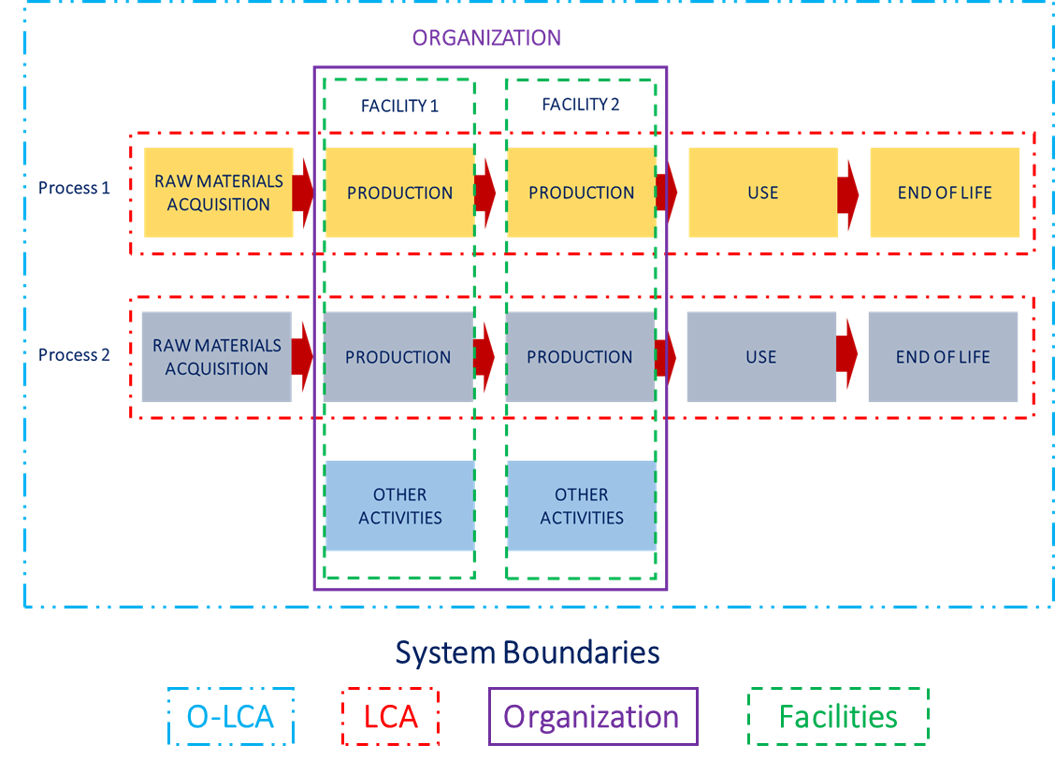

Figure 2. O-LCA Description (ISO, 2014)
O-LCA is regulated by ISO/TS 14072 which provides additional details for its proper implementation. LCA and O-LCA share most of the requirements defined by ISO 14040 and 14044, with minor additions and changes in terminology and the definition of two new constituents, corresponding to the functional unit and reference flow, namely reporting unit (replacing functional unit) and reporting flow (replacing reference flow) (Table 1).

Table 1. Comparison of O-LCA and LCA

 | O-LCA | LCA
Scope | Organizations | Products or processes
Reference | ISO/TS 14071 | ISO 14040 and 14044
Standardization year | 2014 | 2006
Object of study | Reporting Unit | Functional Unit
Outputs measures | Reporting flow | Reference flow
Goal | Monitoring the performance of an organization | Assessment of environmental impacts of products or processes
Phases | 4 | 4
Consolidation methodology | Yes | No

O-LCA is still an unexplored area of research, so much so that entering the keyword "O-LCA" on Scopus yields roughly 20 articles. Among them, the papers all have different objectives (framework development, literature reviews, case studies), and one can certainly point out significant growth potential. Few studies apply the O-LCA for assessing the environmental performance of organizations, such as including O-LCA for universities (Bueno et al., 2022), packaging (Rimano et al., 2021), textiles (Resta et al., 2016), beverages (Manzardo et al., 2016), cosmetics (Moreira de Camargo et al., 2019) and renewable energy (Marx et al., 2020). Recently, O-LCA has also been extended to the assessment of social impacts, through the development of SO-LCA, which although it follows the same guidelines as S-LCA (UNEP, 2009), varies from it mainly to address a methodological shortcoming of S-LCA, according to which, there is some difficulty in identifying social indicators at the product level since social impacts generally occur at the organizational level (Martinez Blanco et al., 2015). SO-LCA, in the face of two literature articles, also remains an understudied area of research.

- O-LCA as a tool for organizations’ disclosure
Over the past few years, organizations increasingly need to describe strategic assets and report differently on their activities, as well as justify corporate strategies. Organizations, therefore, resort to a different form of reporting, called Different Disclosure Not Financial (DDNF). To identify the different balance points that can efficiently intersect the interests of the organization with those of the stakeholders, a materiality matrix has been proposed. This is a qualitative matrix that facilitates organizations’ disclosure in showing their strategies to stakeholders and identifying environmental and social hotspots while meeting organizations’ objectives. It makes it possible to identify everything that could have an impact on the organization and vice versa, demonstrating a company's commitment to sustainability and serves to reflect strategic priorities in sustainability areas relevant to the Group, on which to focus efforts and to increase integrating sustainability into strategy and daily. The matrix, which can be customized to suit the needs of the individual organization, has a basic structure in which, on the x-axis is the relevance of a given issue to the company, while on the y-axis is the relevance of a given issue to stakeholders, as shown in Figure 3. Strategic priorities, based on the different levels of detail of information, can be determined in various ways but for the approach of this study, they were identified according to the six macro-areas identified by Legislative Decree 254/2016, namely society, environment, employer, human rights, corruption and crossing. The matrix can be divided into four quadrants: 1 (very relevant to stakeholders and not very relevant to the company), 2 (very relevant to stakeholders and very relevant to the company), 3 (not very relevant to stakeholders and very relevant to the company) and 4 (not very relevant to stakeholders and not very relevant to the company).
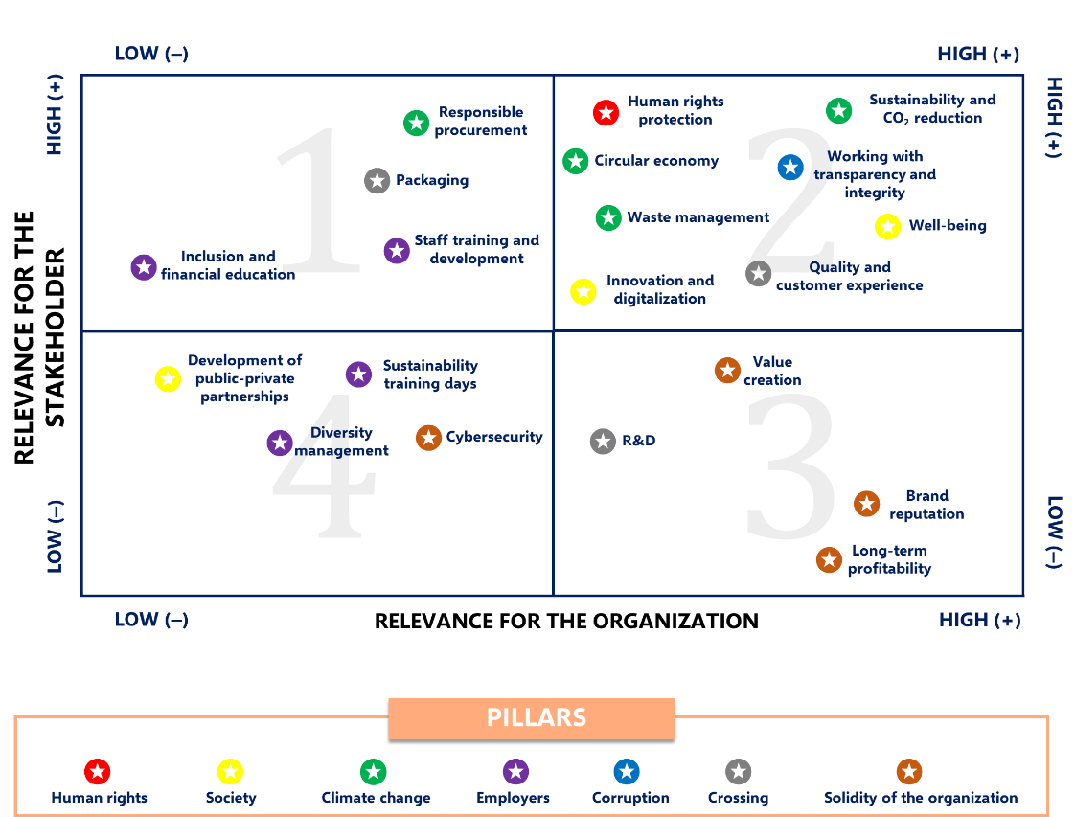

Figure 3. Example of the materiality matrix

The company's goal will be to shift its targets as far as possible toward quadrant 2 (top right), so as to focus on pursuing and meeting goals that have a significant impact on the organization's economic, social, and environmental performance and that could substantially influence stakeholder assessments and decisions. As constructed on the basis of the two criteria described above, the widespread sensitivity to air pollution underscores the need within organizations to have to effectively communicate to their stakeholders what they have achieved in terms of emissions abatement. Indeed, Figure 3 shows that in quadrant 2, in which all elements characterized by high relevance to the organization and stakeholders are placed, are environmental sustainability and CO₂ emission reduction, Scope 1, 2, and 3. To this end, companies will need to employ tools for effective process analysis, and O-LCA and SO-LCA could be of great help. In fact, the materiality matrix presupposes such survey and evaluation activities that a set of indicators and performance measures that define operational guidelines can be identified. O-LCA and SO-LCA could thus be supportive of the organization's search for objective indicators and metrics through which to measure these objectives, not least because investments in strategic assets and sustainability initiatives are difficult to explain through financial data. The application of O-LCA could then allow companies to assess value chain activities, upstream and downstream of the value chain, identifying direct and indirect emission sources and production hotspots. In addition, through the identification of hotspots within the organization, it might be possible to operate production systems efficiencies. O-LCA fits within an evolving and particularly favorable regulatory environment, which organizations could take advantage of. In particular, O-LCA is also supported by the ISO 14067:2018, which defines the guidelines for quantifying the Carbon Footprint, thus giving the organizations the possibility to better understand the opportunities through which to reduce emissions. Currently, the International Standard Organization is working on the drafting of the new ISO 14068 standard (2023) and pending it, the current normative reference is the PAS 2060 (BSI, 2014), created in 2010 by the British Standards Institution (BSI), which serves to guide companies in improving their environmental performance, with particular reference to the pursuit of carbon neutrality. In detail, PAS 2060, ensures uniformity in the techniques for calculating GHGs emissions and their reductions/compensation, defining a decarbonization pathway that starts from the calculation of CF to its offsetting and reduction. Therefore, O-LCA could also be further "enhanced" by taking advantage of a favorable regulatory environment, recently revised and with future developments. But while the application of O-LCA is limited to the environmental impacts of the organization studied, the integration of SO-LCA allows the addition of a social inventory and the identification of social hotspots in the organization's own supply chain for the fulfillment of the remaining elements included in Quadrant 2, for example, such as well-being, transparency, integrity, and protection of human rights. However, the application of O-LCA is not immediate. Indeed, it will be challenging to adopt the method in the case of the service sector, given the difficulty of being able to quantify the organization's performance, which is necessary for activity reporting. However, the difficulty of quantifying production activities in terms of physical output can be overcome through the use of economic and social indicators, such as the economic value of the service and the number of employees. Another limitation to the application of O-LCA is the definition of system boundaries (Marx et al., 2020). Indeed, it is not always possible to assess the impacts of production in cradle-to-grave systems, as in the case of primary material supply services. The last element is the presence of processes and products that are not under the direct control of the company but exert influence on it. However, it is believed that with the widespread application of the methodology, thus through more scientific production with case studies as the object, it will be possible to provide companies with adaptable reference models in business contexts.

Conclusions
The objective of this study was to present a general overview of O-LCA and to show how it can support organizations in intersecting the different interests of the company and stakeholders. Thus, an approach was proposed based on the construction of a materiality matrix based on the 6 pillars identified by Legislative Decree 254/2016, through which it might be possible to facilitate corporate disclosure in showing stakeholders their corporate strategies. In fact, since organizations often need objective data, through O-LCA and SO-LCA it might be possible to provide quantifiable parameters for proper disclosure and for the pursuit of the most relevant strategic objectives for both the organization and the stakeholders, including, for example, the control of Scope 3 emissions, those least controllable by organizations.

References
BSI (2014). PAS 2060. The ideal standard for carbon neutrality.
Bueno, G., de Blas, M., Pérez-Iribarren, E., Zuazo, I., Torre-Pascual, E., Erauskin, A., . . . Barrio, I. (2022). Dataset on the environmental and social footprint of the university of the basque country UPV/EHU. Data in Brief, 41
Camargo, A., Forin, S., Macedo, K., Finkbeiner, M., Martínez-Blanco, J. (2019). The implementation of organizational LCA to internally manage the environmental impacts of a broad product portfolio: an example for a cosmetics, fragrances, and toiletry provider. The International Journal of Life Cycle Assessment. 24.
CDP (2018). Out of the starting blocks Tracking progress on corporate climate action.
Decreto Legislativo 30 dicembre 2016, n. 254. (17G00002) (GU Serie Generale n.7 del 10-01-2017).
Ducoulombier, F. (2021). Understanding the importance of scope 3 emissions and the implications of data limitations. The Journal of Impact and ESG Investing, 1(4), 63-71.
Hertwich, E. G., & Wood, R. (2018). The growing importance of scope 3 greenhouse gas emissions from industry. Environmental Research Letters, 13(10), 104013.
Horowitz, C. A. (2016). Paris Agreement. International Legal Materials, 55(4).
IPCC (2021). Summary for Policymakers. In: Climate Change 2021: The Physical Science Basis. Contribution of Working Group I to the Sixth Assessment Report of the Intergovernmental Panel on Climate Change.
ISO/TS 14072:2014. Environmental Management—Life Cycle Assessment—Requirements and Guidelines for Organizational Life Cycle Assessment. Geneva: International Organization for Standardization.
ISO 14067:2018. Greenhouse gases — Carbon footprint of products — Requirements and guidelines for quantification.
Manzardo, A., Loss, A., Mazzi, A., Scipioni, A. (2016). Organization Life-Cycle Assessment (OLCA): Methodological Issues and Case Studies in the Beverage-Packaging Sector.
Martínez-Blanco, J., Forin, S., & Finkbeiner, M. (2020). Challenges of organizational LCA: Lessons learned from road testing the guidance on organizational life cycle assessment. The International Journal of Life Cycle Assessment, 25(2), 311-331.
Martínez-Blanco, J., Lehmann, A., Chang, Y. J., & Finkbeiner, M. (2015). Social organizational LCA (SOLCA)—a new approach for implementing social LCA. International Journal of Life Cycle Assessment, 20(11).
Marx, H., Forin, S., Finkbeiner, M. (2020). Organizational life cycle assessment of a service-providing SME for renewable energy projects (PV and wind) in the United Kingdom. Sustainability, 12, 4475
Resta, B., Gaiardelli, P., Pinto, R., & Dotti, S. (2016). Enhancing environmental management in the textile sector: An organizational-life cycle assessment approach. Journal of Cleaner Production, 135, 620-632.
Rimano, M., Simboli, A., Taddeo, R., Del Grosso, M., & Raggi, A. (2021). The environmental impact of organizations: A pilot test from the packaging industry based on organizational life cycle assessment. Sustainability (Switzerland), 13(20) doi:10.3390/su132011402
UNEP/SETAC (2009). Guidelines for social life cycle assessment of products. ISBN: 978-92-807-3021-0
WRI and WBCSD (2011). Greenhouse Gas Protocol Corporate Value Chain (Scope 3) Accounting and Reporting Standard.

